HMI SDK UI 设计指导说明书

Version <1.0>

履历

|  |  |  |  |
| --- | --- | --- | --- |
| **日期** | **版本** | **描述** | **作者** |
| 2017-05-05 | 1.0 | 初版作成，完成框架及16个模板内容。 | 范强 |
|  |  |  |  |
|  |  |  |  |
|  |  |  |  |

目录

1. 介绍 8

1.1 目的 8

1.2 适用范围 8

1.3 定义与缩写 8

1.4 引用 8

2. HMI概要设计 9

2.1 HMI 架构设计 9

2.1.1 模块关系图 9

2.1.2 包图 10

2.1.3 类图 11

2.2 注册 App 接口 RPC 11

2.2.1 组件就绪确认 11

2.2.2 注册通知 12

2.2.3 IsReady 时序图 13

2.3 模板 15

2.3.1 布局模板介绍 15

2.3.2 模板的实现 15

3. 可用模板 15

3.1 MEDIA – WITH PROGRASS BAR 15

3.1.1 属性 15

3.1.2 Show 20

3.1.3 AppListView 24

3.1.4 Slider 26

3.1.5 Alert 28

3.1.6 AudioPassThru 30

3.1.7 Choiceset 32

3.1.8 Command 37

3.1.9 ScrollableMessage 39

3.1.10 DialNumber 41

3.1.11 VideoStream 42

3.2 NON-MEDIA –WITH SOFT BUTTON 43

3.2.1 属性 43

3.2.2 Show 47

3.2.3 AppListView 50

3.2.4 Slider 53

3.2.5 Alert 54

3.2.6 AudioPassThru 54

3.2.7 Choiceset 55

3.2.8 Command 55

3.2.9 ScrollableMessage 55

3.2.10 DialNumber 55

3.2.11 VideoStream 55

3.3 GRAPHIC_WITH_TEXT 55

3.3.1 属性 55

3.3.2 Show 60

3.3.3 AppListView 62

3.3.4 Slider 62

3.3.5 Alert 63

3.3.6 AudioPassThru 63

3.3.7 Choiceset 63

3.3.8 Command 63

3.3.9 ScrollableMessage 63

3.3.10 DialNumber 63

3.3.11 VideoStream 63

3.4 TEXT_WITH_GRAPHIC 63

3.4.1 属性 63

3.4.2 Show 68

3.4.3 AppListView 70

3.4.4 Slider 70

3.4.5 Alert 70

3.4.6 AudioPassThru 71

3.4.7 Choiceset 71

3.4.8 Command 71

3.4.9 ScrollableMessage 71

3.4.10 DialNumber 71

3.4.11 VideoStream 71

3.5 TILES_ONLY 71

3.5.1 属性 71

3.5.2 Show 75

3.5.3 AppListView 78

3.5.4 Slider 78

3.5.5 Alert 78

3.5.6 AudioPassThru 78

3.5.7 Choiceset 78

3.5.8 Command 78

3.5.9 ScrollableMessage 78

3.5.10 DialNumber 78

3.5.11 VideoStream 79

3.6 GRAPHIC_WITH_TILES 79

3.6.1 属性 79

3.6.2 Show 83

3.6.3 AppListView 86

3.6.4 Slider 86

3.6.5 Alert 86

3.6.6 AudioPassThru 86

3.6.7 Choiceset 86

3.6.8 Command 86

3.6.9 ScrollableMessage 86

3.6.10 DialNumber 86

3.6.11 VideoStream 87

3.7 TILES_WITH_GRAPHIC 87

3.7.1 属性 87

3.7.2 Show 91

3.7.3 AppListView 94

3.7.4 Slider 94

3.7.5 Alert 94

3.7.6 AudioPassThru 94

3.7.7 Choiceset 94

3.7.8 Command 94

3.7.9 ScrollableMessage 94

3.7.10 DialNumber 94

3.7.11 VideoStream 95

3.8 GRAPHIC_WITH_TEXT_AND_SOFTBUTTONS 95

3.8.1 属性 95

3.8.2 Show 99

3.8.3 AppListView 102

3.8.4 Slider 102

3.8.5 Alert 102

3.8.6 AudioPassThru 102

3.8.7 Choiceset 102

3.8.8 Command 102

3.8.9 ScrollableMessage 102

3.8.10 DialNumber 102

3.8.11 VideoStream 103

3.9 TEXT_AND_SOFTBUTTONS_WITH_GRAPHIC 103

3.9.1 属性 103

3.9.2 Show 107

3.9.3 AppListView 110

3.9.4 Slider 110

3.9.5 Alert 110

3.9.6 AudioPassThru 110

3.9.7 Choiceset 110

3.9.8 Command 110

3.9.9 ScrollableMessage 110

3.9.10 DialNumber 110

3.9.11 VideoStream 111

3.10 GRAPHIC_WITH_TEXTBUTTONS 111

3.10.1 属性 111

3.10.2 Show 115

3.10.3 AppListView 118

3.10.4 Slider 118

3.10.5 Alert 118

3.10.6 AudioPassThru 118

3.10.7 Choiceset 118

3.10.8 Command 118

3.10.9 ScrollableMessage 118

3.10.10 DialNumber 118

3.10.11 VideoStream 119

3.11 DOUBLE_GRAPHIC_SOFTBUTTONS 119

3.11.1 属性 119

3.11.2 Show 123

3.11.3 AppListView 126

3.11.4 Slider 126

3.11.5 Alert 126

3.11.6 AudioPassThru 126

3.11.7 Choiceset 126

3.11.8 Command 126

3.11.9 ScrollableMessage 126

3.11.10 DialNumber 126

3.11.11 VideoStream 127

3.12 TEXTBUTTONS_WITH_GRAPHIC 127

3.12.1 属性 127

3.12.2 Show 131

3.12.3 AppListView 134

3.12.4 Slider 134

3.12.5 Alert 134

3.12.6 AudioPassThru 134

3.12.7 Choiceset 134

3.12.8 Command 134

3.12.9 ScrollableMessage 134

3.12.10 DialNumber 134

3.12.11 VideoStream 135

3.13 TEXTBUTTONS_ONLY 135

3.13.1 属性 135

3.13.2 Show 139

3.13.3 AppListView 141

3.13.4 Slider 142

3.13.5 Alert 142

3.13.6 AudioPassThru 142

3.13.7 Choiceset 142

3.13.8 Command 142

3.13.9 ScrollableMessage 142

3.13.10 DialNumber 142

3.13.11 VideoStream 142

3.14 LARGE_GRAPHIC_WITH_SOFTBUTTONS 142

3.14.1 属性 142

3.14.2 Show 147

3.14.3 AppListView 149

3.14.4 Slider 149

3.14.5 Alert 150

3.14.6 AudioPassThru 150

3.14.7 Choiceset 150

3.14.8 Command 150

3.14.9 ScrollableMessage 150

3.14.10 DialNumber 150

3.14.11 VideoStream 150

3.15 LARGE_GRAPHIC_ONLY 150

3.15.1 属性 150

3.15.2 Show 154

3.15.3 AppListView 157

3.15.4 Slider 157

3.15.5 Alert 157

3.15.6 AudioPassThru 158

3.15.7 Choiceset 158

3.15.8 Command 158

3.15.9 ScrollableMessage 158

3.15.10 DialNumber 158

3.15.11 VideoStream 158

3.16 ONSCREEN_PRESETS 158

3.16.1 属性 158

3.16.2 Show 162

3.16.3 AppListView 167

3.16.4 Slider 167

3.16.5 Alert 167

3.16.6 AudioPassThru 167

3.16.7 Choiceset 167

3.16.8 Command 167

3.16.9 ScrollableMessage 167

3.16.10 DialNumber 167

3.16.11 VideoStream 168

HMI UI 设计指导说明书

# 介绍

本文介绍了HMI SDK内部设计架构以及用户交互UI层的设计，内容包含文档目的、范围、定义、缩写、引用，提供了整个HMI支持的UI模板的设计和HMI架构相关的概述。

## 目的

本文档提供了HMI SDK UI设计的指导，使用了多个不同的模板视图来描述UI设计的不同方面。它的目的是指导开发人员根据模板实现界面以及界面元素和RPC属性对应关系。

## 适用范围

本文档适用于HMI的开发人员，指导其进行UI的画面的实现以及提供HMI与SDL进行交互时，各RPC在UI的如何表现的参考。

## 定义与缩写

|  |  |
| --- | --- |
| **缩写** | **含义** |
| HMI | 人机交互界面 |
| RPC | 远程过程调用 |
| VR | 语音识别 |
| TTS | 语音合成 |
| SDL | SmartDeviceLink |
| JSON | JavaScript 对象表示法 |

## 引用

框架结构设计文档《HMI design.asta》

模板设计原图《HMI templates.vsd》

# HMI概要设计

## HMI 架构设计

### 模块关系图

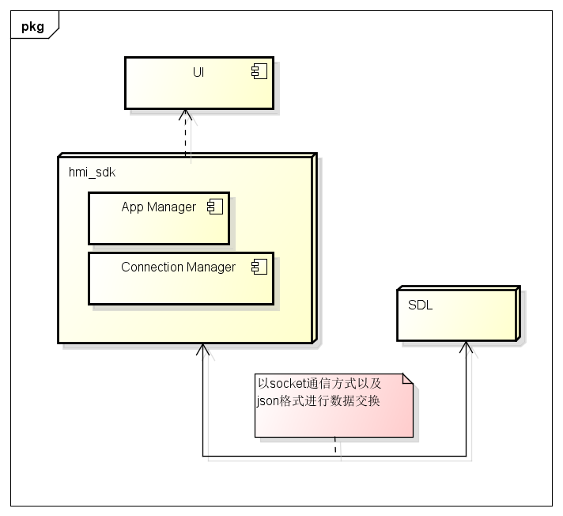

### 包图

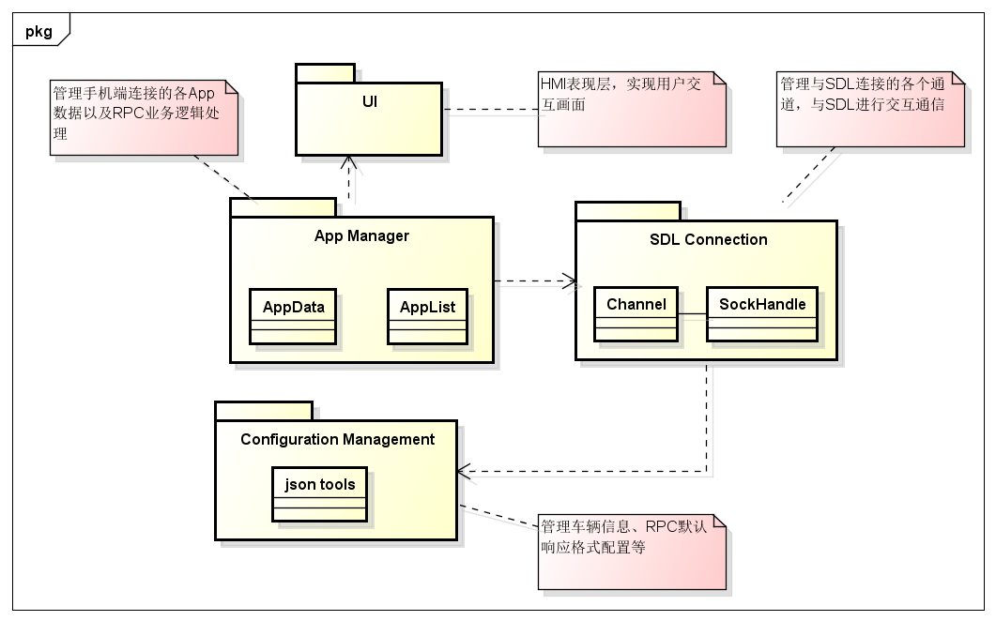

### 类图

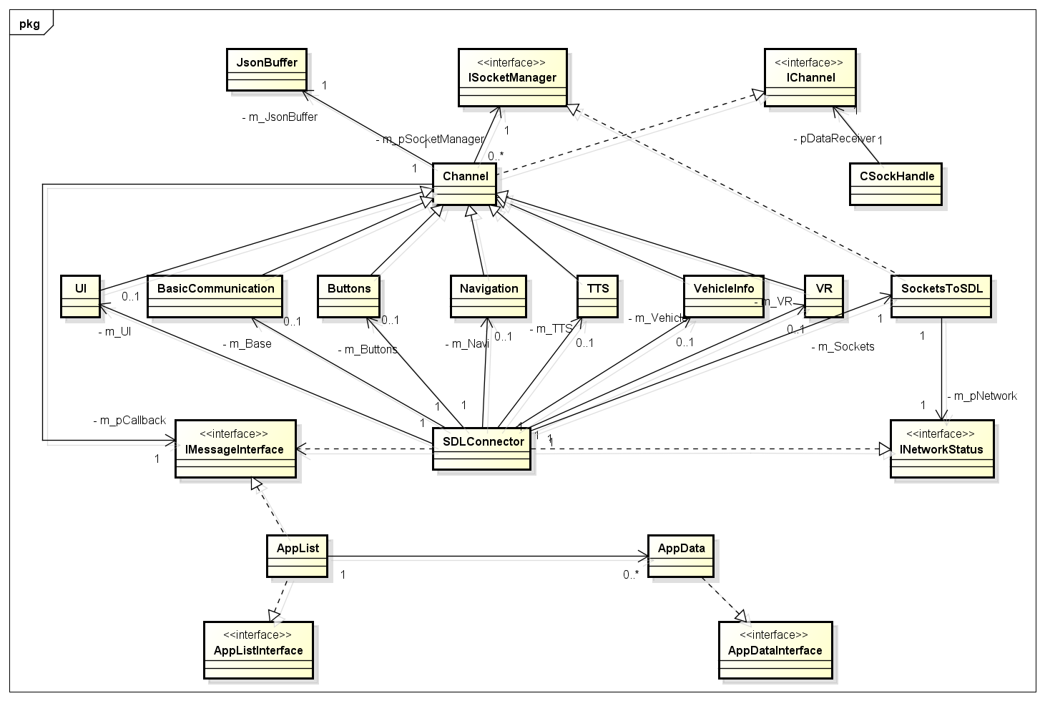

## 注册 App 接口 RPC

### 组件就绪确认

HMI必须注册每一个组件, 该组件能通过以下格式与SDL进行通讯

var JSONMessage = {

"jsonrpc": "2.0",

"id": -1,

"method": "MB.registerComponent",

"params": {

"componentName": "UI"

}

};

可能的组件名称是 UI、 Buttons、 BasicCommunication、VR、TTS、Navigation和VehicleInfo

一旦这些组件被注册，HMI必须通知sdl，它已经准备开始使用BasicCommunication.OnReady进行之后的通讯

*收到 OnReady 通知后，SDL 将开始通过响应链接请求来检查不同 HMI 组件的可用性：*

UI.IsReady - 显示屏可用性

VR.IsReady - 语音识别模块可用性

TTS.IsReady - 语音合成模块可用性

Navigation.IsReady - 导航引擎可用性

VehicleInfo.IsReady - 指示是否可以收集和提供车辆信息。

### 注册通知

HMI也必须通过以下RPC的格式注册每一条通知

var obj = {

"jsonrpc": "2.0",

"id": -1,

"method": "MB.subscribeTo",

"params": {

"propertyName": notificationName

}

}

propertyName 是通知(notification)的名字, 好比 Buttons.OnButtonSubscription

*注意事项：*

a.HMI必须注册他的所有组件, 发送 OnReady的通知, 响应每一个 IsReady 的RPCs, 并且为每一个想要收到的通知进行注册。

b.如果对任何组件 IsReady 请求的响应包含 {"available": false}，SDL 将不再与该组件进行通信。

### IsReady 时序图

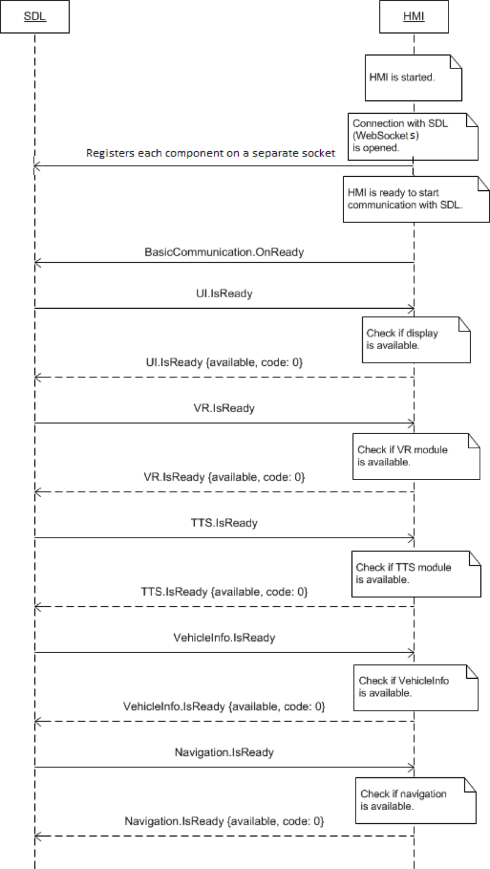

## 模板

### 布局模板介绍

### 模板的实现

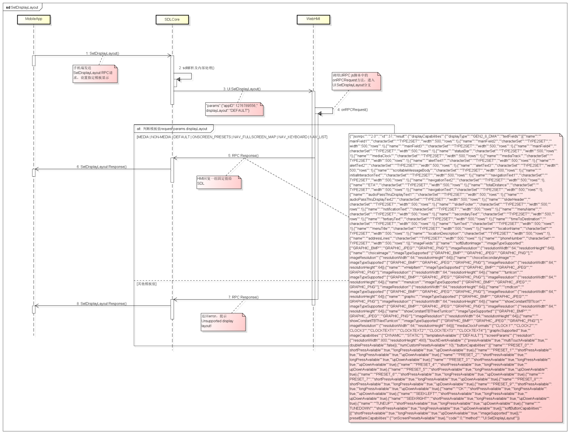

# 可用模板

## MEDIA – WITH PROGRASS BAR

### 属性

{

"id": 31,

"jsonrpc": "2.0",

"result": {

"code": 0,

"displayCapabilities": {

"displayType": "GEN3_8_INCH",

"graphicSupported": true, //支持图像显示

"imageCapabilities": [ //支持动态静态图片

"STATIC",

"DYNAMIC"

],

"imageFields": [

{

"imageResolution": { //softButton图标尺寸

"resolutionHeight": 35,

"resolutionWidth": 35

},

"imageTypeSupported": [ //softButton支持图标类型

"GRAPHIC_BMP",

"GRAPHIC_JPEG",

"GRAPHIC_PNG"

],

"name": "softButtonImage"

},

{

"imageResolution": { //softButton图标尺寸

"resolutionHeight": 70,

"resolutionWidth": 70

},

"imageTypeSupported": [ //softButton支持图标类型

"GRAPHIC_BMP",

"GRAPHIC_JPEG",

"GRAPHIC_PNG"

],

"name": "softButtonImage"

},

{

"imageResolution": { //首选choice图标尺寸

"resolutionHeight": 35,

"resolutionWidth": 35

},

"imageTypeSupported": [ //首选choice支持图标类型

"GRAPHIC_BMP",

"GRAPHIC_JPEG",

"GRAPHIC_PNG"

],

"name": "choiceImage"

},

{

"imageResolution": { //次选choice图标尺寸

"resolutionHeight": 35,

"resolutionWidth": 35

},

"imageTypeSupported": [ //次选choice支持图标类型

"GRAPHIC_BMP",

"GRAPHIC_JPEG",

"GRAPHIC_PNG"

],

"name": "choiceSecondaryImage"

},

{

"imageResolution": { //vr帮助图标占位尺寸

"resolutionHeight": 35,

"resolutionWidth": 35

},

"imageTypeSupported": [ //vr帮助图标支持的格式

"GRAPHIC_BMP",

"GRAPHIC_JPEG",

"GRAPHIC_PNG"

],

"name": "vrHelpItem"

},

{

"imageResolution": { //菜单图标占位尺寸

"resolutionHeight": 35,

"resolutionWidth": 35

},

"imageTypeSupported": [ //菜单图标支持的格式

"GRAPHIC_BMP",

"GRAPHIC_JPEG",

"GRAPHIC_PNG"

],

"name": "menuIcon"

},

{

"imageResolution": { //命令按钮图标占位尺寸

"resolutionHeight": 35,

"resolutionWidth": 35

},

"imageTypeSupported": [ //命令按钮图标支持的格式

"GRAPHIC_BMP",

"GRAPHIC_JPEG",

"GRAPHIC_PNG"

],

"name": "cmdIcon"

},

{

"imageResolution": { //app显示图标占位尺寸

"resolutionHeight": 35,

"resolutionWidth": 35

},

"imageTypeSupported": [ //app显示图标支持的格式

"GRAPHIC_BMP"

],

"name": "appIcon"

},

{

"imageResolution": { //app显示图标占位尺寸

"resolutionHeight": 70,

"resolutionWidth": 70

},

"imageTypeSupported": [ //app显示图标支持的格式

"GRAPHIC_BMP"

],

"name": "appIcon"

},

{

"imageResolution": { //location显示图标占位尺寸

"resolutionHeight": 35,

"resolutionWidth": 35

},

"imageTypeSupported": [ //location显示图标支持的格式

"GRAPHIC_BMP",

"GRAPHIC_JPEG",

"GRAPHIC_PNG"

],

"name": "locationImage"

}

],

"mediaClockFormats": [ //时间显示格式HH:MM:SS

"CLOCK3"

],

"numCustomPresetsAvailable": 8,

"screenParams": {

"resolution": { //画面显示尺寸

"resolutionHeight": 348,

"resolutionWidth": 800

},

"touchEventAvailable": {

"doublePressAvailable": false, // 不支持双击

"multiTouchAvailable": false, //不支持多点触摸

"pressAvailable": true //支持单击

}

},

"templatesAvailable": [ //当前支持的模板

"GRAPHIC_WITH_TEXT",

"TEXT_WITH_GRAPHIC",

"TILES_ONLY",

"GRAPHIC_WITH_TILES",

"TILES_WITH_GRAPHIC",

"GRAPHIC_WITH_TEXT_AND_SOFTBUTTONS",

"TEXT_AND_SOFTBUTTONS_WITH_GRAPHIC",

"GRAPHIC_WITH_TEXTBUTTONS",

"DOUBLE_GRAPHIC_WITH_SOFTBUTTONS",

"TEXTBUTTONS_WITH_GRAPHIC",

"TEXTBUTTONS_ONLY",

"LARGE_GRAPHIC_WITH_SOFTBUTTONS",

"LARGE_GRAPHIC_ONLY",

"MEDIA",

"ONSCREEN_PRESETS"

],

"textFields": [ //各文本字段名字、字符集、显示行数、文本宽度

{

"characterSet": "CID1SET",

"name": "mainField1",

"rows": 1,

"width": 50

},

{

"characterSet": "CID1SET",

"name": "mainField2",

"rows": 1,

"width": 40

},

{

"characterSet": "CID1SET",

"name": "mainField3",

"rows": 1,

"width": 20

},

{

"characterSet": "CID1SET",

"name": "alertText1",

"rows": 1,

"width": 40

},

{

"characterSet": "CID1SET",

"name": "alertText2",

"rows": 1,

"width": 40

},

{

"characterSet": "CID1SET",

"name": "alertText3",

"rows": 1,

"width": 40

},

{

"characterSet": "CID1SET",

"name": "scrollableMessageBody",

"rows": 8,

"width": 67

},

{

"characterSet": "CID1SET",

"name": "audioPassThruDisplayText1",

"rows": 1,

"width": 40

},

{

"characterSet": "CID1SET",

"name": "audioPassThruDisplayText2",

"rows": 1,

"width": 40

},

{

"characterSet": "CID1SET",

"name": "sliderHeader",

"rows": 1,

"width": 60

},

{

"characterSet": "CID1SET",

"name": "sliderFooter",

"rows": 1,

"width": 60

},

{

"characterSet": "CID1SET",

"name": "menuName",

"rows": 1,

"width": 35

},

{

"characterSet": "CID1SET",

"name": "secondaryText",

"rows": 1,

"width": 50

},

{

"characterSet": "CID1SET",

"name": "tertiaryText",

"rows": 1,

"width": 13

},

{

"characterSet": "CID1SET",

"name": "locationName",

"rows": 1,

"width": 20

},

{

"characterSet": "CID1SET",

"name": "locationDescription",

"rows": 1,

"width": 15

},

{

"characterSet": "CID1SET",

"name": "addressLines",

"rows": 4,

"width": 15

},

{

"characterSet": "CID1SET",

"name": "phoneNumber",

"rows": 1,

"width": 30

}

]

},

"method": "UI.SetDisplayLayout",

"softButtonCapabilities": [

{

"imageSupported": true, //按钮支持图片显示

"longPressAvailable": true, //支持长按

"shortPressAvailable": true, //支持短压

"upDownAvailable": true //支持按下弹起,有up、down事件及效果

}

]

}

}

### Show

#### 相关RPC

|  |  |
| --- | --- |
| 名字 | 请求内容 |
| UI.Show | **{**  **"id"**: 46**,**  **"jsonrpc"**: "2.0"**,**  **"method"**: "UI.Show"**,**  **"params"**: **{**  **"alignment"**: "CENTERED"**,**  **"appID"**: 12077**,**  **"customPresets"**: **[**  "GEN0"**,**  "GEN1"**,**  "GEN2"**,**  "GEN3"**,**  "GEN4"**,**  "GEN5"  **],**  **"graphic"**: **{**  **"imageType"**: "DYNAMIC"**,**  **"value"**: "/fs/rwdata/storage/sdl/584421907_6b50de75f3391a9e8117be9ded91461eabe62e54f74c8538e897e6621179721a/icon.png"  **},**  **"secondaryGraphic"**: **{**  **"imageType"**: "DYNAMIC"**,**  **"value"**: "/fs/rwdata/storage/sdl/584421907_6b50de75f3391a9e8117be9ded91461eabe62e54f74c8538e897e6621179721a/action.png"  **},**  **"showStrings"**: **[**  **{**  **"fieldName"**: "mainField1"**,**  **"fieldText"**: "Show Line 1"  **},**  **{**  **"fieldName"**: "mainField2"**,**  **"fieldText"**: "Show Line 2"  **},**  **{**  **"fieldName"**: "mainField3"**,**  **"fieldText"**: "Show Line 3"  **},**  **{**  **"fieldName"**: "mainField4"**,**  **"fieldText"**: "Show Line 4"  **},**  **{**  **"fieldName"**: "mediaClock"**,**  **"fieldText"**: "12:34"  **},**  **{**  **"fieldName"**: "mediaTrack"**,**  **"fieldText"**: "Media Track"  **},**  **{**  **"fieldName"**: "statusBar"**,**  **"fieldText"**: "status bar"  **}**  **],**  **"softButtons"**: **[**  **{**  **"isHighlighted"**: true**,**  **"softButtonID"**: 5547**,**  **"systemAction"**: "DEFAULT_ACTION"**,**  **"text"**: "Close"**,**  **"type"**: "TEXT"  **},**  **{**  **"isHighlighted"**: true**,**  **"softButtonID"**: 5548**,**  **"systemAction"**: "DEFAULT_ACTION"**,**  **"text"**: "Close"**,**  **"type"**: "TEXT"  **},**  **{**  **"isHighlighted"**: true**,**  **"softButtonID"**: 5549**,**  **"systemAction"**: "DEFAULT_ACTION"**,**  **"text"**: "Close"**,**  **"type"**: "TEXT"  **}**  **]**  **}**  **}** |
| UI.SetMediaClockTimer | **{**  **"id"**: 47**,**  **"jsonrpc"**: "2.0"**,**  **"method"**: "UI.SetMediaClockTimer"**,**  **"params"**: **{**  **"appID"**: 12077**,**  **"endTime"**: **{**  **"hours"**: 0**,**  **"minutes"**: 20**,**  **"seconds"**: 50  **},**  **"startTime"**: **{**  **"hours"**: 0**,**  **"minutes"**: 12**,**  **"seconds"**: 34  **},**  **"updateMode"**: "COUNTUP"  **}**  **}** |

#### 设计图

执行SetMediaClockTimer之前

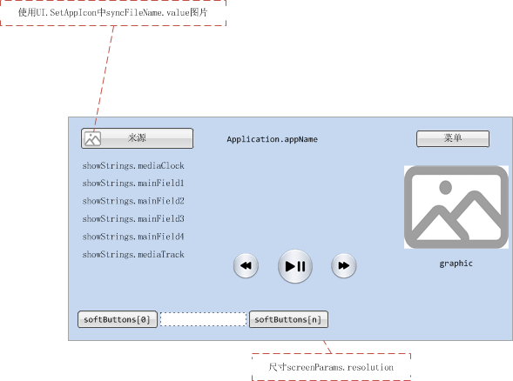

执行SetMediaClockTimer之后

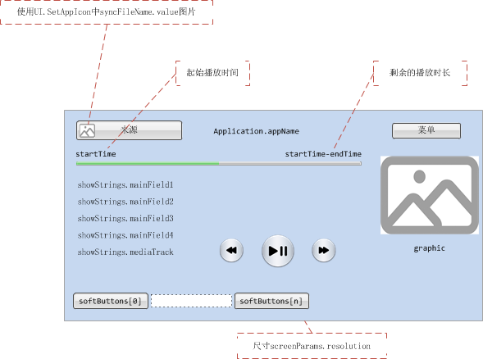

#### 效果图

执行SetMediaClockTimer之前

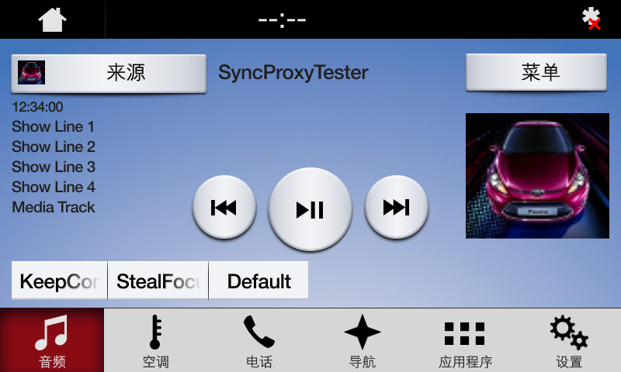

执行SetMediaClockTimer之后

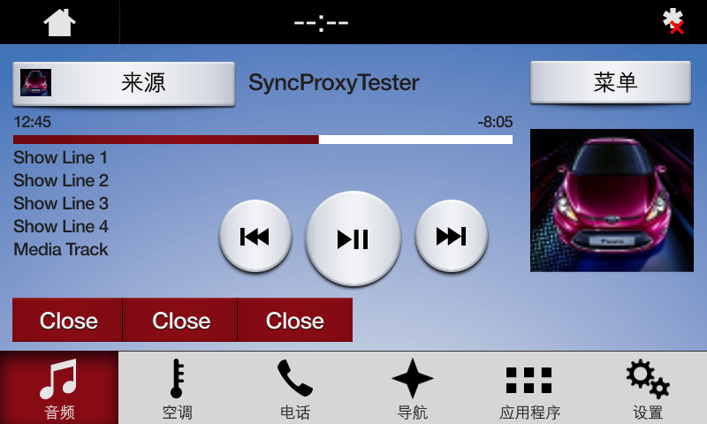

### AppListView

#### 相关RPC

|  |  |
| --- | --- |
| 名字 | 请求内容 |
| UI.SetAppIcon | **{**  **"id"**: 57**,**  **"jsonrpc"**: "2.0"**,**  **"method"**: "UI.SetAppIcon"**,**  **"params"**: **{**  **"appID"**: 11840**,**  **"syncFileName"**: **{**  **"imageType"**: "DYNAMIC"**,**  **"value"**: "/fs/rwdata/storage/sdl/584421907_6b50de75f3391a9e8117be9ded91461eabe62e54f74c8538e897e6621179721a/icon.png"  **}**  **}**  **}** |
| BasicCommunication.OnAppRegistered | **{**  **"jsonrpc"**: "2.0"**,**  **"method"**: "BasicCommunication.OnAppRegistered"**,**  **"params"**: **{**  **"application"**: **{**  **"appID"**: 11840**,**  **"appName"**: "SyncProxyTester"**,**  **"appType"**: **[**  "DEFAULT"  **],**  **"deviceInfo"**: **{**  **"id"**: "6b50de75f3391a9e8117be9ded91461eabe62e54f74c8538e897e6621179721a"**,**  **"isSDLAllowed"**: true**,**  **"name"**: "BTGalaxy On5 (2016)"**,**  **"transportType"**: "BLUETOOTH"  **},**  **"hmiDisplayLanguageDesired"**: "EN-US"**,**  **"icon"**: ""**,**  **"isMediaApplication"**: true**,**  **"ngnMediaScreenAppName"**: "SPT"**,**  **"policyAppID"**: "584421907"**,**  **"requestType"**: **[**  "LAUNCH_APP"**,**  "QUERY_APPS"**,**  "PROPRIETARY"  **]**  **},**  **"priority"**: "NONE"**,**  **"ttsName"**: **[**  **{**  **"text"**: "Sync Proxy Tester"**,**  **"type"**: "TEXT"  **}**  **],**  **"vrSynonyms"**: **[**  "Synonym1"**,**  "Synonym2"  **]**  **}**  **}** |

#### 设计图

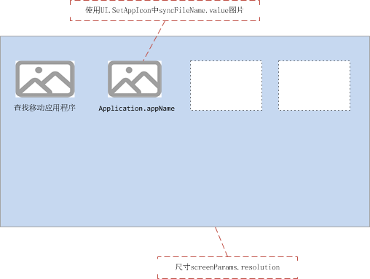

#### 效果图

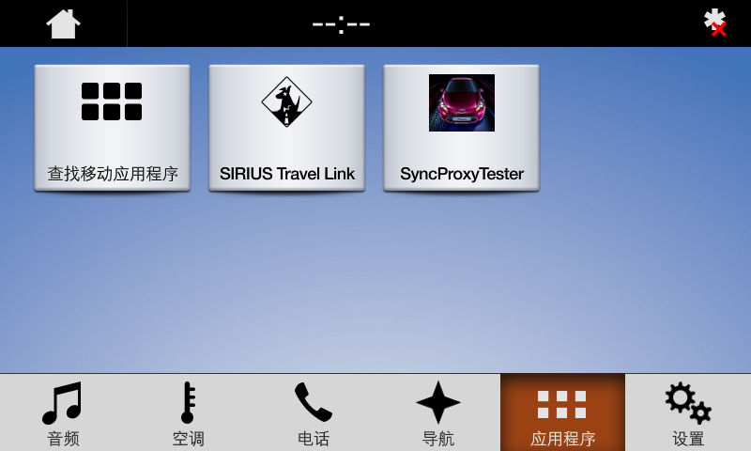

### Slider

#### 相关RPC

|  |  |
| --- | --- |
| 名字 | 请求内容 |
| UI.Slider | **{**  **"id"**: 43**,**  **"jsonrpc"**: "2.0"**,**  **"method"**: "UI.Slider"**,**  **"params"**: **{**  **"appID"**: 1878**,**  **"numTicks"**: 20**,**  **"position"**: 5**,**  **"sliderFooter"**: **[**  "1"**,**  "2"**,**  "3"**,**  "4"**,**  "5"**,**  "6"**,**  "7"**,**  "8"**,**  "9"**,**  "10"**,**  "11"**,**  "12"**,**  "13"**,**  "14"**,**  "15"**,**  "16"**,**  "17"**,**  "18"**,**  "19"**,**  "20"  **],**  **"sliderHeader"**: "Slider Header"**,**  **"timeout"**: 10000  **}**  **}** |

#### 设计图

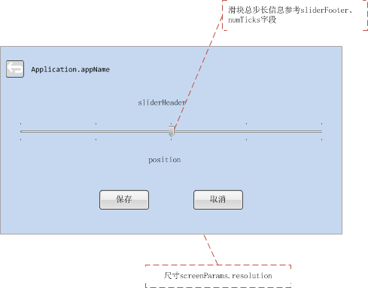

#### 效果图

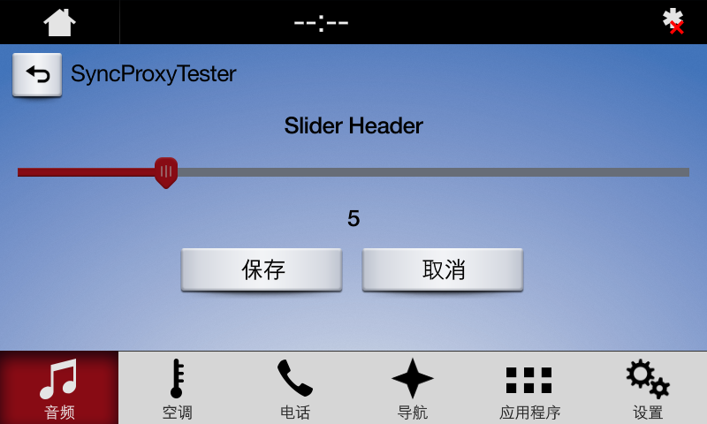

### Alert

#### 相关RPC

|  |  |
| --- | --- |
| 名字 | 请求内容 |
| UI.Alert | **{**  **"id"**: 49**,**  **"jsonrpc"**: "2.0"**,**  **"method"**: "UI.Alert"**,**  **"params"**: **{**  **"alertStrings"**: **[**  **{**  **"fieldName"**: "alertText1"**,**  **"fieldText"**: "Alert Line 1"  **},**  **{**  **"fieldName"**: "alertText2"**,**  **"fieldText"**: "Alert Line 2"  **},**  **{**  **"fieldName"**: "alertText3"**,**  **"fieldText"**: "Alert Line 3"  **}**  **],**  **"alertType"**: "BOTH"**,**  **"appID"**: 12077**,**  **"duration"**: 0**,**  **"progressIndicator"**: true**,**  **"softButtons"**: **[**  **{**  **"isHighlighted"**: true**,**  **"softButtonID"**: 5552**,**  **"systemAction"**: "DEFAULT_ACTION"**,**  **"text"**: "Close"**,**  **"type"**: "TEXT"  **},**  **{**  **"isHighlighted"**: true**,**  **"softButtonID"**: 5553**,**  **"systemAction"**: "DEFAULT_ACTION"**,**  **"text"**: "Close"**,**  **"type"**: "TEXT"  **},**  **{**  **"isHighlighted"**: true**,**  **"softButtonID"**: 5554**,**  **"systemAction"**: "DEFAULT_ACTION"**,**  **"text"**: "Close"**,**  **"type"**: "TEXT"  **}**  **]**  **}**  **}** |

#### 设计图

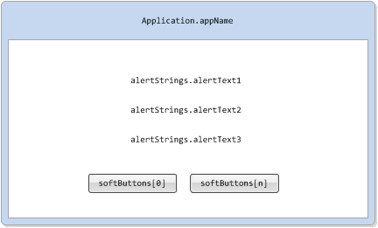

#### 效果图

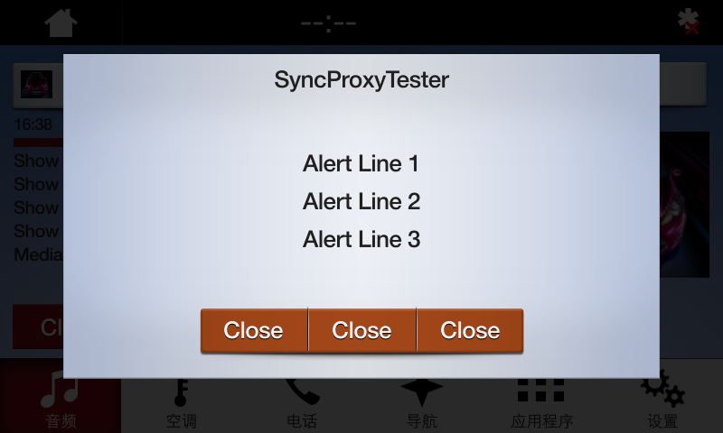

### AudioPassThru

#### 相关RPC

|  |  |
| --- | --- |
| 名字 | 请求内容 |
| UI.PerformAudioPassThru | **{**  **"id"**: 40**,**  **"jsonrpc"**: "2.0"**,**  **"method"**: "UI.PerformAudioPassThru"**,**  **"params"**: **{**  **"appID"**: 9167**,**  **"audioPassThruDisplayTexts"**: **[**  **{**  **"fieldName"**: "audioPassThruDisplayText1"**,**  **"fieldText"**: "AudioPassThru Display Text 1"  **},**  **{**  **"fieldName"**: "audioPassThruDisplayText2"**,**  **"fieldText"**: "AudioPassThru Display Text 2"  **}**  **],**  **"maxDuration"**: 10000**,**  **"muteAudio"**: false  **}**  **}** |
| UI. EndAudioPassThru | **{**  **"id"**: 46**,**  **"jsonrpc"**: "2.0"**,**  **"method"**: "UI.EndAudioPassThru"  **}** |

#### 设计图

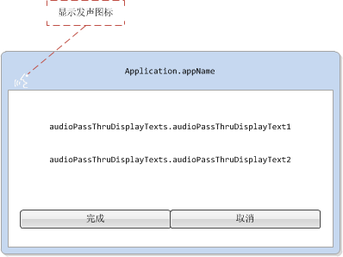

#### 效果图

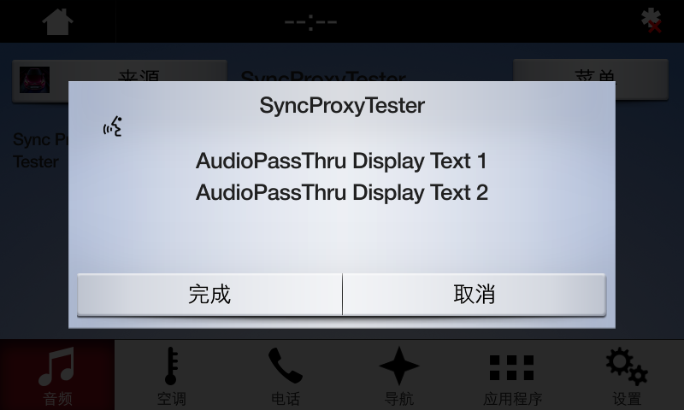

### Choiceset

#### 相关RPC

|  |  |
| --- | --- |
| 名字 | 请求内容 |
| UI.PerformInteraction | **{**  **"id"**: 61**,**  **"jsonrpc"**: "2.0"**,**  **"method"**: "UI.PerformInteraction"**,**  **"params"**: **{**  **"appID"**: 9167**,**  **"choiceSet"**: **[**  **{**  **"choiceID"**: 1**,**  **"image"**: **{**  **"imageType"**: "DYNAMIC"**,**  **"value"**: "/fs/rwdata/storage/sdl/584421907_6b50de75f3391a9e8117be9ded91461eabe62e54f74c8538e897e6621179721a/icon.png"  **},**  **"menuName"**: "Choice1"**,**  **"secondaryImage"**: **{**  **"imageType"**: "DYNAMIC"**,**  **"value"**: "/fs/rwdata/storage/sdl/584421907_6b50de75f3391a9e8117be9ded91461eabe62e54f74c8538e897e6621179721a/action.png"  **},**  **"secondaryText"**: "Secondary text"**,**  **"tertiaryText"**: "Tertiary text"  **},**  **{**  **"choiceID"**: 2**,**  **"image"**: **{**  **"imageType"**: "DYNAMIC"**,**  **"value"**: "/fs/rwdata/storage/sdl/584421907_6b50de75f3391a9e8117be9ded91461eabe62e54f74c8538e897e6621179721a/turn_left.png"  **},**  **"menuName"**: "Choice2"**,**  **"secondaryImage"**: **{**  **"imageType"**: "DYNAMIC"**,**  **"value"**: "/fs/rwdata/storage/sdl/584421907_6b50de75f3391a9e8117be9ded91461eabe62e54f74c8538e897e6621179721a/turn_right.png"  **},**  **"secondaryText"**: "Secondary text"**,**  **"tertiaryText"**: "Tertiary text"  **}**  **],**  **"initialText"**: **{**  **"fieldName"**: "initialInteractionText"**,**  **"fieldText"**: "Pick number:789"  **},**  **"interactionLayout"**: "ICON_WITH_SEARCH"**,**  **"timeout"**: 100000**,**  **"vrHelp"**: **[**  **{**  **"image"**: **{**  **"imageType"**: "DYNAMIC"**,**  **"value"**: "/fs/rwdata/storage/sdl/584421907_6b50de75f3391a9e8117be9ded91461eabe62e54f74c8538e897e6621179721a/turn_forward.png"  **},**  **"position"**: 1**,**  **"text"**: "VR help item1"  **},**  **{**  **"image"**: **{**  **"imageType"**: "DYNAMIC"**,**  **"value"**: "/fs/rwdata/storage/sdl/584421907_6b50de75f3391a9e8117be9ded91461eabe62e54f74c8538e897e6621179721a/icon.png"  **},**  **"position"**: 2**,**  **"text"**: "VR help item2"  **}**  **],**  **"vrHelpTitle"**: "Pick number:789"  **}**  **}** |
| VR.PerformInteraction | **{**  **"id"**: 60**,**  **"jsonrpc"**: "2.0"**,**  **"method"**: "VR.PerformInteraction"**,**  **"params"**: **{**  **"appID"**: 9167**,**  **"grammarID"**: **[**  9403  **],**  **"helpPrompt"**: **[**  **{**  **"text"**: "help me,I'm melting"**,**  **"type"**: "TEXT"  **}**  **],**  **"initialPrompt"**: **[**  **{**  **"text"**: "Pick a command"**,**  **"type"**: "TEXT"  **}**  **],**  **"timeout"**: 100000**,**  **"timeoutPrompt"**: **[**  **{**  **"text"**: "hurry it up"**,**  **"type"**: "TEXT"  **}**  **]**  **}**  **}** |

#### 设计图

VR画面

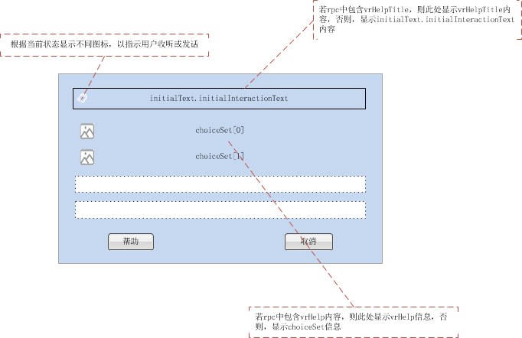

Manual画面

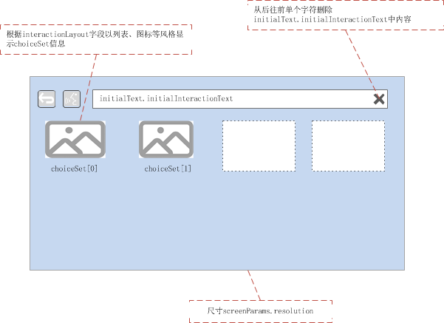

#### 效果图

VR画面

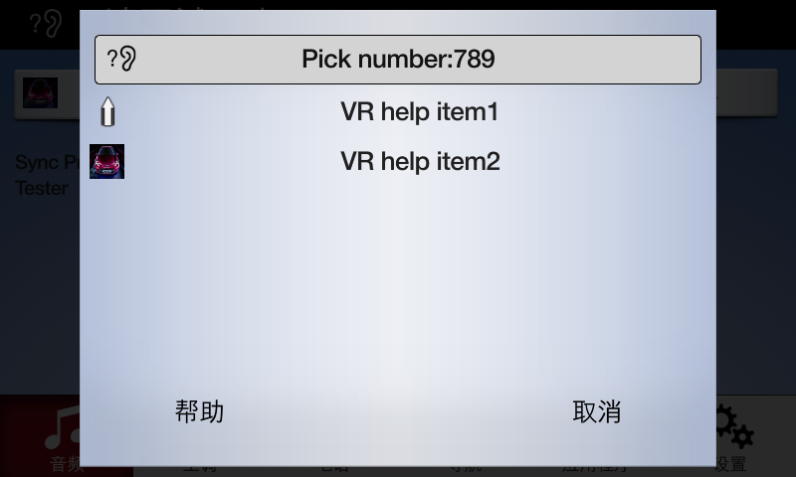

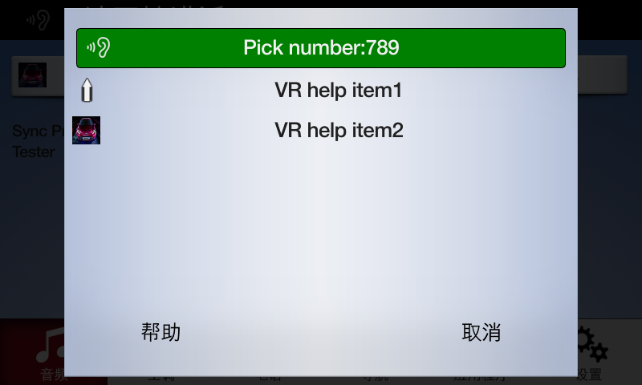

Manual画面

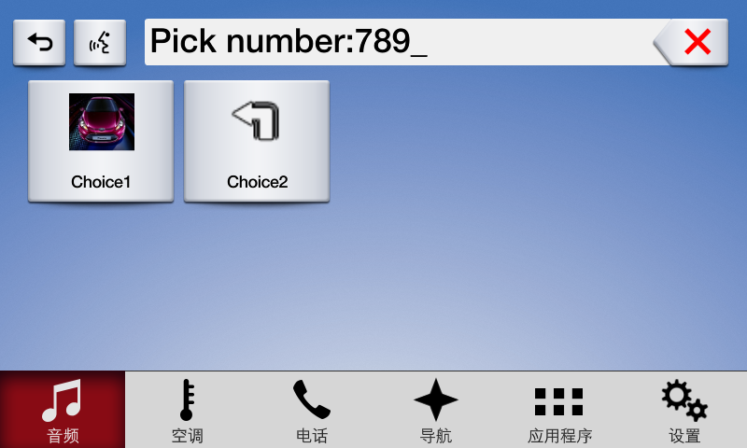

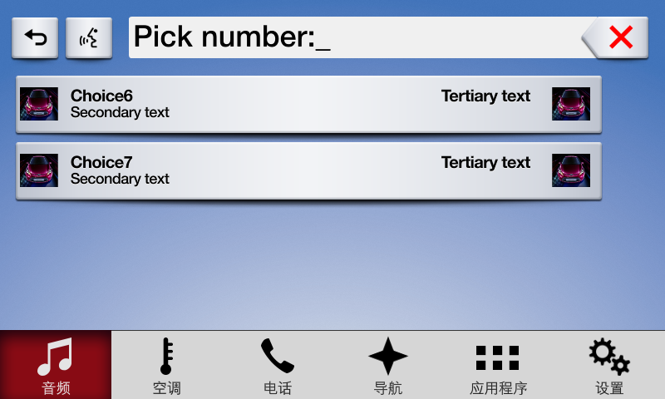

### Command

#### 相关RPC

|  |  |
| --- | --- |
| 名字 | 请求内容 |
| UI. AddSubMenu | **{**  **"id"**: 62**,**  **"jsonrpc"**: "2.0"**,**  **"method"**: "UI.AddSubMenu"**,**  **"params"**: **{**  **"appID"**: 17498**,**  **"menuID"**: 3**,**  **"menuParams"**: **{**  **"menuName"**: "SubmenuName 3"**,**  **"position"**: 0  **}**  **}**  **}** |
| VR.AddCommand | **{**  **"id"**: 63**,**  **"jsonrpc"**: "2.0"**,**  **"method"**: "UI.AddCommand"**,**  **"params"**: **{**  **"appID"**: 17498**,**  **"cmdID"**: 2**,**  **"cmdIcon"**: **{**  **"imageType"**: "DYNAMIC"**,**  **"value"**: "/fs/rwdata/storage/sdl/584421907_6b50de75f3391a9e8117be9ded91461eabe62e54f74c8538e897e6621179721a/action.png"  **},**  **"menuParams"**: **{**  **"menuName"**: "Item To Add 2"**,**  **"parentID"**: 3**,**  **"position"**: 0  **}**  **}**  **}** |
| UI. DeleteCommand | **{**  **"id"**: 65**,**  **"jsonrpc"**: "2.0"**,**  **"method"**: "UI.DeleteCommand"**,**  **"params"**: **{**  **"appID"**: 17498**,**  **"cmdID"**: 2  **}**  **}** |
| UI.DeleteSubMenu | **{**  **"id"**: 68**,**  **"jsonrpc"**: "2.0"**,**  **"method"**: "UI.DeleteSubMenu"**,**  **"params"**: **{**  **"appID"**: 17498**,**  **"menuID"**: 3  **}**  **}** |

#### 设计图

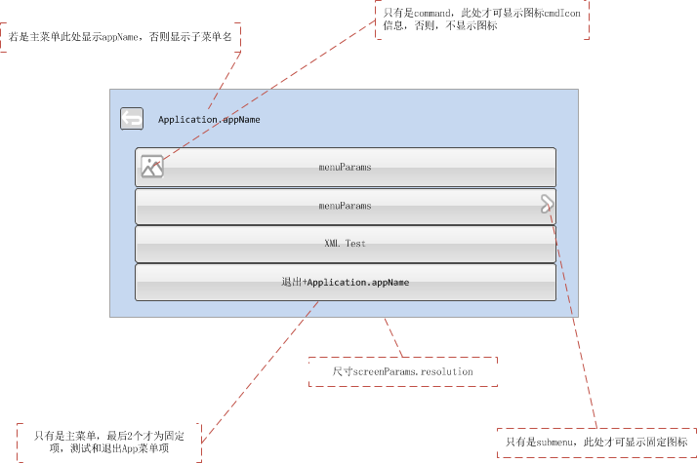

#### 效果图

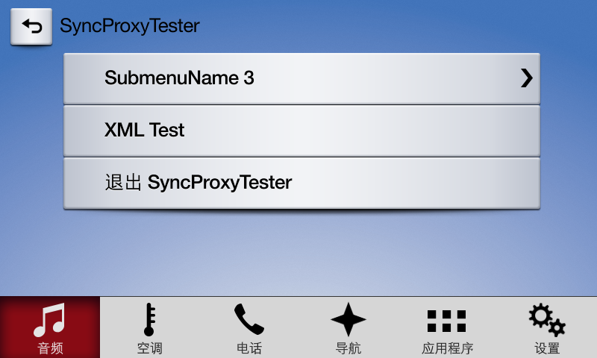

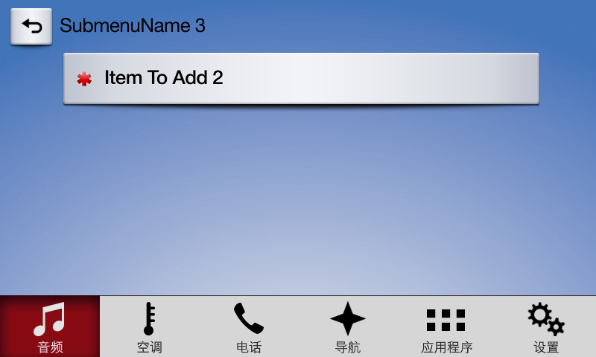

### ScrollableMessage

#### 相关RPC

|  |  |
| --- | --- |
| 名字 | 请求内容 |
| UI.ScrollableMessage | **{**  **"id"**: 37**,**  **"jsonrpc"**: "2.0"**,**  **"method"**: "UI.ScrollableMessage"**,**  **"params"**: **{**  **"appID"**: 1878**,**  **"messageText"**: **{**  **"fieldName"**: "scrollableMessageBody"**,**  **"fieldText"**: "This is where long text can go for a scrollable message"  **},**  **"softButtons"**: **[**  **{**  **"isHighlighted"**: true**,**  **"softButtonID"**: 5505**,**  **"systemAction"**: "DEFAULT_ACTION"**,**  **"text"**: "Close"**,**  **"type"**: "TEXT"  **},**  **{**  **"isHighlighted"**: true**,**  **"softButtonID"**: 5506**,**  **"systemAction"**: "DEFAULT_ACTION"**,**  **"text"**: "Close"**,**  **"type"**: "TEXT"  **}**  **],**  **"timeout"**: 30000  **}**  **}** |

#### 设计图

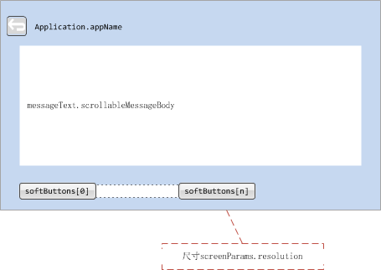

#### 效果图

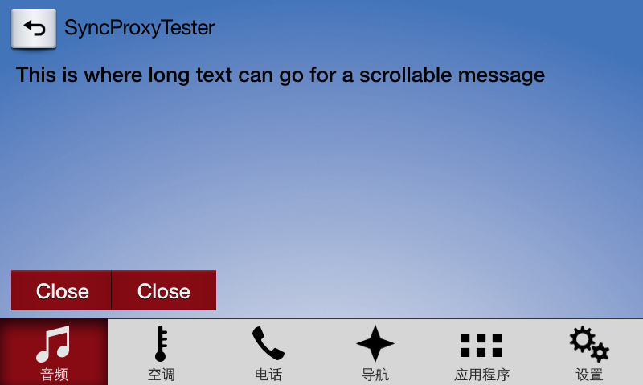

### DialNumber

#### 相关RPC

|  |  |
| --- | --- |
| 名字 | 请求内容 |
| BasicCommunication.DialNumber | **{**  **"id"**: 33**,**  **"jsonrpc"**: "2.0"**,**  **"method"**: "BasicCommunication.DialNumber"**,**  **"params"**: **{**  **"appID"**: 4140**,**  **"number"**: "10086"  **}**  **}** |

#### 设计图

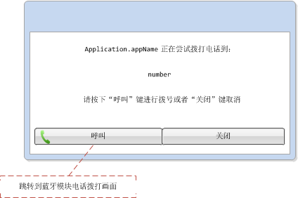

#### 效果图

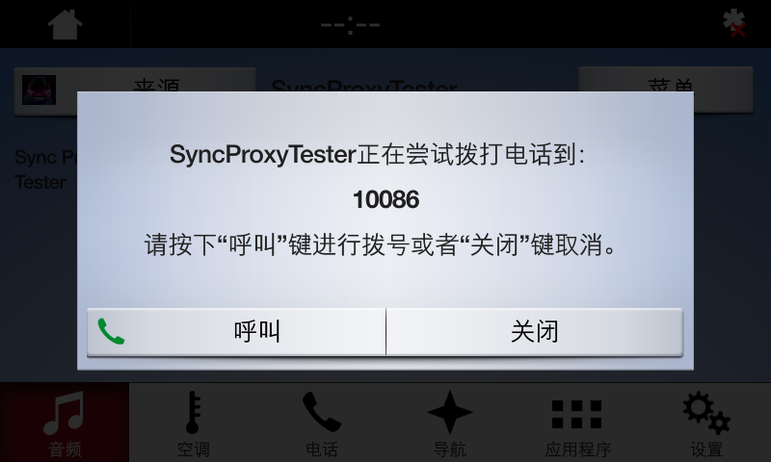

### VideoStream

#### 相关RPC

|  |  |
| --- | --- |
| 名字 | 请求内容 |
|  |  |

在SYNC上，此功能暂不支持

#### 设计图

#### 效果图

## NON-MEDIA –WITH SOFT BUTTON

### 属性

{

"id": 48,

"jsonrpc": "2.0",

"result": {

"code": 0,

"displayCapabilities": {

"displayType": "GEN3_8_INCH",

"graphicSupported": true, //支持图像显示

"imageCapabilities": [ //支持动态静态图片

"STATIC",

"DYNAMIC"

],

"imageFields": [

{

"imageResolution": { //softButton图标尺寸

"resolutionHeight": 35,

"resolutionWidth": 35

},

"imageTypeSupported": [ //softButton支持图标类型

"GRAPHIC_BMP",

"GRAPHIC_JPEG",

"GRAPHIC_PNG"

],

"name": "softButtonImage"

},

{

"imageResolution": { //softButton图标尺寸

"resolutionHeight": 70,

"resolutionWidth": 70

},

"imageTypeSupported": [ //softButton支持图标类型

"GRAPHIC_BMP",

"GRAPHIC_JPEG",

"GRAPHIC_PNG"

],

"name": "softButtonImage"

},

{

"imageResolution": { //首选choice图标尺寸

"resolutionHeight": 35,

"resolutionWidth": 35

},

"imageTypeSupported": [ //首选choice支持图标类型

"GRAPHIC_BMP",

"GRAPHIC_JPEG",

"GRAPHIC_PNG"

],

"name": "choiceImage"

},

{

"imageResolution": { //次选choice图标尺寸

"resolutionHeight": 35,

"resolutionWidth": 35

},

"imageTypeSupported": [ //次选choice支持图标类型

"GRAPHIC_BMP",

"GRAPHIC_JPEG",

"GRAPHIC_PNG"

],

"name": "choiceSecondaryImage"

},

{

"imageResolution": { //vr帮助图标占位尺寸

"resolutionHeight": 35,

"resolutionWidth": 35

},

"imageTypeSupported": [ //vr帮助图标支持的格式

"GRAPHIC_BMP",

"GRAPHIC_JPEG",

"GRAPHIC_PNG"

],

"name": "vrHelpItem"

},

{

"imageResolution": { //菜单图标占位尺寸

"resolutionHeight": 35,

"resolutionWidth": 35

},

"imageTypeSupported": [ //菜单图标支持的格式

"GRAPHIC_BMP",

"GRAPHIC_JPEG",

"GRAPHIC_PNG"

],

"name": "menuIcon"

},

{

"imageResolution": { //命令按钮图标占位尺寸

"resolutionHeight": 35,

"resolutionWidth": 35

},

"imageTypeSupported": [ //命令按钮图标支持的格式

"GRAPHIC_BMP",

"GRAPHIC_JPEG",

"GRAPHIC_PNG"

],

"name": "cmdIcon"

},

{

"imageResolution": { //app显示图标占位尺寸

"resolutionHeight": 35,

"resolutionWidth": 35

},

"imageTypeSupported": [ //app显示图标支持的格式

"GRAPHIC_BMP"

],

"name": "appIcon"

},

{

"imageResolution": { //app显示图标占位尺寸

"resolutionHeight": 70,

"resolutionWidth": 70

},

"imageTypeSupported": [ //app显示图标支持的格式

"GRAPHIC_BMP"

],

"name": "appIcon"

},

{

"imageResolution": { //graphic显示图标占位尺寸

"resolutionHeight": 185,

"resolutionWidth": 185

},

"imageTypeSupported": [ //graphic显示图标支持的格式

"GRAPHIC_BMP",

"GRAPHIC_JPEG",

"GRAPHIC_PNG"

],

"name": "graphic"

},

{

"imageResolution": { //location显示图标占位尺寸

"resolutionHeight": 35,

"resolutionWidth": 35

},

"imageTypeSupported": [ //location显示图标支持的格式

"GRAPHIC_BMP",

"GRAPHIC_JPEG",

"GRAPHIC_PNG"

],

"name": "locationImage"

}

],

"mediaClockFormats": [ //时间显示格式HH:MM:SS

"CLOCK3"

],

"numCustomPresetsAvailable": 8,

"screenParams": {

"resolution": { //画面显示尺寸

"resolutionHeight": 348,

"resolutionWidth": 800

},

"touchEventAvailable": {

"doublePressAvailable": false, // 不支持双击

"multiTouchAvailable": false, //不支持多点触摸

"pressAvailable": true //支持单击

}

},

"templatesAvailable": [ //当前支持的模板

"GRAPHIC_WITH_TEXT",

"TEXT_WITH_GRAPHIC",

"TILES_ONLY",

"GRAPHIC_WITH_TILES",

"TILES_WITH_GRAPHIC",

"GRAPHIC_WITH_TEXT_AND_SOFTBUTTONS",

"TEXT_AND_SOFTBUTTONS_WITH_GRAPHIC",

"GRAPHIC_WITH_TEXTBUTTONS",

"DOUBLE_GRAPHIC_WITH_SOFTBUTTONS",

"TEXTBUTTONS_WITH_GRAPHIC",

"TEXTBUTTONS_ONLY",

"LARGE_GRAPHIC_WITH_SOFTBUTTONS",

"LARGE_GRAPHIC_ONLY",

"MEDIA",

"ONSCREEN_PRESETS"

],

"textFields": [ //各文本字段名字、字符集、显示行数、文本宽度

{

"characterSet": "CID1SET",

"name": "mainField1",

"rows": 1,

"width": 50

},

{

"characterSet": "CID1SET",

"name": "mainField2",

"rows": 1,

"width": 40

},

{

"characterSet": "CID1SET",

"name": "mainField3",

"rows": 1,

"width": 20

},

{

"characterSet": "CID1SET",

"name": "mainField4",

"rows": 1,

"width": 20

},

{

"characterSet": "CID1SET",

"name": "alertText1",

"rows": 1,

"width": 40

},

{

"characterSet": "CID1SET",

"name": "alertText2",

"rows": 1,

"width": 40

},

{

"characterSet": "CID1SET",

"name": "alertText3",

"rows": 1,

"width": 40

},

{

"characterSet": "CID1SET",

"name": "scrollableMessageBody",

"rows": 8,

"width": 67

},

{

"characterSet": "CID1SET",

"name": "audioPassThruDisplayText1",

"rows": 1,

"width": 40

},

{

"characterSet": "CID1SET",

"name": "audioPassThruDisplayText2",

"rows": 1,

"width": 40

},

{

"characterSet": "CID1SET",

"name": "sliderHeader",

"rows": 1,

"width": 60

},

{

"characterSet": "CID1SET",

"name": "sliderFooter",

"rows": 1,

"width": 60

},

{

"characterSet": "CID1SET",

"name": "menuName",

"rows": 1,

"width": 35

},

{

"characterSet": "CID1SET",

"name": "secondaryText",

"rows": 1,

"width": 50

},

{

"characterSet": "CID1SET",

"name": "tertiaryText",

"rows": 1,

"width": 13

},

{

"characterSet": "CID1SET",

"name": "locationName",

"rows": 1,

"width": 20

},

{

"characterSet": "CID1SET",

"name": "locationDescription",

"rows": 1,

"width": 15

},

{

"characterSet": "CID1SET",

"name": "addressLines",

"rows": 4,

"width": 15

},

{

"characterSet": "CID1SET",

"name": "phoneNumber",

"rows": 1,

"width": 30

}

]

},

"method": "UI.SetDisplayLayout",

"softButtonCapabilities": [

{

"imageSupported": true, //按钮支持图片显示

"longPressAvailable": true, //支持长按

"shortPressAvailable": true, //支持短压

"upDownAvailable": true //支持按下弹起,有up、down事件及效果

}

]

}

}

### Show

#### 相关RPC

|  |  |
| --- | --- |
| 名字 | 请求内容 |
| UI.Show | **{**  **"id"**: 46**,**  **"jsonrpc"**: "2.0"**,**  **"method"**: "UI.Show"**,**  **"params"**: **{**  **"alignment"**: "CENTERED"**,**  **"appID"**: 12077**,**  **"customPresets"**: **[**  "GEN0"**,**  "GEN1"**,**  "GEN2"**,**  "GEN3"**,**  "GEN4"**,**  "GEN5"  **],**  **"graphic"**: **{**  **"imageType"**: "DYNAMIC"**,**  **"value"**: "/fs/rwdata/storage/sdl/584421907_6b50de75f3391a9e8117be9ded91461eabe62e54f74c8538e897e6621179721a/icon.png"  **},**  **"secondaryGraphic"**: **{**  **"imageType"**: "DYNAMIC"**,**  **"value"**: "/fs/rwdata/storage/sdl/584421907_6b50de75f3391a9e8117be9ded91461eabe62e54f74c8538e897e6621179721a/action.png"  **},**  **"showStrings"**: **[**  **{**  **"fieldName"**: "mainField1"**,**  **"fieldText"**: "Show Line 1"  **},**  **{**  **"fieldName"**: "mainField2"**,**  **"fieldText"**: "Show Line 2"  **},**  **{**  **"fieldName"**: "mainField3"**,**  **"fieldText"**: "Show Line 3"  **},**  **{**  **"fieldName"**: "mainField4"**,**  **"fieldText"**: "Show Line 4"  **},**  **{**  **"fieldName"**: "mediaClock"**,**  **"fieldText"**: "12:34"  **},**  **{**  **"fieldName"**: "mediaTrack"**,**  **"fieldText"**: "Media Track"  **},**  **{**  **"fieldName"**: "statusBar"**,**  **"fieldText"**: "status bar"  **}**  **],**  **"softButtons"**: **[**  **{**  **"isHighlighted"**: true**,**  **"softButtonID"**: 5547**,**  **"systemAction"**: "DEFAULT_ACTION"**,**  **"text"**: "Close"**,**  **"type"**: "TEXT"  **},**  **{**  **"isHighlighted"**: true**,**  **"softButtonID"**: 5548**,**  **"systemAction"**: "DEFAULT_ACTION"**,**  **"text"**: "Close"**,**  **"type"**: "TEXT"  **},**  **{**  **"isHighlighted"**: true**,**  **"softButtonID"**: 5549**,**  **"systemAction"**: "DEFAULT_ACTION"**,**  **"text"**: "Close"**,**  **"type"**: "TEXT"  **}**  **]**  **}**  **}** |

#### 设计图

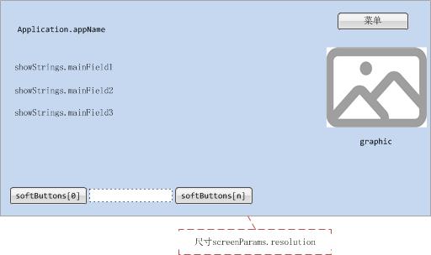

#### 效果图

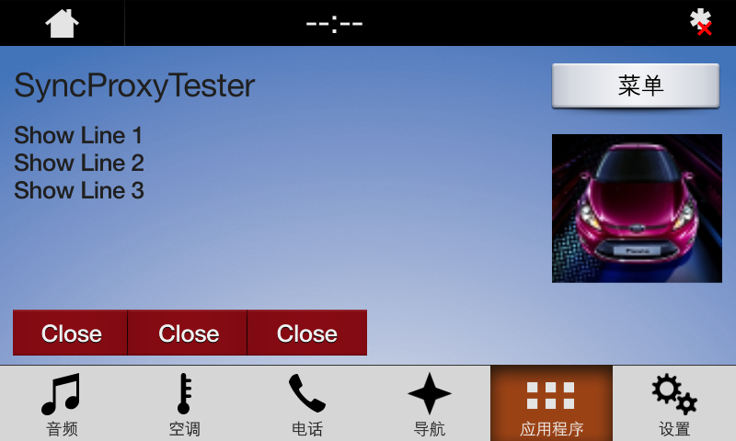

### AppListView

#### 相关RPC

|  |  |
| --- | --- |
| 名字 | 请求内容 |
| UI.SetAppIcon | **{**  **"id"**: 57**,**  **"jsonrpc"**: "2.0"**,**  **"method"**: "UI.SetAppIcon"**,**  **"params"**: **{**  **"appID"**: 11840**,**  **"syncFileName"**: **{**  **"imageType"**: "DYNAMIC"**,**  **"value"**: "/fs/rwdata/storage/sdl/584421907_6b50de75f3391a9e8117be9ded91461eabe62e54f74c8538e897e6621179721a/icon.png"  **}**  **}**  **}** |
| BasicCommunication.OnAppRegistered | **{**  **"jsonrpc"**: "2.0"**,**  **"method"**: "BasicCommunication.OnAppRegistered"**,**  **"params"**: **{**  **"application"**: **{**  **"appID"**: 14438**,**  **"appName"**: "SyncProxyTester"**,**  **"appType"**: **[**  "DEFAULT"  **],**  **"deviceInfo"**: **{**  **"id"**: "6b50de75f3391a9e8117be9ded91461eabe62e54f74c8538e897e6621179721a"**,**  **"isSDLAllowed"**: true**,**  **"name"**: "BTGalaxy On5 (2016)"**,**  **"transportType"**: "BLUETOOTH"  **},**  **"hmiDisplayLanguageDesired"**: "EN-US"**,**  **"icon"**: ""**,**  **"isMediaApplication"**: false**,**  **"ngnMediaScreenAppName"**: "SPT"**,**  **"policyAppID"**: "584421907"**,**  **"requestType"**: **[**  "PROPRIETARY"**,**  "TRAFFIC_MESSAGE_CHANNEL"**,**  "NAVIGATION"  **]**  **},**  **"priority"**: "EMERGENCY"**,**  **"ttsName"**: **[**  **{**  **"text"**: "Sync Proxy Tester"**,**  **"type"**: "TEXT"  **}**  **],**  **"vrSynonyms"**: **[**  "Synonym1"**,**  "Synonym2"  **]**  **}**  **}** |

#### 设计图



#### 效果图



### Slider

#### 相关RPC

|  |  |
| --- | --- |
| 名字 | 请求内容 |
| UI.Slider | **{**  **"id"**: 43**,**  **"jsonrpc"**: "2.0"**,**  **"method"**: "UI.Slider"**,**  **"params"**: **{**  **"appID"**: 1878**,**  **"numTicks"**: 20**,**  **"position"**: 5**,**  **"sliderFooter"**: **[**  "1"**,**  "2"**,**  "3"**,**  "4"**,**  "5"**,**  "6"**,**  "7"**,**  "8"**,**  "9"**,**  "10"**,**  "11"**,**  "12"**,**  "13"**,**  "14"**,**  "15"**,**  "16"**,**  "17"**,**  "18"**,**  "19"**,**  "20"  **],**  **"sliderHeader"**: "Slider Header"**,**  **"timeout"**: 10000  **}**  **}** |

#### 设计图



#### 效果图

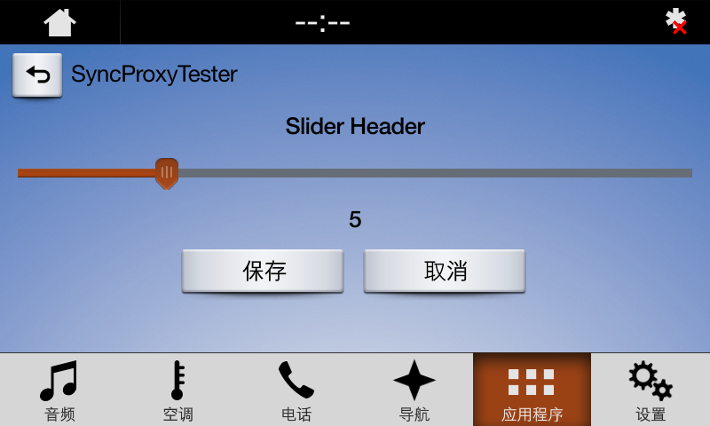

### Alert

参见3.1.5

### AudioPassThru

参见3.1.6

### Choiceset

参见3.1.7

### Command

参见3.1.8

### ScrollableMessage

参见3.1.9

### DialNumber

参见3.1.10

### VideoStream

参见3.1.11

## GRAPHIC_WITH_TEXT

### 属性

{

"id": 52,

"jsonrpc": "2.0",

"result": {

"code": 0,

"displayCapabilities": {

"displayType": "GEN3_8_INCH",

"graphicSupported": true, //支持图像显示

"imageCapabilities": [ //支持动态静态图片

"STATIC",

"DYNAMIC"

],

"imageFields": [

{

"imageResolution": { //softButton图标尺寸

"resolutionHeight": 35,

"resolutionWidth": 35

},

"imageTypeSupported": [ //softButton支持图标类型

"GRAPHIC_BMP",

"GRAPHIC_JPEG",

"GRAPHIC_PNG"

],

"name": "softButtonImage"

},

{

"imageResolution": { //softButton图标尺寸

"resolutionHeight": 70,

"resolutionWidth": 70

},

"imageTypeSupported": [ //softButton支持图标类型

"GRAPHIC_BMP",

"GRAPHIC_JPEG",

"GRAPHIC_PNG"

],

"name": "softButtonImage"

},

{

"imageResolution": { //首选choice图标尺寸

"resolutionHeight": 35,

"resolutionWidth": 35

},

"imageTypeSupported": [ //首选choice支持图标类型

"GRAPHIC_BMP",

"GRAPHIC_JPEG",

"GRAPHIC_PNG"

],

"name": "choiceImage"

},

{

"imageResolution": { //次选choice图标尺寸

"resolutionHeight": 35,

"resolutionWidth": 35

},

"imageTypeSupported": [ //次选choice支持图标类型

"GRAPHIC_BMP",

"GRAPHIC_JPEG",

"GRAPHIC_PNG"

],

"name": "choiceSecondaryImage"

},

{

"imageResolution": { //vr帮助图标占位尺寸

"resolutionHeight": 35,

"resolutionWidth": 35

},

"imageTypeSupported": [ //vr帮助图标支持的格式

"GRAPHIC_BMP",

"GRAPHIC_JPEG",

"GRAPHIC_PNG"

],

"name": "vrHelpItem"

},

{

"imageResolution": { //菜单图标占位尺寸

"resolutionHeight": 35,

"resolutionWidth": 35

},

"imageTypeSupported": [ //菜单图标支持的格式

"GRAPHIC_BMP",

"GRAPHIC_JPEG",

"GRAPHIC_PNG"

],

"name": "menuIcon"

},

{

"imageResolution": { //命令按钮图标占位尺寸

"resolutionHeight": 35,

"resolutionWidth": 35

},

"imageTypeSupported": [ //命令按钮图标支持的格式

"GRAPHIC_BMP",

"GRAPHIC_JPEG",

"GRAPHIC_PNG"

],

"name": "cmdIcon"

},

{

"imageResolution": { //app显示图标占位尺寸

"resolutionHeight": 35,

"resolutionWidth": 35

},

"imageTypeSupported": [ //app显示图标支持的格式

"GRAPHIC_BMP"

],

"name": "appIcon"

},

{

"imageResolution": { //app显示图标占位尺寸

"resolutionHeight": 70,

"resolutionWidth": 70

},

"imageTypeSupported": [ //app显示图标支持的格式

"GRAPHIC_BMP"

],

"name": "appIcon"

},

{

"imageResolution": { //graphic显示图标占位尺寸

"resolutionHeight": 250,

"resolutionWidth": 370

},

"imageTypeSupported": [ //graphic显示图标支持的格式

"GRAPHIC_BMP",

"GRAPHIC_JPEG",

"GRAPHIC_PNG"

],

"name": "graphic"

},

{

"imageResolution": { //location显示图标占位尺寸

"resolutionHeight": 35,

"resolutionWidth": 35

},

"imageTypeSupported": [ //location显示图标支持的格式

"GRAPHIC_BMP",

"GRAPHIC_JPEG",

"GRAPHIC_PNG"

],

"name": "locationImage"

}

],

"mediaClockFormats": [ //时间显示格式HH:MM:SS

"CLOCK3"

],

"numCustomPresetsAvailable": 8,

"screenParams": {

"resolution": { //画面显示尺寸

"resolutionHeight": 348,

"resolutionWidth": 800

},

"touchEventAvailable": {

"doublePressAvailable": false, // 不支持双击

"multiTouchAvailable": false, //不支持多点触摸

"pressAvailable": true //支持单击

}

},

"templatesAvailable": [ //当前支持的模板

"GRAPHIC_WITH_TEXT",

"TEXT_WITH_GRAPHIC",

"TILES_ONLY",

"GRAPHIC_WITH_TILES",

"TILES_WITH_GRAPHIC",

"GRAPHIC_WITH_TEXT_AND_SOFTBUTTONS",

"TEXT_AND_SOFTBUTTONS_WITH_GRAPHIC",

"GRAPHIC_WITH_TEXTBUTTONS",

"DOUBLE_GRAPHIC_WITH_SOFTBUTTONS",

"TEXTBUTTONS_WITH_GRAPHIC",

"TEXTBUTTONS_ONLY",

"LARGE_GRAPHIC_WITH_SOFTBUTTONS",

"LARGE_GRAPHIC_ONLY",

"MEDIA",

"ONSCREEN_PRESETS"

],

"textFields": [ //各文本字段名字、字符集、显示行数、文本宽度

{

"characterSet": "CID1SET",

"name": "mainField1",

"rows": 1,

"width": 50

},

{

"characterSet": "CID1SET",

"name": "mainField2",

"rows": 1,

"width": 40

},

{

"characterSet": "CID1SET",

"name": "mainField3",

"rows": 1,

"width": 20

},

{

"characterSet": "CID1SET",

"name": "alertText1",

"rows": 1,

"width": 40

},

{

"characterSet": "CID1SET",

"name": "alertText2",

"rows": 1,

"width": 40

},

{

"characterSet": "CID1SET",

"name": "alertText3",

"rows": 1,

"width": 40

},

{

"characterSet": "CID1SET",

"name": "scrollableMessageBody",

"rows": 8,

"width": 67

},

{

"characterSet": "CID1SET",

"name": "audioPassThruDisplayText1",

"rows": 1,

"width": 40

},

{

"characterSet": "CID1SET",

"name": "audioPassThruDisplayText2",

"rows": 1,

"width": 40

},

{

"characterSet": "CID1SET",

"name": "sliderHeader",

"rows": 1,

"width": 60

},

{

"characterSet": "CID1SET",

"name": "sliderFooter",

"rows": 1,

"width": 60

},

{

"characterSet": "CID1SET",

"name": "menuName",

"rows": 1,

"width": 35

},

{

"characterSet": "CID1SET",

"name": "secondaryText",

"rows": 1,

"width": 50

},

{

"characterSet": "CID1SET",

"name": "tertiaryText",

"rows": 1,

"width": 13

},

{

"characterSet": "CID1SET",

"name": "locationName",

"rows": 1,

"width": 20

},

{

"characterSet": "CID1SET",

"name": "locationDescription",

"rows": 1,

"width": 15

},

{

"characterSet": "CID1SET",

"name": "addressLines",

"rows": 4,

"width": 15

},

{

"characterSet": "CID1SET",

"name": "phoneNumber",

"rows": 1,

"width": 30

}

]

},

"method": "UI.SetDisplayLayout",

"softButtonCapabilities": [

{

"imageSupported": true, //按钮支持图片显示

"longPressAvailable": true, //支持长按

"shortPressAvailable": true, //支持短压

"upDownAvailable": true //支持按下弹起,有up、down事件及效果

}

]

}

}

### Show

#### 相关RPC

|  |  |
| --- | --- |
| 名字 | 请求内容 |
| UI.Show | **{**  **"id"**: 46**,**  **"jsonrpc"**: "2.0"**,**  **"method"**: "UI.Show"**,**  **"params"**: **{**  **"alignment"**: "CENTERED"**,**  **"appID"**: 12077**,**  **"customPresets"**: **[**  "GEN0"**,**  "GEN1"**,**  "GEN2"**,**  "GEN3"**,**  "GEN4"**,**  "GEN5"  **],**  **"graphic"**: **{**  **"imageType"**: "DYNAMIC"**,**  **"value"**: "/fs/rwdata/storage/sdl/584421907_6b50de75f3391a9e8117be9ded91461eabe62e54f74c8538e897e6621179721a/icon.png"  **},**  **"secondaryGraphic"**: **{**  **"imageType"**: "DYNAMIC"**,**  **"value"**: "/fs/rwdata/storage/sdl/584421907_6b50de75f3391a9e8117be9ded91461eabe62e54f74c8538e897e6621179721a/action.png"  **},**  **"showStrings"**: **[**  **{**  **"fieldName"**: "mainField1"**,**  **"fieldText"**: "Show Line 1"  **},**  **{**  **"fieldName"**: "mainField2"**,**  **"fieldText"**: "Show Line 2"  **},**  **{**  **"fieldName"**: "mainField3"**,**  **"fieldText"**: "Show Line 3"  **},**  **{**  **"fieldName"**: "mainField4"**,**  **"fieldText"**: "Show Line 4"  **},**  **{**  **"fieldName"**: "mediaClock"**,**  **"fieldText"**: "12:34"  **},**  **{**  **"fieldName"**: "mediaTrack"**,**  **"fieldText"**: "Media Track"  **},**  **{**  **"fieldName"**: "statusBar"**,**  **"fieldText"**: "status bar"  **}**  **],**  **"softButtons"**: **[**  **{**  **"isHighlighted"**: true**,**  **"softButtonID"**: 5547**,**  **"systemAction"**: "DEFAULT_ACTION"**,**  **"text"**: "Close"**,**  **"type"**: "TEXT"  **},**  **{**  **"isHighlighted"**: true**,**  **"softButtonID"**: 5548**,**  **"systemAction"**: "DEFAULT_ACTION"**,**  **"text"**: "Close"**,**  **"type"**: "TEXT"  **},**  **{**  **"isHighlighted"**: true**,**  **"softButtonID"**: 5549**,**  **"systemAction"**: "DEFAULT_ACTION"**,**  **"text"**: "Close"**,**  **"type"**: "TEXT"  **}**  **]**  **}**  **}** |

#### 设计图

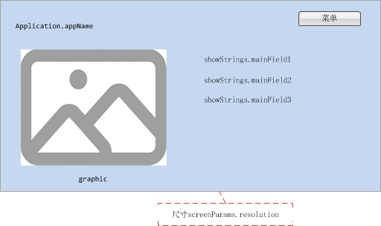

#### 效果图

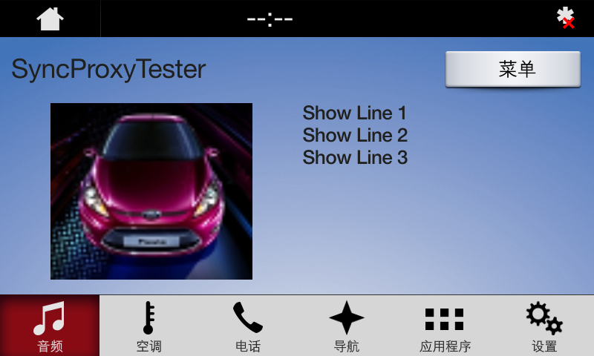

### AppListView

参见3.1.3

### Slider

参见3.1.4

### Alert

参见3.1.5

### AudioPassThru

参见3.1.6

### Choiceset

参见3.1.7

### Command

参见3.1.8

### ScrollableMessage

参见3.1.9

### DialNumber

参见3.1.10

### VideoStream

参见3.1.11

## TEXT_WITH_GRAPHIC

### 属性

{

"id": 35,

"jsonrpc": "2.0",

"result": {

"code": 0,

"displayCapabilities": {

"displayType": "GEN3_8_INCH",

"graphicSupported": true, //支持图像显示

"imageCapabilities": [ //支持动态静态图片

"STATIC",

"DYNAMIC"

],

"imageFields": [

{

"imageResolution": { //softButton图标尺寸

"resolutionHeight": 35,

"resolutionWidth": 35

},

"imageTypeSupported": [ //softButton支持图标类型

"GRAPHIC_BMP",

"GRAPHIC_JPEG",

"GRAPHIC_PNG"

],

"name": "softButtonImage"

},

{

"imageResolution": { //softButton图标尺寸

"resolutionHeight": 70,

"resolutionWidth": 70

},

"imageTypeSupported": [ //softButton支持图标类型

"GRAPHIC_BMP",

"GRAPHIC_JPEG",

"GRAPHIC_PNG"

],

"name": "softButtonImage"

},

{

"imageResolution": { //首选choice图标尺寸

"resolutionHeight": 35,

"resolutionWidth": 35

},

"imageTypeSupported": [ //首选choice支持图标类型

"GRAPHIC_BMP",

"GRAPHIC_JPEG",

"GRAPHIC_PNG"

],

"name": "choiceImage"

},

{

"imageResolution": { //次选choice图标尺寸

"resolutionHeight": 35,

"resolutionWidth": 35

},

"imageTypeSupported": [ //次选choice支持图标类型

"GRAPHIC_BMP",

"GRAPHIC_JPEG",

"GRAPHIC_PNG"

],

"name": "choiceSecondaryImage"

},

{

"imageResolution": { //vr帮助图标占位尺寸

"resolutionHeight": 35,

"resolutionWidth": 35

},

"imageTypeSupported": [ //vr帮助图标支持的格式

"GRAPHIC_BMP",

"GRAPHIC_JPEG",

"GRAPHIC_PNG"

],

"name": "vrHelpItem"

},

{

"imageResolution": { //菜单图标占位尺寸

"resolutionHeight": 35,

"resolutionWidth": 35

},

"imageTypeSupported": [ //菜单图标支持的格式

"GRAPHIC_BMP",

"GRAPHIC_JPEG",

"GRAPHIC_PNG"

],

"name": "menuIcon"

},

{

"imageResolution": { //命令按钮图标占位尺寸

"resolutionHeight": 35,

"resolutionWidth": 35

},

"imageTypeSupported": [ //命令按钮图标支持的格式

"GRAPHIC_BMP",

"GRAPHIC_JPEG",

"GRAPHIC_PNG"

],

"name": "cmdIcon"

},

{

"imageResolution": { //app显示图标占位尺寸

"resolutionHeight": 35,

"resolutionWidth": 35

},

"imageTypeSupported": [ //app显示图标支持的格式

"GRAPHIC_BMP"

],

"name": "appIcon"

},

{

"imageResolution": { //app显示图标占位尺寸

"resolutionHeight": 70,

"resolutionWidth": 70

},

"imageTypeSupported": [ //app显示图标支持的格式

"GRAPHIC_BMP"

],

"name": "appIcon"

},

{

"imageResolution": { //graphic显示图标占位尺寸

"resolutionHeight": 250,

"resolutionWidth": 370

},

"imageTypeSupported": [ //graphic显示图标支持的格式

"GRAPHIC_BMP",

"GRAPHIC_JPEG",

"GRAPHIC_PNG"

],

"name": "graphic"

},

{

"imageResolution": { //location显示图标占位尺寸

"resolutionHeight": 35,

"resolutionWidth": 35

},

"imageTypeSupported": [ //location显示图标支持的格式

"GRAPHIC_BMP",

"GRAPHIC_JPEG",

"GRAPHIC_PNG"

],

"name": "locationImage"

}

],

"mediaClockFormats": [ //时间显示格式HH:MM:SS

"CLOCK3"

],

"numCustomPresetsAvailable": 8,

"screenParams": {

"resolution": { //画面显示尺寸

"resolutionHeight": 348,

"resolutionWidth": 800

},

"touchEventAvailable": {

"doublePressAvailable": false, // 不支持双击

"multiTouchAvailable": false, //不支持多点触摸

"pressAvailable": true //支持单击

}

},

"templatesAvailable": [ //当前支持的模板

"GRAPHIC_WITH_TEXT",

"TEXT_WITH_GRAPHIC",

"TILES_ONLY",

"GRAPHIC_WITH_TILES",

"TILES_WITH_GRAPHIC",

"GRAPHIC_WITH_TEXT_AND_SOFTBUTTONS",

"TEXT_AND_SOFTBUTTONS_WITH_GRAPHIC",

"GRAPHIC_WITH_TEXTBUTTONS",

"DOUBLE_GRAPHIC_WITH_SOFTBUTTONS",

"TEXTBUTTONS_WITH_GRAPHIC",

"TEXTBUTTONS_ONLY",

"LARGE_GRAPHIC_WITH_SOFTBUTTONS",

"LARGE_GRAPHIC_ONLY",

"MEDIA",

"ONSCREEN_PRESETS"

],

"textFields": [ //各文本字段名字、字符集、显示行数、文本宽度

{

"characterSet": "CID1SET",

"name": "mainField1",

"rows": 1,

"width": 50

},

{

"characterSet": "CID1SET",

"name": "mainField2",

"rows": 1,

"width": 40

},

{

"characterSet": "CID1SET",

"name": "mainField3",

"rows": 1,

"width": 20

},

{

"characterSet": "CID1SET",

"name": "alertText1",

"rows": 1,

"width": 40

},

{

"characterSet": "CID1SET",

"name": "alertText2",

"rows": 1,

"width": 40

},

{

"characterSet": "CID1SET",

"name": "alertText3",

"rows": 1,

"width": 40

},

{

"characterSet": "CID1SET",

"name": "scrollableMessageBody",

"rows": 8,

"width": 67

},

{

"characterSet": "CID1SET",

"name": "audioPassThruDisplayText1",

"rows": 1,

"width": 40

},

{

"characterSet": "CID1SET",

"name": "audioPassThruDisplayText2",

"rows": 1,

"width": 40

},

{

"characterSet": "CID1SET",

"name": "sliderHeader",

"rows": 1,

"width": 60

},

{

"characterSet": "CID1SET",

"name": "sliderFooter",

"rows": 1,

"width": 60

},

{

"characterSet": "CID1SET",

"name": "menuName",

"rows": 1,

"width": 35

},

{

"characterSet": "CID1SET",

"name": "secondaryText",

"rows": 1,

"width": 50

},

{

"characterSet": "CID1SET",

"name": "tertiaryText",

"rows": 1,

"width": 13

},

{

"characterSet": "CID1SET",

"name": "locationName",

"rows": 1,

"width": 20

},

{

"characterSet": "CID1SET",

"name": "locationDescription",

"rows": 1,

"width": 15

},

{

"characterSet": "CID1SET",

"name": "addressLines",

"rows": 4,

"width": 15

},

{

"characterSet": "CID1SET",

"name": "phoneNumber",

"rows": 1,

"width": 30

}

]

},

"method": "UI.SetDisplayLayout",

"softButtonCapabilities": [

{

"imageSupported": true, //按钮支持图片显示

"longPressAvailable": true, //支持长按

"shortPressAvailable": true, //支持短压

"upDownAvailable": true //支持按下弹起,有up、down事件及效果

}

]

}

}

### Show

#### 相关RPC

|  |  |
| --- | --- |
| 名字 | 请求内容 |
| UI.Show | **{**  **"id"**: 46**,**  **"jsonrpc"**: "2.0"**,**  **"method"**: "UI.Show"**,**  **"params"**: **{**  **"alignment"**: "CENTERED"**,**  **"appID"**: 12077**,**  **"customPresets"**: **[**  "GEN0"**,**  "GEN1"**,**  "GEN2"**,**  "GEN3"**,**  "GEN4"**,**  "GEN5"  **],**  **"graphic"**: **{**  **"imageType"**: "DYNAMIC"**,**  **"value"**: "/fs/rwdata/storage/sdl/584421907_6b50de75f3391a9e8117be9ded91461eabe62e54f74c8538e897e6621179721a/icon.png"  **},**  **"secondaryGraphic"**: **{**  **"imageType"**: "DYNAMIC"**,**  **"value"**: "/fs/rwdata/storage/sdl/584421907_6b50de75f3391a9e8117be9ded91461eabe62e54f74c8538e897e6621179721a/action.png"  **},**  **"showStrings"**: **[**  **{**  **"fieldName"**: "mainField1"**,**  **"fieldText"**: "Show Line 1"  **},**  **{**  **"fieldName"**: "mainField2"**,**  **"fieldText"**: "Show Line 2"  **},**  **{**  **"fieldName"**: "mainField3"**,**  **"fieldText"**: "Show Line 3"  **},**  **{**  **"fieldName"**: "mainField4"**,**  **"fieldText"**: "Show Line 4"  **},**  **{**  **"fieldName"**: "mediaClock"**,**  **"fieldText"**: "12:34"  **},**  **{**  **"fieldName"**: "mediaTrack"**,**  **"fieldText"**: "Media Track"  **},**  **{**  **"fieldName"**: "statusBar"**,**  **"fieldText"**: "status bar"  **}**  **],**  **"softButtons"**: **[**  **{**  **"isHighlighted"**: true**,**  **"softButtonID"**: 5547**,**  **"systemAction"**: "DEFAULT_ACTION"**,**  **"text"**: "Close"**,**  **"type"**: "TEXT"  **},**  **{**  **"isHighlighted"**: true**,**  **"softButtonID"**: 5548**,**  **"systemAction"**: "DEFAULT_ACTION"**,**  **"text"**: "Close"**,**  **"type"**: "TEXT"  **},**  **{**  **"isHighlighted"**: true**,**  **"softButtonID"**: 5549**,**  **"systemAction"**: "DEFAULT_ACTION"**,**  **"text"**: "Close"**,**  **"type"**: "TEXT"  **}**  **]**  **}**  **}** |

#### 设计图

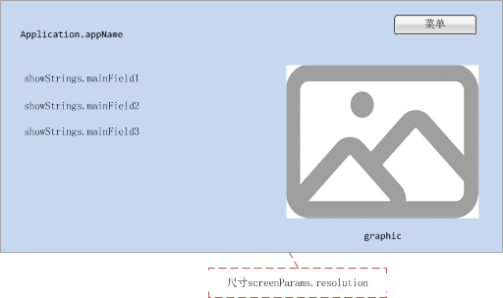

#### 效果图

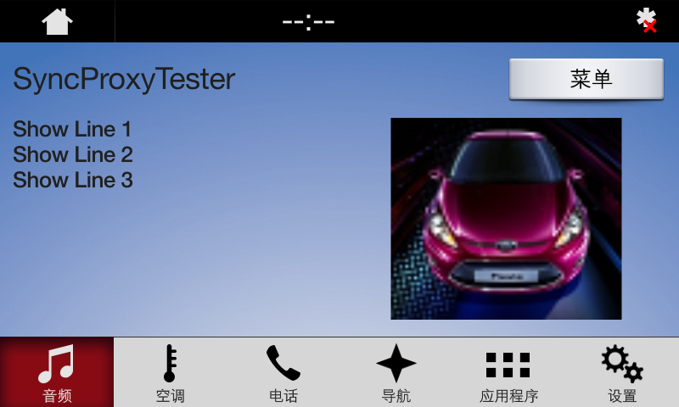

### AppListView

参见3.1.3

### Slider

参见3.1.4

### Alert

参见3.1.5

### AudioPassThru

参见3.1.6

### Choiceset

参见3.1.7

### Command

参见3.1.8

### ScrollableMessage

参见3.1.9

### DialNumber

参见3.1.10

### VideoStream

参见3.1.11

## TILES_ONLY

### 属性

{

"id": 51,

"jsonrpc": "2.0",

"result": {

"code": 0,

"displayCapabilities": {

"displayType": "GEN3_8_INCH",

"graphicSupported": true, //支持图像显示

"imageCapabilities": [ //支持动态静态图片

"STATIC",

"DYNAMIC"

],

"imageFields": [

{

"imageResolution": { //softButton图标尺寸

"resolutionHeight": 35,

"resolutionWidth": 35

},

"imageTypeSupported": [ //softButton支持图标类型

"GRAPHIC_BMP",

"GRAPHIC_JPEG",

"GRAPHIC_PNG"

],

"name": "softButtonImage"

},

{

"imageResolution": { //softButton图标尺寸

"resolutionHeight": 70,

"resolutionWidth": 70

},

"imageTypeSupported": [ //softButton支持图标类型

"GRAPHIC_BMP",

"GRAPHIC_JPEG",

"GRAPHIC_PNG"

],

"name": "softButtonImage"

},

{

"imageResolution": { //首选choice图标尺寸

"resolutionHeight": 35,

"resolutionWidth": 35

},

"imageTypeSupported": [ //首选choice支持图标类型

"GRAPHIC_BMP",

"GRAPHIC_JPEG",

"GRAPHIC_PNG"

],

"name": "choiceImage"

},

{

"imageResolution": { //次选choice图标尺寸

"resolutionHeight": 35,

"resolutionWidth": 35

},

"imageTypeSupported": [ //次选choice支持图标类型

"GRAPHIC_BMP",

"GRAPHIC_JPEG",

"GRAPHIC_PNG"

],

"name": "choiceSecondaryImage"

},

{

"imageResolution": { //vr帮助图标占位尺寸

"resolutionHeight": 35,

"resolutionWidth": 35

},

"imageTypeSupported": [ //vr帮助图标支持的格式

"GRAPHIC_BMP",

"GRAPHIC_JPEG",

"GRAPHIC_PNG"

],

"name": "vrHelpItem"

},

{

"imageResolution": { //菜单图标占位尺寸

"resolutionHeight": 35,

"resolutionWidth": 35

},

"imageTypeSupported": [ //菜单图标支持的格式

"GRAPHIC_BMP",

"GRAPHIC_JPEG",

"GRAPHIC_PNG"

],

"name": "menuIcon"

},

{

"imageResolution": { //命令按钮图标占位尺寸

"resolutionHeight": 35,

"resolutionWidth": 35

},

"imageTypeSupported": [ //命令按钮图标支持的格式

"GRAPHIC_BMP",

"GRAPHIC_JPEG",

"GRAPHIC_PNG"

],

"name": "cmdIcon"

},

{

"imageResolution": { //app显示图标占位尺寸

"resolutionHeight": 35,

"resolutionWidth": 35

},

"imageTypeSupported": [ //app显示图标支持的格式

"GRAPHIC_BMP"

],

"name": "appIcon"

},

{

"imageResolution": { //app显示图标占位尺寸

"resolutionHeight": 70,

"resolutionWidth": 70

},

"imageTypeSupported": [ //app显示图标支持的格式

"GRAPHIC_BMP"

],

"name": "appIcon"

},

{

"imageResolution": { //location显示图标占位尺寸

"resolutionHeight": 35,

"resolutionWidth": 35

},

"imageTypeSupported": [ //location显示图标支持的格式

"GRAPHIC_BMP",

"GRAPHIC_JPEG",

"GRAPHIC_PNG"

],

"name": "locationImage"

}

],

"mediaClockFormats": [ //时间显示格式HH:MM:SS

"CLOCK3"

],

"numCustomPresetsAvailable": 8,

"screenParams": {

"resolution": { //画面显示尺寸

"resolutionHeight": 348,

"resolutionWidth": 800

},

"touchEventAvailable": {

"doublePressAvailable": false, // 不支持双击

"multiTouchAvailable": false, //不支持多点触摸

"pressAvailable": true //支持单击

}

},

"templatesAvailable": [ //当前支持的模板

"GRAPHIC_WITH_TEXT",

"TEXT_WITH_GRAPHIC",

"TILES_ONLY",

"GRAPHIC_WITH_TILES",

"TILES_WITH_GRAPHIC",

"GRAPHIC_WITH_TEXT_AND_SOFTBUTTONS",

"TEXT_AND_SOFTBUTTONS_WITH_GRAPHIC",

"GRAPHIC_WITH_TEXTBUTTONS",

"DOUBLE_GRAPHIC_WITH_SOFTBUTTONS",

"TEXTBUTTONS_WITH_GRAPHIC",

"TEXTBUTTONS_ONLY",

"LARGE_GRAPHIC_WITH_SOFTBUTTONS",

"LARGE_GRAPHIC_ONLY",

"MEDIA",

"ONSCREEN_PRESETS"

],

"textFields": [ //各文本字段名字、字符集、显示行数、文本宽度

{

"characterSet": "CID1SET",

"name": "alertText1",

"rows": 1,

"width": 40

},

{

"characterSet": "CID1SET",

"name": "alertText2",

"rows": 1,

"width": 40

},

{

"characterSet": "CID1SET",

"name": "alertText3",

"rows": 1,

"width": 40

},

{

"characterSet": "CID1SET",

"name": "scrollableMessageBody",

"rows": 8,

"width": 67

},

{

"characterSet": "CID1SET",

"name": "audioPassThruDisplayText1",

"rows": 1,

"width": 40

},

{

"characterSet": "CID1SET",

"name": "audioPassThruDisplayText2",

"rows": 1,

"width": 40

},

{

"characterSet": "CID1SET",

"name": "sliderHeader",

"rows": 1,

"width": 60

},

{

"characterSet": "CID1SET",

"name": "sliderFooter",

"rows": 1,

"width": 60

},

{

"characterSet": "CID1SET",

"name": "menuName",

"rows": 1,

"width": 35

},

{

"characterSet": "CID1SET",

"name": "secondaryText",

"rows": 1,

"width": 50

},

{

"characterSet": "CID1SET",

"name": "tertiaryText",

"rows": 1,

"width": 13

},

{

"characterSet": "CID1SET",

"name": "locationName",

"rows": 1,

"width": 20

},

{

"characterSet": "CID1SET",

"name": "locationDescription",

"rows": 1,

"width": 15

},

{

"characterSet": "CID1SET",

"name": "addressLines",

"rows": 4,

"width": 15

},

{

"characterSet": "CID1SET",

"name": "phoneNumber",

"rows": 1,

"width": 30

}

]

},

"method": "UI.SetDisplayLayout",

"softButtonCapabilities": [

{

"imageSupported": true, //按钮支持图片显示

"longPressAvailable": true, //支持长按

"shortPressAvailable": true, //支持短压

"upDownAvailable": true //支持按下弹起,有up、down事件及效果

}

]

}

}

### Show

#### 相关RPC

|  |  |
| --- | --- |
| 名字 | 请求内容 |
| UI.Show | **{**  **"id"**: 56**,**  **"jsonrpc"**: "2.0"**,**  **"method"**: "UI.Show"**,**  **"params"**: **{**  **"alignment"**: "CENTERED"**,**  **"appID"**: 22675**,**  **"customPresets"**: **[**  "GEN0"**,**  "GEN1"**,**  "GEN2"**,**  "GEN3"**,**  "GEN4"**,**  "GEN5"  **],**  **"graphic"**: **{**  **"imageType"**: "DYNAMIC"**,**  **"value"**: "/fs/rwdata/storage/sdl/584421907_6b50de75f3391a9e8117be9ded91461eabe62e54f74c8538e897e6621179721a/turn_forward.png"  **},**  **"secondaryGraphic"**: **{**  **"imageType"**: "DYNAMIC"**,**  **"value"**: "/fs/rwdata/storage/sdl/584421907_6b50de75f3391a9e8117be9ded91461eabe62e54f74c8538e897e6621179721a/icon.png"  **},**  **"showStrings"**: **[**  **{**  **"fieldName"**: "mainField1"**,**  **"fieldText"**: "Show Line 1"  **},**  **{**  **"fieldName"**: "mainField2"**,**  **"fieldText"**: "Show Line 2"  **},**  **{**  **"fieldName"**: "mainField3"**,**  **"fieldText"**: "Show Line 3"  **},**  **{**  **"fieldName"**: "mainField4"**,**  **"fieldText"**: "Show Line 4"  **},**  **{**  **"fieldName"**: "mediaClock"**,**  **"fieldText"**: "12:34"  **},**  **{**  **"fieldName"**: "mediaTrack"**,**  **"fieldText"**: "Media Track"  **},**  **{**  **"fieldName"**: "statusBar"**,**  **"fieldText"**: "status bar"  **}**  **],**  **"softButtons"**: **[**  **{**  **"isHighlighted"**: true**,**  **"softButtonID"**: 5540**,**  **"systemAction"**: "KEEP_CONTEXT"**,**  **"text"**: "KeepContext"**,**  **"type"**: "TEXT"  **},**  **{**  **"isHighlighted"**: true**,**  **"softButtonID"**: 5541**,**  **"systemAction"**: "STEAL_FOCUS"**,**  **"text"**: "StealFocus"**,**  **"type"**: "TEXT"  **},**  **{**  **"isHighlighted"**: false**,**  **"softButtonID"**: 5542**,**  **"systemAction"**: "DEFAULT_ACTION"**,**  **"text"**: "Default"**,**  **"type"**: "TEXT"  **}**  **]**  **}**  **}** |

#### 设计图

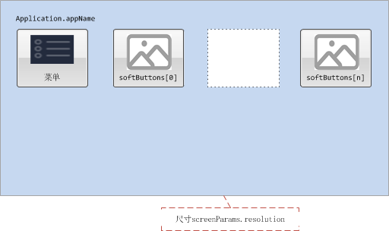

#### 效果图

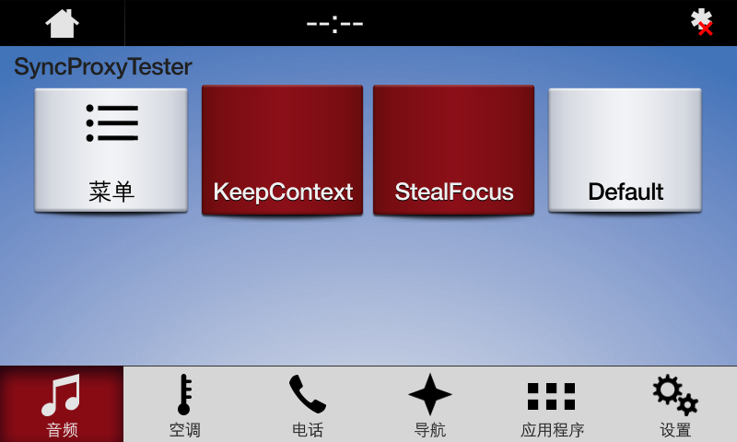

### AppListView

参见3.1.3

### Slider

参见3.1.4

### Alert

参见3.1.5

### AudioPassThru

参见3.1.6

### Choiceset

参见3.1.7

### Command

参见3.1.8

### ScrollableMessage

参见3.1.9

### DialNumber

参见3.1.10

### VideoStream

参见3.1.11

## GRAPHIC_WITH_TILES

### 属性

{

"id": 43,

"jsonrpc": "2.0",

"result": {

"code": 0,

"displayCapabilities": {

"displayType": "GEN3_8_INCH",

"graphicSupported": true, //支持图像显示

"imageCapabilities": [ //支持动态静态图片

"STATIC",

"DYNAMIC"

],

"imageFields": [

{

"imageResolution": { //softButton图标尺寸

"resolutionHeight": 35,

"resolutionWidth": 35

},

"imageTypeSupported": [ //softButton支持图标类型

"GRAPHIC_BMP",

"GRAPHIC_JPEG",

"GRAPHIC_PNG"

],

"name": "softButtonImage"

},

{

"imageResolution": { //softButton图标尺寸

"resolutionHeight": 70,

"resolutionWidth": 70

},

"imageTypeSupported": [ //softButton支持图标类型

"GRAPHIC_BMP",

"GRAPHIC_JPEG",

"GRAPHIC_PNG"

],

"name": "softButtonImage"

},

{

"imageResolution": { //首选choice图标尺寸

"resolutionHeight": 35,

"resolutionWidth": 35

},

"imageTypeSupported": [ //首选choice支持图标类型

"GRAPHIC_BMP",

"GRAPHIC_JPEG",

"GRAPHIC_PNG"

],

"name": "choiceImage"

},

{

"imageResolution": { //次选choice图标尺寸

"resolutionHeight": 35,

"resolutionWidth": 35

},

"imageTypeSupported": [ //次选choice支持图标类型

"GRAPHIC_BMP",

"GRAPHIC_JPEG",

"GRAPHIC_PNG"

],

"name": "choiceSecondaryImage"

},

{

"imageResolution": { //vr帮助图标占位尺寸

"resolutionHeight": 35,

"resolutionWidth": 35

},

"imageTypeSupported": [ //vr帮助图标支持的格式

"GRAPHIC_BMP",

"GRAPHIC_JPEG",

"GRAPHIC_PNG"

],

"name": "vrHelpItem"

},

{

"imageResolution": { //菜单图标占位尺寸

"resolutionHeight": 35,

"resolutionWidth": 35

},

"imageTypeSupported": [ //菜单图标支持的格式

"GRAPHIC_BMP",

"GRAPHIC_JPEG",

"GRAPHIC_PNG"

],

"name": "menuIcon"

},

{

"imageResolution": { //命令按钮图标占位尺寸

"resolutionHeight": 35,

"resolutionWidth": 35

},

"imageTypeSupported": [ //命令按钮图标支持的格式

"GRAPHIC_BMP",

"GRAPHIC_JPEG",

"GRAPHIC_PNG"

],

"name": "cmdIcon"

},

{

"imageResolution": { //app显示图标占位尺寸

"resolutionHeight": 35,

"resolutionWidth": 35

},

"imageTypeSupported": [ //app显示图标支持的格式

"GRAPHIC_BMP"

],

"name": "appIcon"

},

{

"imageResolution": { //app显示图标占位尺寸

"resolutionHeight": 70,

"resolutionWidth": 70

},

"imageTypeSupported": [ //app显示图标支持的格式

"GRAPHIC_BMP"

],

"name": "appIcon"

},

{

"imageResolution": { //graphic显示图标占位尺寸

"resolutionHeight": 280,

"resolutionWidth": 380

},

"imageTypeSupported": [ //graphic显示图标支持的格式

"GRAPHIC_BMP",

"GRAPHIC_JPEG",

"GRAPHIC_PNG"

],

"name": "graphic"

},

{

"imageResolution": { //location显示图标占位尺寸

"resolutionHeight": 35,

"resolutionWidth": 35

},

"imageTypeSupported": [ //location显示图标支持的格式

"GRAPHIC_BMP",

"GRAPHIC_JPEG",

"GRAPHIC_PNG"

],

"name": "locationImage"

}

],

"mediaClockFormats": [ //时间显示格式HH:MM:SS

"CLOCK3"

],

"numCustomPresetsAvailable": 8,

"screenParams": {

"resolution": { //画面显示尺寸

"resolutionHeight": 348,

"resolutionWidth": 800

},

"touchEventAvailable": {

"doublePressAvailable": false, // 不支持双击

"multiTouchAvailable": false, //不支持多点触摸

"pressAvailable": true //支持单击

}

},

"templatesAvailable": [ //当前支持的模板

"GRAPHIC_WITH_TEXT",

"TEXT_WITH_GRAPHIC",

"TILES_ONLY",

"GRAPHIC_WITH_TILES",

"TILES_WITH_GRAPHIC",

"GRAPHIC_WITH_TEXT_AND_SOFTBUTTONS",

"TEXT_AND_SOFTBUTTONS_WITH_GRAPHIC",

"GRAPHIC_WITH_TEXTBUTTONS",

"DOUBLE_GRAPHIC_WITH_SOFTBUTTONS",

"TEXTBUTTONS_WITH_GRAPHIC",

"TEXTBUTTONS_ONLY",

"LARGE_GRAPHIC_WITH_SOFTBUTTONS",

"LARGE_GRAPHIC_ONLY",

"MEDIA",

"ONSCREEN_PRESETS"

],

"textFields": [ //各文本字段名字、字符集、显示行数、文本宽度

{

"characterSet": "CID1SET",

"name": "alertText1",

"rows": 1,

"width": 40

},

{

"characterSet": "CID1SET",

"name": "alertText2",

"rows": 1,

"width": 40

},

{

"characterSet": "CID1SET",

"name": "alertText3",

"rows": 1,

"width": 40

},

{

"characterSet": "CID1SET",

"name": "scrollableMessageBody",

"rows": 8,

"width": 67

},

{

"characterSet": "CID1SET",

"name": "audioPassThruDisplayText1",

"rows": 1,

"width": 40

},

{

"characterSet": "CID1SET",

"name": "audioPassThruDisplayText2",

"rows": 1,

"width": 40

},

{

"characterSet": "CID1SET",

"name": "sliderHeader",

"rows": 1,

"width": 60

},

{

"characterSet": "CID1SET",

"name": "sliderFooter",

"rows": 1,

"width": 60

},

{

"characterSet": "CID1SET",

"name": "menuName",

"rows": 1,

"width": 35

},

{

"characterSet": "CID1SET",

"name": "secondaryText",

"rows": 1,

"width": 50

},

{

"characterSet": "CID1SET",

"name": "tertiaryText",

"rows": 1,

"width": 13

},

{

"characterSet": "CID1SET",

"name": "locationName",

"rows": 1,

"width": 20

},

{

"characterSet": "CID1SET",

"name": "locationDescription",

"rows": 1,

"width": 15

},

{

"characterSet": "CID1SET",

"name": "addressLines",

"rows": 4,

"width": 15

},

{

"characterSet": "CID1SET",

"name": "phoneNumber",

"rows": 1,

"width": 30

}

]

},

"method": "UI.SetDisplayLayout",

"softButtonCapabilities": [

{

"imageSupported": true, //按钮支持图片显示

"longPressAvailable": true, //支持长按

"shortPressAvailable": true, //支持短压

"upDownAvailable": true //支持按下弹起,有up、down事件及效果

}

]

}

}

### Show

#### 相关RPC

|  |  |
| --- | --- |
| 名字 | 请求内容 |
| UI.Show | **{**  **"id"**: 45**,**  **"jsonrpc"**: "2.0"**,**  **"method"**: "UI.Show"**,**  **"params"**: **{**  **"alignment"**: "CENTERED"**,**  **"appID"**: 22675**,**  **"customPresets"**: **[**  "GEN0"**,**  "GEN1"**,**  "GEN2"**,**  "GEN3"**,**  "GEN4"**,**  "GEN5"  **],**  **"graphic"**: **{**  **"imageType"**: "DYNAMIC"**,**  **"value"**: "/fs/rwdata/storage/sdl/584421907_6b50de75f3391a9e8117be9ded91461eabe62e54f74c8538e897e6621179721a/icon.png"  **},**  **"secondaryGraphic"**: **{**  **"imageType"**: "DYNAMIC"**,**  **"value"**: "/fs/rwdata/storage/sdl/584421907_6b50de75f3391a9e8117be9ded91461eabe62e54f74c8538e897e6621179721a/turn_right.png"  **},**  **"showStrings"**: **[**  **{**  **"fieldName"**: "mainField1"**,**  **"fieldText"**: "Show Line 1"  **},**  **{**  **"fieldName"**: "mainField2"**,**  **"fieldText"**: "Show Line 2"  **},**  **{**  **"fieldName"**: "mainField3"**,**  **"fieldText"**: "Show Line 3"  **},**  **{**  **"fieldName"**: "mainField4"**,**  **"fieldText"**: "Show Line 4"  **},**  **{**  **"fieldName"**: "mediaClock"**,**  **"fieldText"**: "12:34"  **},**  **{**  **"fieldName"**: "mediaTrack"**,**  **"fieldText"**: "Media Track"  **},**  **{**  **"fieldName"**: "statusBar"**,**  **"fieldText"**: "status bar"  **}**  **],**  **"softButtons"**: **[**  **{**  **"isHighlighted"**: false**,**  **"softButtonID"**: 5552**,**  **"systemAction"**: "KEEP_CONTEXT"**,**  **"text"**: "KeepContext"**,**  **"type"**: "TEXT"  **},**  **{**  **"isHighlighted"**: false**,**  **"softButtonID"**: 5553**,**  **"systemAction"**: "STEAL_FOCUS"**,**  **"text"**: "StealFocus"**,**  **"type"**: "TEXT"  **},**  **{**  **"isHighlighted"**: false**,**  **"softButtonID"**: 5554**,**  **"systemAction"**: "DEFAULT_ACTION"**,**  **"text"**: "Default"**,**  **"type"**: "TEXT"  **}**  **]**  **}**  **}** |

#### 设计图

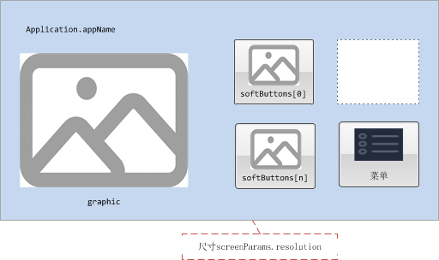

#### 效果图

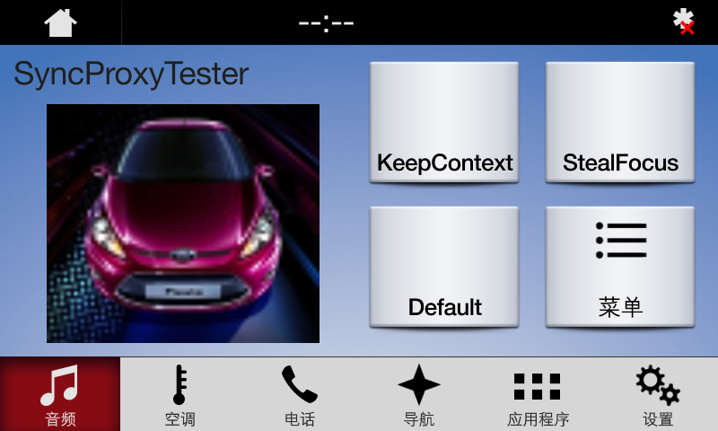

### AppListView

参见3.1.3

### Slider

参见3.1.4

### Alert

参见3.1.5

### AudioPassThru

参见3.1.6

### Choiceset

参见3.1.7

### Command

参见3.1.8

### ScrollableMessage

参见3.1.9

### DialNumber

参见3.1.10

### VideoStream

参见3.1.11

## TILES_WITH_GRAPHIC

### 属性

{

"id": 33,

"jsonrpc": "2.0",

"result": {

"code": 0,

"displayCapabilities": {

"displayType": "GEN3_8_INCH",

"graphicSupported": true, //支持图像显示

"imageCapabilities": [ //支持动态静态图片

"STATIC",

"DYNAMIC"

],

"imageFields": [

{

"imageResolution": { //softButton图标尺寸

"resolutionHeight": 35,

"resolutionWidth": 35

},

"imageTypeSupported": [ //softButton支持图标类型

"GRAPHIC_BMP",

"GRAPHIC_JPEG",

"GRAPHIC_PNG"

],

"name": "softButtonImage"

},

{

"imageResolution": { //softButton图标尺寸

"resolutionHeight": 70,

"resolutionWidth": 70

},

"imageTypeSupported": [ //softButton支持图标类型

"GRAPHIC_BMP",

"GRAPHIC_JPEG",

"GRAPHIC_PNG"

],

"name": "softButtonImage"

},

{

"imageResolution": { //首选choice图标尺寸

"resolutionHeight": 35,

"resolutionWidth": 35

},

"imageTypeSupported": [ //首选choice支持图标类型

"GRAPHIC_BMP",

"GRAPHIC_JPEG",

"GRAPHIC_PNG"

],

"name": "choiceImage"

},

{

"imageResolution": { //次选choice图标尺寸

"resolutionHeight": 35,

"resolutionWidth": 35

},

"imageTypeSupported": [ //次选choice支持图标类型

"GRAPHIC_BMP",

"GRAPHIC_JPEG",

"GRAPHIC_PNG"

],

"name": "choiceSecondaryImage"

},

{

"imageResolution": { //vr帮助图标占位尺寸

"resolutionHeight": 35,

"resolutionWidth": 35

},

"imageTypeSupported": [ //vr帮助图标支持的格式

"GRAPHIC_BMP",

"GRAPHIC_JPEG",

"GRAPHIC_PNG"

],

"name": "vrHelpItem"

},

{

"imageResolution": { //菜单图标占位尺寸

"resolutionHeight": 35,

"resolutionWidth": 35

},

"imageTypeSupported": [ //菜单图标支持的格式

"GRAPHIC_BMP",

"GRAPHIC_JPEG",

"GRAPHIC_PNG"

],

"name": "menuIcon"

},

{

"imageResolution": { //命令按钮图标占位尺寸

"resolutionHeight": 35,

"resolutionWidth": 35

},

"imageTypeSupported": [ //命令按钮图标支持的格式

"GRAPHIC_BMP",

"GRAPHIC_JPEG",

"GRAPHIC_PNG"

],

"name": "cmdIcon"

},

{

"imageResolution": { //app显示图标占位尺寸

"resolutionHeight": 35,

"resolutionWidth": 35

},

"imageTypeSupported": [ //app显示图标支持的格式

"GRAPHIC_BMP"

],

"name": "appIcon"

},

{

"imageResolution": { //app显示图标占位尺寸

"resolutionHeight": 70,

"resolutionWidth": 70

},

"imageTypeSupported": [ //app显示图标支持的格式

"GRAPHIC_BMP"

],

"name": "appIcon"

},

{

"imageResolution": { //graphic显示图标占位尺寸

"resolutionHeight": 280,

"resolutionWidth": 380

},

"imageTypeSupported": [ //graphic显示图标支持的格式

"GRAPHIC_BMP",

"GRAPHIC_JPEG",

"GRAPHIC_PNG"

],

"name": "graphic"

},

{

"imageResolution": { //location显示图标占位尺寸

"resolutionHeight": 35,

"resolutionWidth": 35

},

"imageTypeSupported": [ //location显示图标支持的格式

"GRAPHIC_BMP",

"GRAPHIC_JPEG",

"GRAPHIC_PNG"

],

"name": "locationImage"

}

],

"mediaClockFormats": [ //时间显示格式HH:MM:SS

"CLOCK3"

],

"numCustomPresetsAvailable": 8,

"screenParams": {

"resolution": { //画面显示尺寸

"resolutionHeight": 348,

"resolutionWidth": 800

},

"touchEventAvailable": {

"doublePressAvailable": false, // 不支持双击

"multiTouchAvailable": false, //不支持多点触摸

"pressAvailable": true //支持单击

}

},

"templatesAvailable": [ //当前支持的模板

"GRAPHIC_WITH_TEXT",

"TEXT_WITH_GRAPHIC",

"TILES_ONLY",

"GRAPHIC_WITH_TILES",

"TILES_WITH_GRAPHIC",

"GRAPHIC_WITH_TEXT_AND_SOFTBUTTONS",

"TEXT_AND_SOFTBUTTONS_WITH_GRAPHIC",

"GRAPHIC_WITH_TEXTBUTTONS",

"DOUBLE_GRAPHIC_WITH_SOFTBUTTONS",

"TEXTBUTTONS_WITH_GRAPHIC",

"TEXTBUTTONS_ONLY",

"LARGE_GRAPHIC_WITH_SOFTBUTTONS",

"LARGE_GRAPHIC_ONLY",

"MEDIA",

"ONSCREEN_PRESETS"

],

"textFields": [ //各文本字段名字、字符集、显示行数、文本宽度

{

"characterSet": "CID1SET",

"name": "alertText1",

"rows": 1,

"width": 40

},

{

"characterSet": "CID1SET",

"name": "alertText2",

"rows": 1,

"width": 40

},

{

"characterSet": "CID1SET",

"name": "alertText3",

"rows": 1,

"width": 40

},

{

"characterSet": "CID1SET",

"name": "scrollableMessageBody",

"rows": 8,

"width": 67

},

{

"characterSet": "CID1SET",

"name": "audioPassThruDisplayText1",

"rows": 1,

"width": 40

},

{

"characterSet": "CID1SET",

"name": "audioPassThruDisplayText2",

"rows": 1,

"width": 40

},

{

"characterSet": "CID1SET",

"name": "sliderHeader",

"rows": 1,

"width": 60

},

{

"characterSet": "CID1SET",

"name": "sliderFooter",

"rows": 1,

"width": 60

},

{

"characterSet": "CID1SET",

"name": "menuName",

"rows": 1,

"width": 35

},

{

"characterSet": "CID1SET",

"name": "secondaryText",

"rows": 1,

"width": 50

},

{

"characterSet": "CID1SET",

"name": "tertiaryText",

"rows": 1,

"width": 13

},

{

"characterSet": "CID1SET",

"name": "locationName",

"rows": 1,

"width": 20

},

{

"characterSet": "CID1SET",

"name": "locationDescription",

"rows": 1,

"width": 15

},

{

"characterSet": "CID1SET",

"name": "addressLines",

"rows": 4,

"width": 15

},

{

"characterSet": "CID1SET",

"name": "phoneNumber",

"rows": 1,

"width": 30

}

]

},

"method": "UI.SetDisplayLayout",

"softButtonCapabilities": [

{

"imageSupported": true, //按钮支持图片显示

"longPressAvailable": true, //支持长按

"shortPressAvailable": true, //支持短压

"upDownAvailable": true //支持按下弹起,有up、down事件及效果

}

]

}

}

### Show

#### 相关RPC

|  |  |
| --- | --- |
| 名字 | 请求内容 |
| UI.Show | **{**  **"id"**: 45**,**  **"jsonrpc"**: "2.0"**,**  **"method"**: "UI.Show"**,**  **"params"**: **{**  **"alignment"**: "CENTERED"**,**  **"appID"**: 22675**,**  **"customPresets"**: **[**  "GEN0"**,**  "GEN1"**,**  "GEN2"**,**  "GEN3"**,**  "GEN4"**,**  "GEN5"  **],**  **"graphic"**: **{**  **"imageType"**: "DYNAMIC"**,**  **"value"**: "/fs/rwdata/storage/sdl/584421907_6b50de75f3391a9e8117be9ded91461eabe62e54f74c8538e897e6621179721a/icon.png"  **},**  **"secondaryGraphic"**: **{**  **"imageType"**: "DYNAMIC"**,**  **"value"**: "/fs/rwdata/storage/sdl/584421907_6b50de75f3391a9e8117be9ded91461eabe62e54f74c8538e897e6621179721a/turn_right.png"  **},**  **"showStrings"**: **[**  **{**  **"fieldName"**: "mainField1"**,**  **"fieldText"**: "Show Line 1"  **},**  **{**  **"fieldName"**: "mainField2"**,**  **"fieldText"**: "Show Line 2"  **},**  **{**  **"fieldName"**: "mainField3"**,**  **"fieldText"**: "Show Line 3"  **},**  **{**  **"fieldName"**: "mainField4"**,**  **"fieldText"**: "Show Line 4"  **},**  **{**  **"fieldName"**: "mediaClock"**,**  **"fieldText"**: "12:34"  **},**  **{**  **"fieldName"**: "mediaTrack"**,**  **"fieldText"**: "Media Track"  **},**  **{**  **"fieldName"**: "statusBar"**,**  **"fieldText"**: "status bar"  **}**  **],**  **"softButtons"**: **[**  **{**  **"isHighlighted"**: false**,**  **"softButtonID"**: 5552**,**  **"systemAction"**: "KEEP_CONTEXT"**,**  **"text"**: "KeepContext"**,**  **"type"**: "TEXT"  **},**  **{**  **"isHighlighted"**: false**,**  **"softButtonID"**: 5553**,**  **"systemAction"**: "STEAL_FOCUS"**,**  **"text"**: "StealFocus"**,**  **"type"**: "TEXT"  **},**  **{**  **"isHighlighted"**: false**,**  **"softButtonID"**: 5554**,**  **"systemAction"**: "DEFAULT_ACTION"**,**  **"text"**: "Default"**,**  **"type"**: "TEXT"  **}**  **]**  **}**  **}** |

#### 设计图

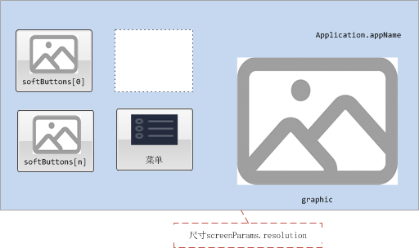

#### 效果图

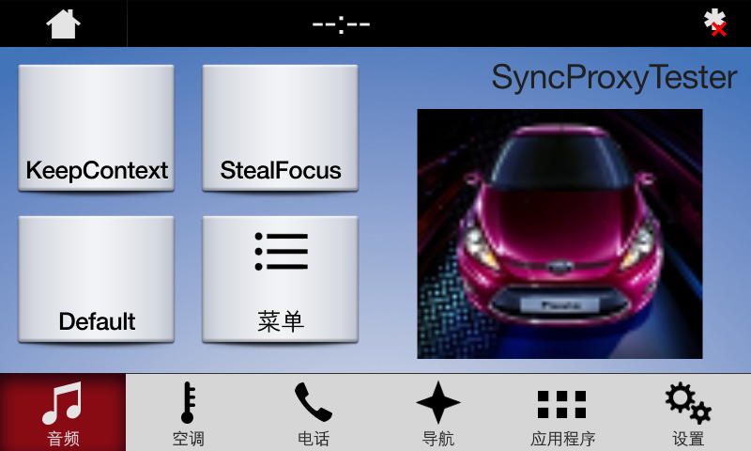

### AppListView

参见3.1.3

### Slider

参见3.1.4

### Alert

参见3.1.5

### AudioPassThru

参见3.1.6

### Choiceset

参见3.1.7

### Command

参见3.1.8

### ScrollableMessage

参见3.1.9

### DialNumber

参见3.1.10

### VideoStream

参见3.1.11

## GRAPHIC_WITH_TEXT_AND_SOFTBUTTONS

### 属性

{

"id": 53,

"jsonrpc": "2.0",

"result": {

"code": 0,

"displayCapabilities": {

"displayType": "GEN3_8_INCH",

"graphicSupported": true, //支持图像显示

"imageCapabilities": [ //支持动态静态图片

"STATIC",

"DYNAMIC"

],

"imageFields": [

{

"imageResolution": { //softButton图标尺寸

"resolutionHeight": 35,

"resolutionWidth": 35

},

"imageTypeSupported": [ //softButton支持图标类型

"GRAPHIC_BMP",

"GRAPHIC_JPEG",

"GRAPHIC_PNG"

],

"name": "softButtonImage"

},

{

"imageResolution": { //softButton图标尺寸

"resolutionHeight": 70,

"resolutionWidth": 70

},

"imageTypeSupported": [ //softButton支持图标类型

"GRAPHIC_BMP",

"GRAPHIC_JPEG",

"GRAPHIC_PNG"

],

"name": "softButtonImage"

},

{

"imageResolution": { //首选choice图标尺寸

"resolutionHeight": 35,

"resolutionWidth": 35

},

"imageTypeSupported": [ //首选choice支持图标类型

"GRAPHIC_BMP",

"GRAPHIC_JPEG",

"GRAPHIC_PNG"

],

"name": "choiceImage"

},

{

"imageResolution": { //次选choice图标尺寸

"resolutionHeight": 35,

"resolutionWidth": 35

},

"imageTypeSupported": [ //次选choice支持图标类型

"GRAPHIC_BMP",

"GRAPHIC_JPEG",

"GRAPHIC_PNG"

],

"name": "choiceSecondaryImage"

},

{

"imageResolution": { //vr帮助图标占位尺寸

"resolutionHeight": 35,

"resolutionWidth": 35

},

"imageTypeSupported": [ //vr帮助图标支持的格式

"GRAPHIC_BMP",

"GRAPHIC_JPEG",

"GRAPHIC_PNG"

],

"name": "vrHelpItem"

},

{

"imageResolution": { //菜单图标占位尺寸

"resolutionHeight": 35,

"resolutionWidth": 35

},

"imageTypeSupported": [ //菜单图标支持的格式

"GRAPHIC_BMP",

"GRAPHIC_JPEG",

"GRAPHIC_PNG"

],

"name": "menuIcon"

},

{

"imageResolution": { //命令按钮图标占位尺寸

"resolutionHeight": 35,

"resolutionWidth": 35

},

"imageTypeSupported": [ //命令按钮图标支持的格式

"GRAPHIC_BMP",

"GRAPHIC_JPEG",

"GRAPHIC_PNG"

],

"name": "cmdIcon"

},

{

"imageResolution": { //app显示图标占位尺寸

"resolutionHeight": 35,

"resolutionWidth": 35

},

"imageTypeSupported": [ //app显示图标支持的格式

"GRAPHIC_BMP"

],

"name": "appIcon"

},

{

"imageResolution": { //app显示图标占位尺寸

"resolutionHeight": 70,

"resolutionWidth": 70

},

"imageTypeSupported": [ //app显示图标支持的格式

"GRAPHIC_BMP"

],

"name": "appIcon"

},

{

"imageResolution": { //graphic显示图标占位尺寸

"resolutionHeight": 320,

"resolutionWidth": 380

},

"imageTypeSupported": [ //graphic显示图标支持的格式

"GRAPHIC_BMP",

"GRAPHIC_JPEG",

"GRAPHIC_PNG"

],

"name": "graphic"

},

{

"imageResolution": { //location显示图标占位尺寸

"resolutionHeight": 35,

"resolutionWidth": 35

},

"imageTypeSupported": [ //location显示图标支持的格式

"GRAPHIC_BMP",

"GRAPHIC_JPEG",

"GRAPHIC_PNG"

],

"name": "locationImage"

}

],

"mediaClockFormats": [ //时间显示格式HH:MM:SS

"CLOCK3"

],

"numCustomPresetsAvailable": 8,

"screenParams": {

"resolution": { //画面显示尺寸

"resolutionHeight": 348,

"resolutionWidth": 800

},

"touchEventAvailable": {

"doublePressAvailable": false, // 不支持双击

"multiTouchAvailable": false, //不支持多点触摸

"pressAvailable": true //支持单击

}

},

"templatesAvailable": [ //当前支持的模板

"GRAPHIC_WITH_TEXT",

"TEXT_WITH_GRAPHIC",

"TILES_ONLY",

"GRAPHIC_WITH_TILES",

"TILES_WITH_GRAPHIC",

"GRAPHIC_WITH_TEXT_AND_SOFTBUTTONS",

"TEXT_AND_SOFTBUTTONS_WITH_GRAPHIC",

"GRAPHIC_WITH_TEXTBUTTONS",

"DOUBLE_GRAPHIC_WITH_SOFTBUTTONS",

"TEXTBUTTONS_WITH_GRAPHIC",

"TEXTBUTTONS_ONLY",

"LARGE_GRAPHIC_WITH_SOFTBUTTONS",

"LARGE_GRAPHIC_ONLY",

"MEDIA",

"ONSCREEN_PRESETS"

],

"textFields": [ //各文本字段名字、字符集、显示行数、文本宽度

{

"characterSet": "CID1SET",

"name": "mainField1",

"rows": 1,

"width": 50

},

{

"characterSet": "CID1SET",

"name": "mainField2",

"rows": 1,

"width": 40

},

{

"characterSet": "CID1SET",

"name": "mainField3",

"rows": 1,

"width": 20

},

{

"characterSet": "CID1SET",

"name": "alertText1",

"rows": 1,

"width": 40

},

{

"characterSet": "CID1SET",

"name": "alertText2",

"rows": 1,

"width": 40

},

{

"characterSet": "CID1SET",

"name": "alertText3",

"rows": 1,

"width": 40

},

{

"characterSet": "CID1SET",

"name": "scrollableMessageBody",

"rows": 8,

"width": 67

},

{

"characterSet": "CID1SET",

"name": "audioPassThruDisplayText1",

"rows": 1,

"width": 40

},

{

"characterSet": "CID1SET",

"name": "audioPassThruDisplayText2",

"rows": 1,

"width": 40

},

{

"characterSet": "CID1SET",

"name": "sliderHeader",

"rows": 1,

"width": 60

},

{

"characterSet": "CID1SET",

"name": "sliderFooter",

"rows": 1,

"width": 60

},

{

"characterSet": "CID1SET",

"name": "menuName",

"rows": 1,

"width": 35

},

{

"characterSet": "CID1SET",

"name": "secondaryText",

"rows": 1,

"width": 50

},

{

"characterSet": "CID1SET",

"name": "tertiaryText",

"rows": 1,

"width": 13

},

{

"characterSet": "CID1SET",

"name": "locationName",

"rows": 1,

"width": 20

},

{

"characterSet": "CID1SET",

"name": "locationDescription",

"rows": 1,

"width": 15

},

{

"characterSet": "CID1SET",

"name": "addressLines",

"rows": 4,

"width": 15

},

{

"characterSet": "CID1SET",

"name": "phoneNumber",

"rows": 1,

"width": 30

}

]

},

"method": "UI.SetDisplayLayout",

"softButtonCapabilities": [

{

"imageSupported": true, //按钮支持图片显示

"longPressAvailable": true, //支持长按

"shortPressAvailable": true, //支持短压

"upDownAvailable": true //支持按下弹起,有up、down事件及效果

}

]

}

}

### Show

#### 相关RPC

|  |  |
| --- | --- |
| 名字 | 请求内容 |
| UI.Show | **{**  **"id"**: 45**,**  **"jsonrpc"**: "2.0"**,**  **"method"**: "UI.Show"**,**  **"params"**: **{**  **"alignment"**: "CENTERED"**,**  **"appID"**: 22675**,**  **"customPresets"**: **[**  "GEN0"**,**  "GEN1"**,**  "GEN2"**,**  "GEN3"**,**  "GEN4"**,**  "GEN5"  **],**  **"graphic"**: **{**  **"imageType"**: "DYNAMIC"**,**  **"value"**: "/fs/rwdata/storage/sdl/584421907_6b50de75f3391a9e8117be9ded91461eabe62e54f74c8538e897e6621179721a/icon.png"  **},**  **"secondaryGraphic"**: **{**  **"imageType"**: "DYNAMIC"**,**  **"value"**: "/fs/rwdata/storage/sdl/584421907_6b50de75f3391a9e8117be9ded91461eabe62e54f74c8538e897e6621179721a/turn_right.png"  **},**  **"showStrings"**: **[**  **{**  **"fieldName"**: "mainField1"**,**  **"fieldText"**: "Show Line 1"  **},**  **{**  **"fieldName"**: "mainField2"**,**  **"fieldText"**: "Show Line 2"  **},**  **{**  **"fieldName"**: "mainField3"**,**  **"fieldText"**: "Show Line 3"  **},**  **{**  **"fieldName"**: "mainField4"**,**  **"fieldText"**: "Show Line 4"  **},**  **{**  **"fieldName"**: "mediaClock"**,**  **"fieldText"**: "12:34"  **},**  **{**  **"fieldName"**: "mediaTrack"**,**  **"fieldText"**: "Media Track"  **},**  **{**  **"fieldName"**: "statusBar"**,**  **"fieldText"**: "status bar"  **}**  **],**  **"softButtons"**: **[**  **{**  **"isHighlighted"**: false**,**  **"softButtonID"**: 5552**,**  **"systemAction"**: "KEEP_CONTEXT"**,**  **"text"**: "KeepContext"**,**  **"type"**: "TEXT"  **},**  **{**  **"isHighlighted"**: false**,**  **"softButtonID"**: 5553**,**  **"systemAction"**: "STEAL_FOCUS"**,**  **"text"**: "StealFocus"**,**  **"type"**: "TEXT"  **},**  **{**  **"isHighlighted"**: false**,**  **"softButtonID"**: 5554**,**  **"systemAction"**: "DEFAULT_ACTION"**,**  **"text"**: "Default"**,**  **"type"**: "TEXT"  **}**  **]**  **}**  **}** |

#### 设计图

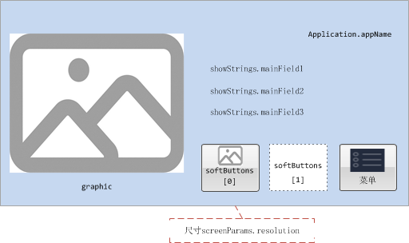

#### 效果图

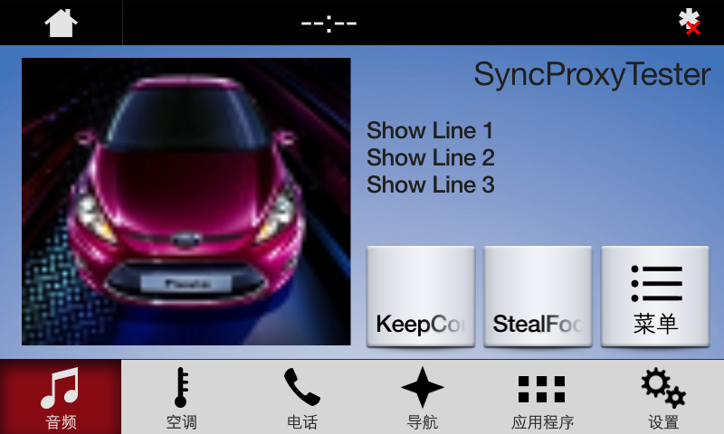

### AppListView

参见3.1.3

### Slider

参见3.1.4

### Alert

参见3.1.5

### AudioPassThru

参见3.1.6

### Choiceset

参见3.1.7

### Command

参见3.1.8

### ScrollableMessage

参见3.1.9

### DialNumber

参见3.1.10

### VideoStream

参见3.1.11

## TEXT_AND_SOFTBUTTONS_WITH_GRAPHIC

### 属性

{

"id": 56,

"jsonrpc": "2.0",

"result": {

"code": 0,

"displayCapabilities": {

"displayType": "GEN3_8_INCH",

"graphicSupported": true, //支持图像显示

"imageCapabilities": [ //支持动态静态图片

"STATIC",

"DYNAMIC"

],

"imageFields": [

{

"imageResolution": { //softButton图标尺寸

"resolutionHeight": 35,

"resolutionWidth": 35

},

"imageTypeSupported": [ //softButton支持图标类型

"GRAPHIC_BMP",

"GRAPHIC_JPEG",

"GRAPHIC_PNG"

],

"name": "softButtonImage"

},

{

"imageResolution": { //softButton图标尺寸

"resolutionHeight": 70,

"resolutionWidth": 70

},

"imageTypeSupported": [ //softButton支持图标类型

"GRAPHIC_BMP",

"GRAPHIC_JPEG",

"GRAPHIC_PNG"

],

"name": "softButtonImage"

},

{

"imageResolution": { //首选choice图标尺寸

"resolutionHeight": 35,

"resolutionWidth": 35

},

"imageTypeSupported": [ //首选choice支持图标类型

"GRAPHIC_BMP",

"GRAPHIC_JPEG",

"GRAPHIC_PNG"

],

"name": "choiceImage"

},

{

"imageResolution": { //次选choice图标尺寸

"resolutionHeight": 35,

"resolutionWidth": 35

},

"imageTypeSupported": [ //次选choice支持图标类型

"GRAPHIC_BMP",

"GRAPHIC_JPEG",

"GRAPHIC_PNG"

],

"name": "choiceSecondaryImage"

},

{

"imageResolution": { //vr帮助图标占位尺寸

"resolutionHeight": 35,

"resolutionWidth": 35

},

"imageTypeSupported": [ //vr帮助图标支持的格式

"GRAPHIC_BMP",

"GRAPHIC_JPEG",

"GRAPHIC_PNG"

],

"name": "vrHelpItem"

},

{

"imageResolution": { //菜单图标占位尺寸

"resolutionHeight": 35,

"resolutionWidth": 35

},

"imageTypeSupported": [ //菜单图标支持的格式

"GRAPHIC_BMP",

"GRAPHIC_JPEG",

"GRAPHIC_PNG"

],

"name": "menuIcon"

},

{

"imageResolution": { //命令按钮图标占位尺寸

"resolutionHeight": 35,

"resolutionWidth": 35

},

"imageTypeSupported": [ //命令按钮图标支持的格式

"GRAPHIC_BMP",

"GRAPHIC_JPEG",

"GRAPHIC_PNG"

],

"name": "cmdIcon"

},

{

"imageResolution": { //app显示图标占位尺寸

"resolutionHeight": 35,

"resolutionWidth": 35

},

"imageTypeSupported": [ //app显示图标支持的格式

"GRAPHIC_BMP"

],

"name": "appIcon"

},

{

"imageResolution": { //app显示图标占位尺寸

"resolutionHeight": 70,

"resolutionWidth": 70

},

"imageTypeSupported": [ //app显示图标支持的格式

"GRAPHIC_BMP"

],

"name": "appIcon"

},

{

"imageResolution": { //graphic显示图标占位尺寸

"resolutionHeight": 320,

"resolutionWidth": 380

},

"imageTypeSupported": [ //graphic显示图标支持的格式

"GRAPHIC_BMP",

"GRAPHIC_JPEG",

"GRAPHIC_PNG"

],

"name": "graphic"

},

{

"imageResolution": { //location显示图标占位尺寸

"resolutionHeight": 35,

"resolutionWidth": 35

},

"imageTypeSupported": [ //location显示图标支持的格式

"GRAPHIC_BMP",

"GRAPHIC_JPEG",

"GRAPHIC_PNG"

],

"name": "locationImage"

}

],

"mediaClockFormats": [ //时间显示格式HH:MM:SS

"CLOCK3"

],

"numCustomPresetsAvailable": 8,

"screenParams": {

"resolution": { //画面显示尺寸

"resolutionHeight": 348,

"resolutionWidth": 800

},

"touchEventAvailable": {

"doublePressAvailable": false, // 不支持双击

"multiTouchAvailable": false, //不支持多点触摸

"pressAvailable": true //支持单击

}

},

"templatesAvailable": [ //当前支持的模板

"GRAPHIC_WITH_TEXT",

"TEXT_WITH_GRAPHIC",

"TILES_ONLY",

"GRAPHIC_WITH_TILES",

"TILES_WITH_GRAPHIC",

"GRAPHIC_WITH_TEXT_AND_SOFTBUTTONS",

"TEXT_AND_SOFTBUTTONS_WITH_GRAPHIC",

"GRAPHIC_WITH_TEXTBUTTONS",

"DOUBLE_GRAPHIC_WITH_SOFTBUTTONS",

"TEXTBUTTONS_WITH_GRAPHIC",

"TEXTBUTTONS_ONLY",

"LARGE_GRAPHIC_WITH_SOFTBUTTONS",

"LARGE_GRAPHIC_ONLY",

"MEDIA",

"ONSCREEN_PRESETS"

],

"textFields": [ //各文本字段名字、字符集、显示行数、文本宽度

{

"characterSet": "CID1SET",

"name": "mainField1",

"rows": 1,

"width": 50

},

{

"characterSet": "CID1SET",

"name": "mainField2",

"rows": 1,

"width": 40

},

{

"characterSet": "CID1SET",

"name": "mainField3",

"rows": 1,

"width": 20

},

{

"characterSet": "CID1SET",

"name": "alertText1",

"rows": 1,

"width": 40

},

{

"characterSet": "CID1SET",

"name": "alertText2",

"rows": 1,

"width": 40

},

{

"characterSet": "CID1SET",

"name": "alertText3",

"rows": 1,

"width": 40

},

{

"characterSet": "CID1SET",

"name": "scrollableMessageBody",

"rows": 8,

"width": 67

},

{

"characterSet": "CID1SET",

"name": "audioPassThruDisplayText1",

"rows": 1,

"width": 40

},

{

"characterSet": "CID1SET",

"name": "audioPassThruDisplayText2",

"rows": 1,

"width": 40

},

{

"characterSet": "CID1SET",

"name": "sliderHeader",

"rows": 1,

"width": 60

},

{

"characterSet": "CID1SET",

"name": "sliderFooter",

"rows": 1,

"width": 60

},

{

"characterSet": "CID1SET",

"name": "menuName",

"rows": 1,

"width": 35

},

{

"characterSet": "CID1SET",

"name": "secondaryText",

"rows": 1,

"width": 50

},

{

"characterSet": "CID1SET",

"name": "tertiaryText",

"rows": 1,

"width": 13

},

{

"characterSet": "CID1SET",

"name": "locationName",

"rows": 1,

"width": 20

},

{

"characterSet": "CID1SET",

"name": "locationDescription",

"rows": 1,

"width": 15

},

{

"characterSet": "CID1SET",

"name": "addressLines",

"rows": 4,

"width": 15

},

{

"characterSet": "CID1SET",

"name": "phoneNumber",

"rows": 1,

"width": 30

}

]

},

"method": "UI.SetDisplayLayout",

"softButtonCapabilities": [

{

"imageSupported": true, //按钮支持图片显示

"longPressAvailable": true, //支持长按

"shortPressAvailable": true, //支持短压

"upDownAvailable": true //支持按下弹起,有up、down事件及效果

}

]

}

}

### Show

#### 相关RPC

|  |  |
| --- | --- |
| 名字 | 请求内容 |
| UI.Show | **{**  **"id"**: 45**,**  **"jsonrpc"**: "2.0"**,**  **"method"**: "UI.Show"**,**  **"params"**: **{**  **"alignment"**: "CENTERED"**,**  **"appID"**: 22675**,**  **"customPresets"**: **[**  "GEN0"**,**  "GEN1"**,**  "GEN2"**,**  "GEN3"**,**  "GEN4"**,**  "GEN5"  **],**  **"graphic"**: **{**  **"imageType"**: "DYNAMIC"**,**  **"value"**: "/fs/rwdata/storage/sdl/584421907_6b50de75f3391a9e8117be9ded91461eabe62e54f74c8538e897e6621179721a/icon.png"  **},**  **"secondaryGraphic"**: **{**  **"imageType"**: "DYNAMIC"**,**  **"value"**: "/fs/rwdata/storage/sdl/584421907_6b50de75f3391a9e8117be9ded91461eabe62e54f74c8538e897e6621179721a/turn_right.png"  **},**  **"showStrings"**: **[**  **{**  **"fieldName"**: "mainField1"**,**  **"fieldText"**: "Show Line 1"  **},**  **{**  **"fieldName"**: "mainField2"**,**  **"fieldText"**: "Show Line 2"  **},**  **{**  **"fieldName"**: "mainField3"**,**  **"fieldText"**: "Show Line 3"  **},**  **{**  **"fieldName"**: "mainField4"**,**  **"fieldText"**: "Show Line 4"  **},**  **{**  **"fieldName"**: "mediaClock"**,**  **"fieldText"**: "12:34"  **},**  **{**  **"fieldName"**: "mediaTrack"**,**  **"fieldText"**: "Media Track"  **},**  **{**  **"fieldName"**: "statusBar"**,**  **"fieldText"**: "status bar"  **}**  **],**  **"softButtons"**: **[**  **{**  **"isHighlighted"**: false**,**  **"softButtonID"**: 5552**,**  **"systemAction"**: "KEEP_CONTEXT"**,**  **"text"**: "KeepContext"**,**  **"type"**: "TEXT"  **},**  **{**  **"isHighlighted"**: false**,**  **"softButtonID"**: 5553**,**  **"systemAction"**: "STEAL_FOCUS"**,**  **"text"**: "StealFocus"**,**  **"type"**: "TEXT"  **},**  **{**  **"isHighlighted"**: false**,**  **"softButtonID"**: 5554**,**  **"systemAction"**: "DEFAULT_ACTION"**,**  **"text"**: "Default"**,**  **"type"**: "TEXT"  **}**  **]**  **}**  **}** |

#### 设计图

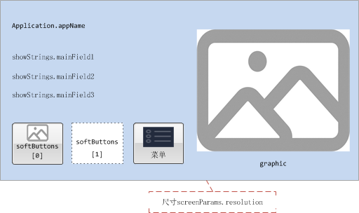

#### 效果图

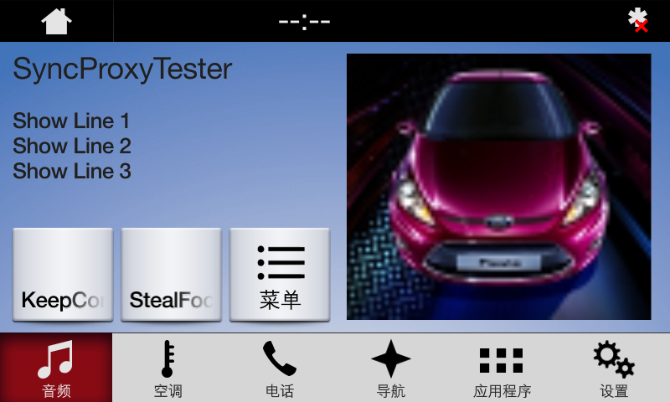

### AppListView

参见3.1.3

### Slider

参见3.1.4

### Alert

参见3.1.5

### AudioPassThru

参见3.1.6

### Choiceset

参见3.1.7

### Command

参见3.1.8

### ScrollableMessage

参见3.1.9

### DialNumber

参见3.1.10

### VideoStream

参见3.1.11

## GRAPHIC_WITH_TEXTBUTTONS

### 属性

{

"id": 58,

"jsonrpc": "2.0",

"result": {

"code": 0,

"displayCapabilities": {

"displayType": "GEN3_8_INCH",

"graphicSupported": true, //支持图像显示

"imageCapabilities": [ //支持动态静态图片

"STATIC",

"DYNAMIC"

],

"imageFields": [

{

"imageResolution": { //softButton图标尺寸

"resolutionHeight": 35,

"resolutionWidth": 35

},

"imageTypeSupported": [ //softButton支持图标类型

"GRAPHIC_BMP",

"GRAPHIC_JPEG",

"GRAPHIC_PNG"

],

"name": "softButtonImage"

},

{

"imageResolution": { //softButton图标尺寸

"resolutionHeight": 70,

"resolutionWidth": 70

},

"imageTypeSupported": [ //softButton支持图标类型

"GRAPHIC_BMP",

"GRAPHIC_JPEG",

"GRAPHIC_PNG"

],

"name": "softButtonImage"

},

{

"imageResolution": { //首选choice图标尺寸

"resolutionHeight": 35,

"resolutionWidth": 35

},

"imageTypeSupported": [ //首选choice支持图标类型

"GRAPHIC_BMP",

"GRAPHIC_JPEG",

"GRAPHIC_PNG"

],

"name": "choiceImage"

},

{

"imageResolution": { //次选choice图标尺寸

"resolutionHeight": 35,

"resolutionWidth": 35

},

"imageTypeSupported": [ //次选choice支持图标类型

"GRAPHIC_BMP",

"GRAPHIC_JPEG",

"GRAPHIC_PNG"

],

"name": "choiceSecondaryImage"

},

{

"imageResolution": { //vr帮助图标占位尺寸

"resolutionHeight": 35,

"resolutionWidth": 35

},

"imageTypeSupported": [ //vr帮助图标支持的格式

"GRAPHIC_BMP",

"GRAPHIC_JPEG",

"GRAPHIC_PNG"

],

"name": "vrHelpItem"

},

{

"imageResolution": { //菜单图标占位尺寸

"resolutionHeight": 35,

"resolutionWidth": 35

},

"imageTypeSupported": [ //菜单图标支持的格式

"GRAPHIC_BMP",

"GRAPHIC_JPEG",

"GRAPHIC_PNG"

],

"name": "menuIcon"

},

{

"imageResolution": { //命令按钮图标占位尺寸

"resolutionHeight": 35,

"resolutionWidth": 35

},

"imageTypeSupported": [ //命令按钮图标支持的格式

"GRAPHIC_BMP",

"GRAPHIC_JPEG",

"GRAPHIC_PNG"

],

"name": "cmdIcon"

},

{

"imageResolution": { //app显示图标占位尺寸

"resolutionHeight": 35,

"resolutionWidth": 35

},

"imageTypeSupported": [ //app显示图标支持的格式

"GRAPHIC_BMP"

],

"name": "appIcon"

},

{

"imageResolution": { //app显示图标占位尺寸

"resolutionHeight": 70,

"resolutionWidth": 70

},

"imageTypeSupported": [ //app显示图标支持的格式

"GRAPHIC_BMP"

],

"name": "appIcon"

},

{

"imageResolution": { //graphic显示图标占位尺寸

"resolutionHeight": 320,

"resolutionWidth": 380

},

"imageTypeSupported": [ //graphic显示图标支持的格式

"GRAPHIC_BMP",

"GRAPHIC_JPEG",

"GRAPHIC_PNG"

],

"name": "graphic"

},

{

"imageResolution": { //location显示图标占位尺寸

"resolutionHeight": 35,

"resolutionWidth": 35

},

"imageTypeSupported": [ //location显示图标支持的格式

"GRAPHIC_BMP",

"GRAPHIC_JPEG",

"GRAPHIC_PNG"

],

"name": "locationImage"

}

],

"mediaClockFormats": [ //时间显示格式HH:MM:SS

"CLOCK3"

],

"numCustomPresetsAvailable": 8,

"screenParams": {

"resolution": { //画面显示尺寸

"resolutionHeight": 348,

"resolutionWidth": 800

},

"touchEventAvailable": {

"doublePressAvailable": false, // 不支持双击

"multiTouchAvailable": false, //不支持多点触摸

"pressAvailable": true //支持单击

}

},

"templatesAvailable": [ //当前支持的模板

"GRAPHIC_WITH_TEXT",

"TEXT_WITH_GRAPHIC",

"TILES_ONLY",

"GRAPHIC_WITH_TILES",

"TILES_WITH_GRAPHIC",

"GRAPHIC_WITH_TEXT_AND_SOFTBUTTONS",

"TEXT_AND_SOFTBUTTONS_WITH_GRAPHIC",

"GRAPHIC_WITH_TEXTBUTTONS",

"DOUBLE_GRAPHIC_WITH_SOFTBUTTONS",

"TEXTBUTTONS_WITH_GRAPHIC",

"TEXTBUTTONS_ONLY",

"LARGE_GRAPHIC_WITH_SOFTBUTTONS",

"LARGE_GRAPHIC_ONLY",

"MEDIA",

"ONSCREEN_PRESETS"

],

"textFields": [ //各文本字段名字、字符集、显示行数、文本宽度

{

"characterSet": "CID1SET",

"name": "alertText1",

"rows": 1,

"width": 40

},

{

"characterSet": "CID1SET",

"name": "alertText2",

"rows": 1,

"width": 40

},

{

"characterSet": "CID1SET",

"name": "alertText3",

"rows": 1,

"width": 40

},

{

"characterSet": "CID1SET",

"name": "scrollableMessageBody",

"rows": 8,

"width": 67

},

{

"characterSet": "CID1SET",

"name": "audioPassThruDisplayText1",

"rows": 1,

"width": 40

},

{

"characterSet": "CID1SET",

"name": "audioPassThruDisplayText2",

"rows": 1,

"width": 40

},

{

"characterSet": "CID1SET",

"name": "sliderHeader",

"rows": 1,

"width": 60

},

{

"characterSet": "CID1SET",

"name": "sliderFooter",

"rows": 1,

"width": 60

},

{

"characterSet": "CID1SET",

"name": "menuName",

"rows": 1,

"width": 35

},

{

"characterSet": "CID1SET",

"name": "secondaryText",

"rows": 1,

"width": 50

},

{

"characterSet": "CID1SET",

"name": "tertiaryText",

"rows": 1,

"width": 13

},

{

"characterSet": "CID1SET",

"name": "locationName",

"rows": 1,

"width": 20

},

{

"characterSet": "CID1SET",

"name": "locationDescription",

"rows": 1,

"width": 15

},

{

"characterSet": "CID1SET",

"name": "addressLines",

"rows": 4,

"width": 15

},

{

"characterSet": "CID1SET",

"name": "phoneNumber",

"rows": 1,

"width": 30

}

]

},

"method": "UI.SetDisplayLayout",

"softButtonCapabilities": [

{

"imageSupported": true, //按钮支持图片显示

"longPressAvailable": true, //支持长按

"shortPressAvailable": true, //支持短压

"upDownAvailable": true //支持按下弹起,有up、down事件及效果

}

]

}

}

### Show

#### 相关RPC

|  |  |
| --- | --- |
| 名字 | 请求内容 |
| UI.Show | **{**  **"id"**: 45**,**  **"jsonrpc"**: "2.0"**,**  **"method"**: "UI.Show"**,**  **"params"**: **{**  **"alignment"**: "CENTERED"**,**  **"appID"**: 22675**,**  **"customPresets"**: **[**  "GEN0"**,**  "GEN1"**,**  "GEN2"**,**  "GEN3"**,**  "GEN4"**,**  "GEN5"  **],**  **"graphic"**: **{**  **"imageType"**: "DYNAMIC"**,**  **"value"**: "/fs/rwdata/storage/sdl/584421907_6b50de75f3391a9e8117be9ded91461eabe62e54f74c8538e897e6621179721a/icon.png"  **},**  **"secondaryGraphic"**: **{**  **"imageType"**: "DYNAMIC"**,**  **"value"**: "/fs/rwdata/storage/sdl/584421907_6b50de75f3391a9e8117be9ded91461eabe62e54f74c8538e897e6621179721a/turn_right.png"  **},**  **"showStrings"**: **[**  **{**  **"fieldName"**: "mainField1"**,**  **"fieldText"**: "Show Line 1"  **},**  **{**  **"fieldName"**: "mainField2"**,**  **"fieldText"**: "Show Line 2"  **},**  **{**  **"fieldName"**: "mainField3"**,**  **"fieldText"**: "Show Line 3"  **},**  **{**  **"fieldName"**: "mainField4"**,**  **"fieldText"**: "Show Line 4"  **},**  **{**  **"fieldName"**: "mediaClock"**,**  **"fieldText"**: "12:34"  **},**  **{**  **"fieldName"**: "mediaTrack"**,**  **"fieldText"**: "Media Track"  **},**  **{**  **"fieldName"**: "statusBar"**,**  **"fieldText"**: "status bar"  **}**  **],**  **"softButtons"**: **[**  **{**  **"isHighlighted"**: false**,**  **"softButtonID"**: 5552**,**  **"systemAction"**: "KEEP_CONTEXT"**,**  **"text"**: "KeepContext"**,**  **"type"**: "TEXT"  **},**  **{**  **"isHighlighted"**: false**,**  **"softButtonID"**: 5553**,**  **"systemAction"**: "STEAL_FOCUS"**,**  **"text"**: "StealFocus"**,**  **"type"**: "TEXT"  **},**  **{**  **"isHighlighted"**: false**,**  **"softButtonID"**: 5554**,**  **"systemAction"**: "DEFAULT_ACTION"**,**  **"text"**: "Default"**,**  **"type"**: "TEXT"  **}**  **]**  **}**  **}** |

#### 设计图

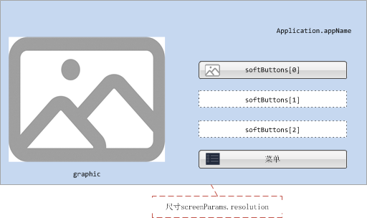

#### 效果图

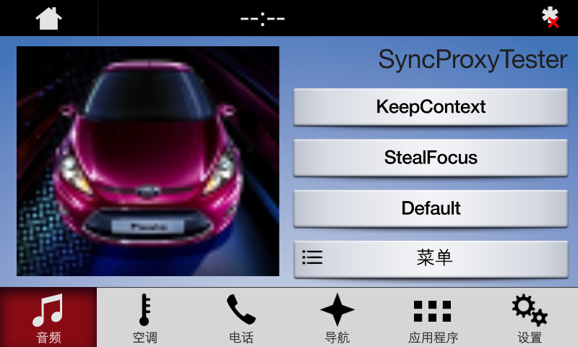

### AppListView

参见3.1.3

### Slider

参见3.1.4

### Alert

参见3.1.5

### AudioPassThru

参见3.1.6

### Choiceset

参见3.1.7

### Command

参见3.1.8

### ScrollableMessage

参见3.1.9

### DialNumber

参见3.1.10

### VideoStream

参见3.1.11

## DOUBLE_GRAPHIC_SOFTBUTTONS

### 属性

{

"id": 63,

"jsonrpc": "2.0",

"result": {

"code": 0,

"displayCapabilities": {

"displayType": "GEN3_8_INCH",

"graphicSupported": true, //支持图像显示

"imageCapabilities": [ //支持动态静态图片

"STATIC",

"DYNAMIC"

],

"imageFields": [

{

"imageResolution": { //softButton图标尺寸

"resolutionHeight": 35,

"resolutionWidth": 35

},

"imageTypeSupported": [ //softButton支持图标类型

"GRAPHIC_BMP",

"GRAPHIC_JPEG",

"GRAPHIC_PNG"

],

"name": "softButtonImage"

},

{

"imageResolution": { //softButton图标尺寸

"resolutionHeight": 70,

"resolutionWidth": 70

},

"imageTypeSupported": [ //softButton支持图标类型

"GRAPHIC_BMP",

"GRAPHIC_JPEG",

"GRAPHIC_PNG"

],

"name": "softButtonImage"

},

{

"imageResolution": { //首选choice图标尺寸

"resolutionHeight": 35,

"resolutionWidth": 35

},

"imageTypeSupported": [ //首选choice支持图标类型

"GRAPHIC_BMP",

"GRAPHIC_JPEG",

"GRAPHIC_PNG"

],

"name": "choiceImage"

},

{

"imageResolution": { //次选choice图标尺寸

"resolutionHeight": 35,

"resolutionWidth": 35

},

"imageTypeSupported": [ //次选choice支持图标类型

"GRAPHIC_BMP",

"GRAPHIC_JPEG",

"GRAPHIC_PNG"

],

"name": "choiceSecondaryImage"

},

{

"imageResolution": { //vr帮助图标占位尺寸

"resolutionHeight": 35,

"resolutionWidth": 35

},

"imageTypeSupported": [ //vr帮助图标支持的格式

"GRAPHIC_BMP",

"GRAPHIC_JPEG",

"GRAPHIC_PNG"

],

"name": "vrHelpItem"

},

{

"imageResolution": { //菜单图标占位尺寸

"resolutionHeight": 35,

"resolutionWidth": 35

},

"imageTypeSupported": [ //菜单图标支持的格式

"GRAPHIC_BMP",

"GRAPHIC_JPEG",

"GRAPHIC_PNG"

],

"name": "menuIcon"

},

{

"imageResolution": { //命令按钮图标占位尺寸

"resolutionHeight": 35,

"resolutionWidth": 35

},

"imageTypeSupported": [ //命令按钮图标支持的格式

"GRAPHIC_BMP",

"GRAPHIC_JPEG",

"GRAPHIC_PNG"

],

"name": "cmdIcon"

},

{

"imageResolution": { //app显示图标占位尺寸

"resolutionHeight": 35,

"resolutionWidth": 35

},

"imageTypeSupported": [ //app显示图标支持的格式

"GRAPHIC_BMP"

],

"name": "appIcon"

},

{

"imageResolution": { //app显示图标占位尺寸

"resolutionHeight": 70,

"resolutionWidth": 70

},

"imageTypeSupported": [ //app显示图标支持的格式

"GRAPHIC_BMP"

],

"name": "appIcon"

},

{

"imageResolution": { //graphic显示图标占位尺寸

"resolutionHeight": 210,

"resolutionWidth": 370

},

"imageTypeSupported": [ //graphic显示图标支持的格式

"GRAPHIC_BMP",

"GRAPHIC_JPEG",

"GRAPHIC_PNG"

],

"name": "graphic"

},

{

"imageResolution": { //location显示图标占位尺寸

"resolutionHeight": 35,

"resolutionWidth": 35

},

"imageTypeSupported": [ //location显示图标支持的格式

"GRAPHIC_BMP",

"GRAPHIC_JPEG",

"GRAPHIC_PNG"

],

"name": "locationImage"

}

],

"mediaClockFormats": [ //时间显示格式HH:MM:SS

"CLOCK3"

],

"numCustomPresetsAvailable": 8,

"screenParams": {

"resolution": { //画面显示尺寸

"resolutionHeight": 348,

"resolutionWidth": 800

},

"touchEventAvailable": {

"doublePressAvailable": false, // 不支持双击

"multiTouchAvailable": false, //不支持多点触摸

"pressAvailable": true //支持单击

}

},

"templatesAvailable": [ //当前支持的模板

"GRAPHIC_WITH_TEXT",

"TEXT_WITH_GRAPHIC",

"TILES_ONLY",

"GRAPHIC_WITH_TILES",

"TILES_WITH_GRAPHIC",

"GRAPHIC_WITH_TEXT_AND_SOFTBUTTONS",

"TEXT_AND_SOFTBUTTONS_WITH_GRAPHIC",

"GRAPHIC_WITH_TEXTBUTTONS",

"DOUBLE_GRAPHIC_WITH_SOFTBUTTONS",

"TEXTBUTTONS_WITH_GRAPHIC",

"TEXTBUTTONS_ONLY",

"LARGE_GRAPHIC_WITH_SOFTBUTTONS",

"LARGE_GRAPHIC_ONLY",

"MEDIA",

"ONSCREEN_PRESETS"

],

"textFields": [ //各文本字段名字、字符集、显示行数、文本宽度

{

"characterSet": "CID1SET",

"name": "alertText1",

"rows": 1,

"width": 40

},

{

"characterSet": "CID1SET",

"name": "alertText2",

"rows": 1,

"width": 40

},

{

"characterSet": "CID1SET",

"name": "alertText3",

"rows": 1,

"width": 40

},

{

"characterSet": "CID1SET",

"name": "scrollableMessageBody",

"rows": 8,

"width": 67

},

{

"characterSet": "CID1SET",

"name": "audioPassThruDisplayText1",

"rows": 1,

"width": 40

},

{

"characterSet": "CID1SET",

"name": "audioPassThruDisplayText2",

"rows": 1,

"width": 40

},

{

"characterSet": "CID1SET",

"name": "sliderHeader",

"rows": 1,

"width": 60

},

{

"characterSet": "CID1SET",

"name": "sliderFooter",

"rows": 1,

"width": 60

},

{

"characterSet": "CID1SET",

"name": "menuName",

"rows": 1,

"width": 35

},

{

"characterSet": "CID1SET",

"name": "secondaryText",

"rows": 1,

"width": 50

},

{

"characterSet": "CID1SET",

"name": "tertiaryText",

"rows": 1,

"width": 13

},

{

"characterSet": "CID1SET",

"name": "locationName",

"rows": 1,

"width": 20

},

{

"characterSet": "CID1SET",

"name": "locationDescription",

"rows": 1,

"width": 15

},

{

"characterSet": "CID1SET",

"name": "addressLines",

"rows": 4,

"width": 15

},

{

"characterSet": "CID1SET",

"name": "phoneNumber",

"rows": 1,

"width": 30

}

]

},

"method": "UI.SetDisplayLayout",

"softButtonCapabilities": [

{

"imageSupported": true, //按钮支持图片显示

"longPressAvailable": true, //支持长按

"shortPressAvailable": true, //支持短压

"upDownAvailable": true //支持按下弹起,有up、down事件及效果

}

]

}

}

### Show

#### 相关RPC

|  |  |
| --- | --- |
| 名字 | 请求内容 |
| UI.Show | **{**  **"id"**: 45**,**  **"jsonrpc"**: "2.0"**,**  **"method"**: "UI.Show"**,**  **"params"**: **{**  **"alignment"**: "CENTERED"**,**  **"appID"**: 22675**,**  **"customPresets"**: **[**  "GEN0"**,**  "GEN1"**,**  "GEN2"**,**  "GEN3"**,**  "GEN4"**,**  "GEN5"  **],**  **"graphic"**: **{**  **"imageType"**: "DYNAMIC"**,**  **"value"**: "/fs/rwdata/storage/sdl/584421907_6b50de75f3391a9e8117be9ded91461eabe62e54f74c8538e897e6621179721a/icon.png"  **},**  **"secondaryGraphic"**: **{**  **"imageType"**: "DYNAMIC"**,**  **"value"**: "/fs/rwdata/storage/sdl/584421907_6b50de75f3391a9e8117be9ded91461eabe62e54f74c8538e897e6621179721a/turn_right.png"  **},**  **"showStrings"**: **[**  **{**  **"fieldName"**: "mainField1"**,**  **"fieldText"**: "Show Line 1"  **},**  **{**  **"fieldName"**: "mainField2"**,**  **"fieldText"**: "Show Line 2"  **},**  **{**  **"fieldName"**: "mainField3"**,**  **"fieldText"**: "Show Line 3"  **},**  **{**  **"fieldName"**: "mainField4"**,**  **"fieldText"**: "Show Line 4"  **},**  **{**  **"fieldName"**: "mediaClock"**,**  **"fieldText"**: "12:34"  **},**  **{**  **"fieldName"**: "mediaTrack"**,**  **"fieldText"**: "Media Track"  **},**  **{**  **"fieldName"**: "statusBar"**,**  **"fieldText"**: "status bar"  **}**  **],**  **"softButtons"**: **[**  **{**  **"isHighlighted"**: false**,**  **"softButtonID"**: 5552**,**  **"systemAction"**: "KEEP_CONTEXT"**,**  **"text"**: "KeepContext"**,**  **"type"**: "TEXT"  **},**  **{**  **"isHighlighted"**: false**,**  **"softButtonID"**: 5553**,**  **"systemAction"**: "STEAL_FOCUS"**,**  **"text"**: "StealFocus"**,**  **"type"**: "TEXT"  **},**  **{**  **"isHighlighted"**: false**,**  **"softButtonID"**: 5554**,**  **"systemAction"**: "DEFAULT_ACTION"**,**  **"text"**: "Default"**,**  **"type"**: "TEXT"  **}**  **]**  **}**  **}** |

#### 设计图

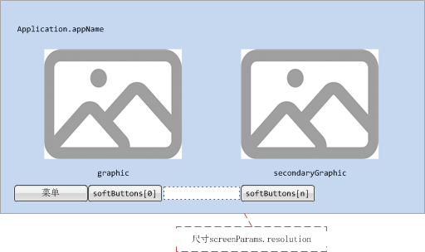

#### 效果图

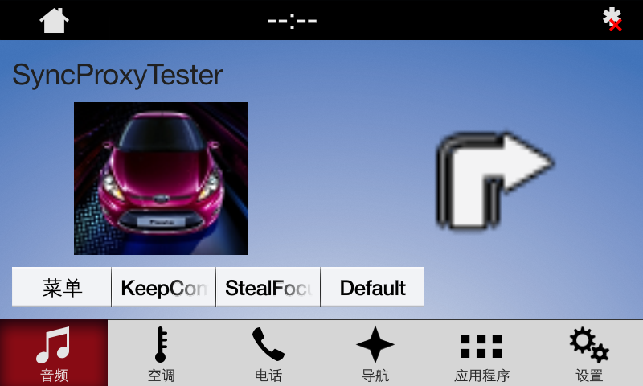

### AppListView

参见3.1.3

### Slider

参见3.1.4

### Alert

参见3.1.5

### AudioPassThru

参见3.1.6

### Choiceset

参见3.1.7

### Command

参见3.1.8

### ScrollableMessage

参见3.1.9

### DialNumber

参见3.1.10

### VideoStream

参见3.1.11

## TEXTBUTTONS_WITH_GRAPHIC

### 属性

{

"id": 87,

"jsonrpc": "2.0",

"result": {

"code": 0,

"displayCapabilities": {

"displayType": "GEN3_8_INCH",

"graphicSupported": true, //支持图像显示

"imageCapabilities": [ //支持动态静态图片

"STATIC",

"DYNAMIC"

],

"imageFields": [

{

"imageResolution": { //softButton图标尺寸

"resolutionHeight": 35,

"resolutionWidth": 35

},

"imageTypeSupported": [ //softButton支持图标类型

"GRAPHIC_BMP",

"GRAPHIC_JPEG",

"GRAPHIC_PNG"

],

"name": "softButtonImage"

},

{

"imageResolution": { //softButton图标尺寸

"resolutionHeight": 70,

"resolutionWidth": 70

},

"imageTypeSupported": [ //softButton支持图标类型

"GRAPHIC_BMP",

"GRAPHIC_JPEG",

"GRAPHIC_PNG"

],

"name": "softButtonImage"

},

{

"imageResolution": { //首选choice图标尺寸

"resolutionHeight": 35,

"resolutionWidth": 35

},

"imageTypeSupported": [ //首选choice支持图标类型

"GRAPHIC_BMP",

"GRAPHIC_JPEG",

"GRAPHIC_PNG"

],

"name": "choiceImage"

},

{

"imageResolution": { //次选choice图标尺寸

"resolutionHeight": 35,

"resolutionWidth": 35

},

"imageTypeSupported": [ //次选choice支持图标类型

"GRAPHIC_BMP",

"GRAPHIC_JPEG",

"GRAPHIC_PNG"

],

"name": "choiceSecondaryImage"

},

{

"imageResolution": { //vr帮助图标占位尺寸

"resolutionHeight": 35,

"resolutionWidth": 35

},

"imageTypeSupported": [ //vr帮助图标支持的格式

"GRAPHIC_BMP",

"GRAPHIC_JPEG",

"GRAPHIC_PNG"

],

"name": "vrHelpItem"

},

{

"imageResolution": { //菜单图标占位尺寸

"resolutionHeight": 35,

"resolutionWidth": 35

},

"imageTypeSupported": [ //菜单图标支持的格式

"GRAPHIC_BMP",

"GRAPHIC_JPEG",

"GRAPHIC_PNG"

],

"name": "menuIcon"

},

{

"imageResolution": { //命令按钮图标占位尺寸

"resolutionHeight": 35,

"resolutionWidth": 35

},

"imageTypeSupported": [ //命令按钮图标支持的格式

"GRAPHIC_BMP",

"GRAPHIC_JPEG",

"GRAPHIC_PNG"

],

"name": "cmdIcon"

},

{

"imageResolution": { //app显示图标占位尺寸

"resolutionHeight": 35,

"resolutionWidth": 35

},

"imageTypeSupported": [ //app显示图标支持的格式

"GRAPHIC_BMP"

],

"name": "appIcon"

},

{

"imageResolution": { //app显示图标占位尺寸

"resolutionHeight": 70,

"resolutionWidth": 70

},

"imageTypeSupported": [ //app显示图标支持的格式

"GRAPHIC_BMP"

],

"name": "appIcon"

},

{

"imageResolution": { //graphic显示图标占位尺寸

"resolutionHeight": 320,

"resolutionWidth": 380

},

"imageTypeSupported": [ //graphic显示图标支持的格式

"GRAPHIC_BMP",

"GRAPHIC_JPEG",

"GRAPHIC_PNG"

],

"name": "graphic"

},

{

"imageResolution": { //location显示图标占位尺寸

"resolutionHeight": 35,

"resolutionWidth": 35

},

"imageTypeSupported": [ //location显示图标支持的格式

"GRAPHIC_BMP",

"GRAPHIC_JPEG",

"GRAPHIC_PNG"

],

"name": "locationImage"

}

],

"mediaClockFormats": [ //时间显示格式HH:MM:SS

"CLOCK3"

],

"numCustomPresetsAvailable": 8,

"screenParams": {

"resolution": { //画面显示尺寸

"resolutionHeight": 348,

"resolutionWidth": 800

},

"touchEventAvailable": {

"doublePressAvailable": false, // 不支持双击

"multiTouchAvailable": false, //不支持多点触摸

"pressAvailable": true //支持单击

}

},

"templatesAvailable": [ //当前支持的模板

"GRAPHIC_WITH_TEXT",

"TEXT_WITH_GRAPHIC",

"TILES_ONLY",

"GRAPHIC_WITH_TILES",

"TILES_WITH_GRAPHIC",

"GRAPHIC_WITH_TEXT_AND_SOFTBUTTONS",

"TEXT_AND_SOFTBUTTONS_WITH_GRAPHIC",

"GRAPHIC_WITH_TEXTBUTTONS",

"DOUBLE_GRAPHIC_WITH_SOFTBUTTONS",

"TEXTBUTTONS_WITH_GRAPHIC",

"TEXTBUTTONS_ONLY",

"LARGE_GRAPHIC_WITH_SOFTBUTTONS",

"LARGE_GRAPHIC_ONLY",

"MEDIA",

"ONSCREEN_PRESETS"

],

"textFields": [ //各文本字段名字、字符集、显示行数、文本宽度

{

"characterSet": "CID1SET",

"name": "alertText1",

"rows": 1,

"width": 40

},

{

"characterSet": "CID1SET",

"name": "alertText2",

"rows": 1,

"width": 40

},

{

"characterSet": "CID1SET",

"name": "alertText3",

"rows": 1,

"width": 40

},

{

"characterSet": "CID1SET",

"name": "scrollableMessageBody",

"rows": 8,

"width": 67

},

{

"characterSet": "CID1SET",

"name": "audioPassThruDisplayText1",

"rows": 1,

"width": 40

},

{

"characterSet": "CID1SET",

"name": "audioPassThruDisplayText2",

"rows": 1,

"width": 40

},

{

"characterSet": "CID1SET",

"name": "sliderHeader",

"rows": 1,

"width": 60

},

{

"characterSet": "CID1SET",

"name": "sliderFooter",

"rows": 1,

"width": 60

},

{

"characterSet": "CID1SET",

"name": "menuName",

"rows": 1,

"width": 35

},

{

"characterSet": "CID1SET",

"name": "secondaryText",

"rows": 1,

"width": 50

},

{

"characterSet": "CID1SET",

"name": "tertiaryText",

"rows": 1,

"width": 13

},

{

"characterSet": "CID1SET",

"name": "locationName",

"rows": 1,

"width": 20

},

{

"characterSet": "CID1SET",

"name": "locationDescription",

"rows": 1,

"width": 15

},

{

"characterSet": "CID1SET",

"name": "addressLines",

"rows": 4,

"width": 15

},

{

"characterSet": "CID1SET",

"name": "phoneNumber",

"rows": 1,

"width": 30

}

]

},

"method": "UI.SetDisplayLayout",

"softButtonCapabilities": [

{

"imageSupported": true, //按钮支持图片显示

"longPressAvailable": true, //支持长按

"shortPressAvailable": true, //支持短压

"upDownAvailable": true //支持按下弹起,有up、down事件及效果

}

]

}

}

### Show

#### 相关RPC

|  |  |
| --- | --- |
| 名字 | 请求内容 |
| UI.Show | **{**  **"id"**: 45**,**  **"jsonrpc"**: "2.0"**,**  **"method"**: "UI.Show"**,**  **"params"**: **{**  **"alignment"**: "CENTERED"**,**  **"appID"**: 22675**,**  **"customPresets"**: **[**  "GEN0"**,**  "GEN1"**,**  "GEN2"**,**  "GEN3"**,**  "GEN4"**,**  "GEN5"  **],**  **"graphic"**: **{**  **"imageType"**: "DYNAMIC"**,**  **"value"**: "/fs/rwdata/storage/sdl/584421907_6b50de75f3391a9e8117be9ded91461eabe62e54f74c8538e897e6621179721a/turn_left.png"  **},**  **"secondaryGraphic"**: **{**  **"imageType"**: "DYNAMIC"**,**  **"value"**: "/fs/rwdata/storage/sdl/584421907_6b50de75f3391a9e8117be9ded91461eabe62e54f74c8538e897e6621179721a/turn_right.png"  **},**  **"showStrings"**: **[**  **{**  **"fieldName"**: "mainField1"**,**  **"fieldText"**: "Show Line 1"  **},**  **{**  **"fieldName"**: "mainField2"**,**  **"fieldText"**: "Show Line 2"  **},**  **{**  **"fieldName"**: "mainField3"**,**  **"fieldText"**: "Show Line 3"  **},**  **{**  **"fieldName"**: "mainField4"**,**  **"fieldText"**: "Show Line 4"  **},**  **{**  **"fieldName"**: "mediaClock"**,**  **"fieldText"**: "12:34"  **},**  **{**  **"fieldName"**: "mediaTrack"**,**  **"fieldText"**: "Media Track"  **},**  **{**  **"fieldName"**: "statusBar"**,**  **"fieldText"**: "status bar"  **}**  **],**  **"softButtons"**: **[**  **{**  **"isHighlighted"**: false**,**  **"softButtonID"**: 5552**,**  **"systemAction"**: "KEEP_CONTEXT"**,**  **"text"**: "KeepContext"**,**  **"type"**: "TEXT"  **},**  **{**  **"isHighlighted"**: false**,**  **"softButtonID"**: 5553**,**  **"systemAction"**: "STEAL_FOCUS"**,**  **"text"**: "StealFocus"**,**  **"type"**: "TEXT"  **},**  **{**  **"isHighlighted"**: false**,**  **"softButtonID"**: 5554**,**  **"systemAction"**: "DEFAULT_ACTION"**,**  **"text"**: "Default"**,**  **"type"**: "TEXT"  **}**  **]**  **}**  **}** |

#### 设计图

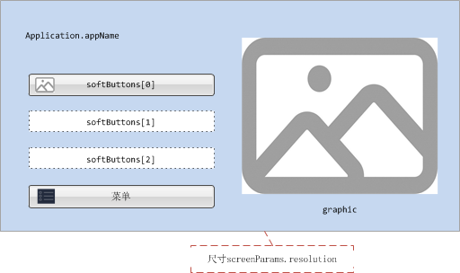

#### 效果图

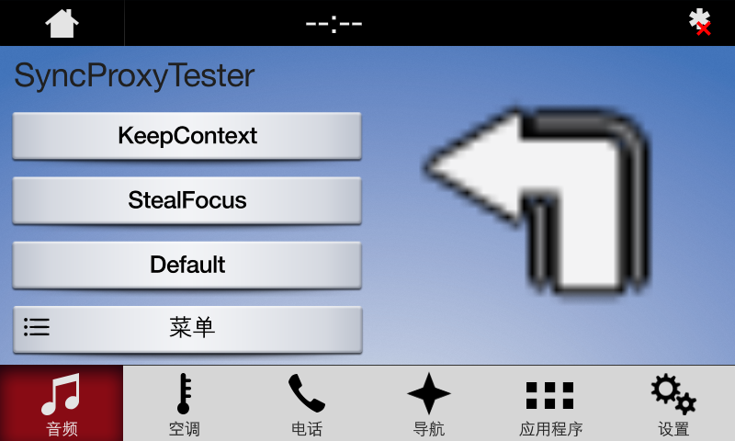

### AppListView

参见3.1.3

### Slider

参见3.1.4

### Alert

参见3.1.5

### AudioPassThru

参见3.1.6

### Choiceset

参见3.1.7

### Command

参见3.1.8

### ScrollableMessage

参见3.1.9

### DialNumber

参见3.1.10

### VideoStream

参见3.1.11

## TEXTBUTTONS_ONLY

### 属性

{

"id": 36,

"jsonrpc": "2.0",

"result": {

"code": 0,

"displayCapabilities": {

"displayType": "GEN3_8_INCH",

"graphicSupported": true, //支持图像显示

"imageCapabilities": [ //支持动态静态图片

"STATIC",

"DYNAMIC"

],

"imageFields": [

{

"imageResolution": { //softButton图标尺寸

"resolutionHeight": 35,

"resolutionWidth": 35

},

"imageTypeSupported": [ //softButton支持图标类型

"GRAPHIC_BMP",

"GRAPHIC_JPEG",

"GRAPHIC_PNG"

],

"name": "softButtonImage"

},

{

"imageResolution": { //softButton图标尺寸

"resolutionHeight": 70,

"resolutionWidth": 70

},

"imageTypeSupported": [ //softButton支持图标类型

"GRAPHIC_BMP",

"GRAPHIC_JPEG",

"GRAPHIC_PNG"

],

"name": "softButtonImage"

},

{

"imageResolution": { //首选choice图标尺寸

"resolutionHeight": 35,

"resolutionWidth": 35

},

"imageTypeSupported": [ //首选choice支持图标类型

"GRAPHIC_BMP",

"GRAPHIC_JPEG",

"GRAPHIC_PNG"

],

"name": "choiceImage"

},

{

"imageResolution": { //次选choice图标尺寸

"resolutionHeight": 35,

"resolutionWidth": 35

},

"imageTypeSupported": [ //次选choice支持图标类型

"GRAPHIC_BMP",

"GRAPHIC_JPEG",

"GRAPHIC_PNG"

],

"name": "choiceSecondaryImage"

},

{

"imageResolution": { //vr帮助图标占位尺寸

"resolutionHeight": 35,

"resolutionWidth": 35

},

"imageTypeSupported": [ //vr帮助图标支持的格式

"GRAPHIC_BMP",

"GRAPHIC_JPEG",

"GRAPHIC_PNG"

],

"name": "vrHelpItem"

},

{

"imageResolution": { //菜单图标占位尺寸

"resolutionHeight": 35,

"resolutionWidth": 35

},

"imageTypeSupported": [ //菜单图标支持的格式

"GRAPHIC_BMP",

"GRAPHIC_JPEG",

"GRAPHIC_PNG"

],

"name": "menuIcon"

},

{

"imageResolution": { //命令按钮图标占位尺寸

"resolutionHeight": 35,

"resolutionWidth": 35

},

"imageTypeSupported": [ //命令按钮图标支持的格式

"GRAPHIC_BMP",

"GRAPHIC_JPEG",

"GRAPHIC_PNG"

],

"name": "cmdIcon"

},

{

"imageResolution": { //app显示图标占位尺寸

"resolutionHeight": 35,

"resolutionWidth": 35

},

"imageTypeSupported": [ //app显示图标支持的格式

"GRAPHIC_BMP"

],

"name": "appIcon"

},

{

"imageResolution": { //app显示图标占位尺寸

"resolutionHeight": 70,

"resolutionWidth": 70

},

"imageTypeSupported": [ //app显示图标支持的格式

"GRAPHIC_BMP"

],

"name": "appIcon"

},

{

"imageResolution": { //location显示图标占位尺寸

"resolutionHeight": 35,

"resolutionWidth": 35

},

"imageTypeSupported": [ //location显示图标支持的格式

"GRAPHIC_BMP",

"GRAPHIC_JPEG",

"GRAPHIC_PNG"

],

"name": "locationImage"

}

],

"mediaClockFormats": [ //时间显示格式HH:MM:SS

"CLOCK3"

],

"numCustomPresetsAvailable": 8,

"screenParams": {

"resolution": { //画面显示尺寸

"resolutionHeight": 348,

"resolutionWidth": 800

},

"touchEventAvailable": {

"doublePressAvailable": false, // 不支持双击

"multiTouchAvailable": false, //不支持多点触摸

"pressAvailable": true //支持单击

}

},

"templatesAvailable": [ //当前支持的模板

"GRAPHIC_WITH_TEXT",

"TEXT_WITH_GRAPHIC",

"TILES_ONLY",

"GRAPHIC_WITH_TILES",

"TILES_WITH_GRAPHIC",

"GRAPHIC_WITH_TEXT_AND_SOFTBUTTONS",

"TEXT_AND_SOFTBUTTONS_WITH_GRAPHIC",

"GRAPHIC_WITH_TEXTBUTTONS",

"DOUBLE_GRAPHIC_WITH_SOFTBUTTONS",

"TEXTBUTTONS_WITH_GRAPHIC",

"TEXTBUTTONS_ONLY",

"LARGE_GRAPHIC_WITH_SOFTBUTTONS",

"LARGE_GRAPHIC_ONLY",

"MEDIA",

"ONSCREEN_PRESETS"

],

{

"characterSet": "CID1SET",

"name": "alertText1",

"rows": 1,

"width": 40

},

{

"characterSet": "CID1SET",

"name": "alertText2",

"rows": 1,

"width": 40

},

{

"characterSet": "CID1SET",

"name": "alertText3",

"rows": 1,

"width": 40

},

{

"characterSet": "CID1SET",

"name": "scrollableMessageBody",

"rows": 8,

"width": 67

},

{

"characterSet": "CID1SET",

"name": "audioPassThruDisplayText1",

"rows": 1,

"width": 40

},

{

"characterSet": "CID1SET",

"name": "audioPassThruDisplayText2",

"rows": 1,

"width": 40

},

{

"characterSet": "CID1SET",

"name": "sliderHeader",

"rows": 1,

"width": 60

},

{

"characterSet": "CID1SET",

"name": "sliderFooter",

"rows": 1,

"width": 60

},

{

"characterSet": "CID1SET",

"name": "menuName",

"rows": 1,

"width": 35

},

{

"characterSet": "CID1SET",

"name": "secondaryText",

"rows": 1,

"width": 50

},

{

"characterSet": "CID1SET",

"name": "tertiaryText",

"rows": 1,

"width": 13

},

{

"characterSet": "CID1SET",

"name": "locationName",

"rows": 1,

"width": 20

},

{

"characterSet": "CID1SET",

"name": "locationDescription",

"rows": 1,

"width": 15

},

{

"characterSet": "CID1SET",

"name": "addressLines",

"rows": 4,

"width": 15

},

{

"characterSet": "CID1SET",

"name": "phoneNumber",

"rows": 1,

"width": 30

}

]

},

"method": "UI.SetDisplayLayout",

"softButtonCapabilities": [

{

"imageSupported": true, //按钮支持图片显示

"longPressAvailable": true, //支持长按

"shortPressAvailable": true, //支持短压

"upDownAvailable": true //支持按下弹起,有up、down事件及效果

}

]

}

}

### Show

#### 相关RPC

|  |  |
| --- | --- |
| 名字 | 请求内容 |
| UI.Show | **{**  **"id"**: 45**,**  **"jsonrpc"**: "2.0"**,**  **"method"**: "UI.Show"**,**  **"params"**: **{**  **"alignment"**: "CENTERED"**,**  **"appID"**: 22675**,**  **"customPresets"**: **[**  "GEN0"**,**  "GEN1"**,**  "GEN2"**,**  "GEN3"**,**  "GEN4"**,**  "GEN5"  **],**  **"graphic"**: **{**  **"imageType"**: "DYNAMIC"**,**  **"value"**: "/fs/rwdata/storage/sdl/584421907_6b50de75f3391a9e8117be9ded91461eabe62e54f74c8538e897e6621179721a/icon.png"  **},**  **"secondaryGraphic"**: **{**  **"imageType"**: "DYNAMIC"**,**  **"value"**: "/fs/rwdata/storage/sdl/584421907_6b50de75f3391a9e8117be9ded91461eabe62e54f74c8538e897e6621179721a/turn_right.png"  **},**  **"showStrings"**: **[**  **{**  **"fieldName"**: "mainField1"**,**  **"fieldText"**: "Show Line 1"  **},**  **{**  **"fieldName"**: "mainField2"**,**  **"fieldText"**: "Show Line 2"  **},**  **{**  **"fieldName"**: "mainField3"**,**  **"fieldText"**: "Show Line 3"  **},**  **{**  **"fieldName"**: "mainField4"**,**  **"fieldText"**: "Show Line 4"  **},**  **{**  **"fieldName"**: "mediaClock"**,**  **"fieldText"**: "12:34"  **},**  **{**  **"fieldName"**: "mediaTrack"**,**  **"fieldText"**: "Media Track"  **},**  **{**  **"fieldName"**: "statusBar"**,**  **"fieldText"**: "status bar"  **}**  **],**  **"softButtons"**: **[**  **{**  **"isHighlighted"**: false**,**  **"softButtonID"**: 5552**,**  **"systemAction"**: "KEEP_CONTEXT"**,**  **"text"**: "KeepContext"**,**  **"type"**: "TEXT"  **},**  **{**  **"isHighlighted"**: false**,**  **"softButtonID"**: 5553**,**  **"systemAction"**: "STEAL_FOCUS"**,**  **"text"**: "StealFocus"**,**  **"type"**: "TEXT"  **},**  **{**  **"isHighlighted"**: false**,**  **"softButtonID"**: 5554**,**  **"systemAction"**: "DEFAULT_ACTION"**,**  **"text"**: "Default"**,**  **"type"**: "TEXT"  **}**  **]**  **}**  **}** |

#### 设计图

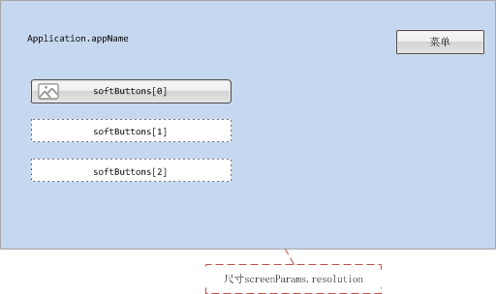

#### 效果图

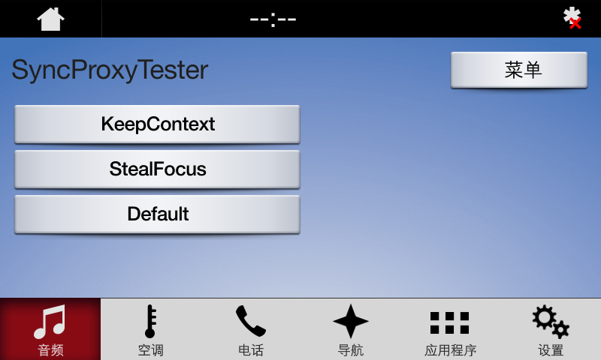

### AppListView

参见3.1.3

### Slider

参见3.1.4

### Alert

参见3.1.5

### AudioPassThru

参见3.1.6

### Choiceset

参见3.1.7

### Command

参见3.1.8

### ScrollableMessage

参见3.1.9

### DialNumber

参见3.1.10

### VideoStream

参见3.1.11

## LARGE_GRAPHIC_WITH_SOFTBUTTONS

### 属性

{

"id": 52,

"jsonrpc": "2.0",

"result": {

"code": 0,

"displayCapabilities": {

"displayType": "GEN3_8_INCH",

"graphicSupported": true, //支持图像显示

"imageCapabilities": [ //支持动态静态图片

"STATIC",

"DYNAMIC"

],

"imageFields": [

{

"imageResolution": { //softButton图标尺寸

"resolutionHeight": 35,

"resolutionWidth": 35

},

"imageTypeSupported": [ //softButton支持图标类型

"GRAPHIC_BMP",

"GRAPHIC_JPEG",

"GRAPHIC_PNG"

],

"name": "softButtonImage"

},

{

"imageResolution": { //softButton图标尺寸

"resolutionHeight": 70,

"resolutionWidth": 70

},

"imageTypeSupported": [ //softButton支持图标类型

"GRAPHIC_BMP",

"GRAPHIC_JPEG",

"GRAPHIC_PNG"

],

"name": "softButtonImage"

},

{

"imageResolution": { //首选choice图标尺寸

"resolutionHeight": 35,

"resolutionWidth": 35

},

"imageTypeSupported": [ //首选choice支持图标类型

"GRAPHIC_BMP",

"GRAPHIC_JPEG",

"GRAPHIC_PNG"

],

"name": "choiceImage"

},

{

"imageResolution": { //次选choice图标尺寸

"resolutionHeight": 35,

"resolutionWidth": 35

},

"imageTypeSupported": [ //次选choice支持图标类型

"GRAPHIC_BMP",

"GRAPHIC_JPEG",

"GRAPHIC_PNG"

],

"name": "choiceSecondaryImage"

},

{

"imageResolution": { //vr帮助图标占位尺寸

"resolutionHeight": 35,

"resolutionWidth": 35

},

"imageTypeSupported": [ //vr帮助图标支持的格式

"GRAPHIC_BMP",

"GRAPHIC_JPEG",

"GRAPHIC_PNG"

],

"name": "vrHelpItem"

},

{

"imageResolution": { //菜单图标占位尺寸

"resolutionHeight": 35,

"resolutionWidth": 35

},

"imageTypeSupported": [ //菜单图标支持的格式

"GRAPHIC_BMP",

"GRAPHIC_JPEG",

"GRAPHIC_PNG"

],

"name": "menuIcon"

},

{

"imageResolution": { //命令按钮图标占位尺寸

"resolutionHeight": 35,

"resolutionWidth": 35

},

"imageTypeSupported": [ //命令按钮图标支持的格式

"GRAPHIC_BMP",

"GRAPHIC_JPEG",

"GRAPHIC_PNG"

],

"name": "cmdIcon"

},

{

"imageResolution": { //app显示图标占位尺寸

"resolutionHeight": 35,

"resolutionWidth": 35

},

"imageTypeSupported": [ //app显示图标支持的格式

"GRAPHIC_BMP"

],

"name": "appIcon"

},

{

"imageResolution": { //app显示图标占位尺寸

"resolutionHeight": 70,

"resolutionWidth": 70

},

"imageTypeSupported": [ //app显示图标支持的格式

"GRAPHIC_BMP"

],

"name": "appIcon"

},

{

"imageResolution": { //graphic显示图标占位尺寸

"resolutionHeight": 210,

"resolutionWidth": 770

},

"imageTypeSupported": [ //graphic显示图标支持的格式

"GRAPHIC_BMP",

"GRAPHIC_JPEG",

"GRAPHIC_PNG"

],

"name": "graphic"

},

{

"imageResolution": { //location显示图标占位尺寸

"resolutionHeight": 35,

"resolutionWidth": 35

},

"imageTypeSupported": [ //location显示图标支持的格式

"GRAPHIC_BMP",

"GRAPHIC_JPEG",

"GRAPHIC_PNG"

],

"name": "locationImage"

}

],

"mediaClockFormats": [ //时间显示格式HH:MM:SS

"CLOCK3"

],

"numCustomPresetsAvailable": 8,

"screenParams": {

"resolution": { //画面显示尺寸

"resolutionHeight": 348,

"resolutionWidth": 800

},

"touchEventAvailable": {

"doublePressAvailable": false, // 不支持双击

"multiTouchAvailable": false, //不支持多点触摸

"pressAvailable": true //支持单击

}

},

"templatesAvailable": [ //当前支持的模板

"GRAPHIC_WITH_TEXT",

"TEXT_WITH_GRAPHIC",

"TILES_ONLY",

"GRAPHIC_WITH_TILES",

"TILES_WITH_GRAPHIC",

"GRAPHIC_WITH_TEXT_AND_SOFTBUTTONS",

"TEXT_AND_SOFTBUTTONS_WITH_GRAPHIC",

"GRAPHIC_WITH_TEXTBUTTONS",

"DOUBLE_GRAPHIC_WITH_SOFTBUTTONS",

"TEXTBUTTONS_WITH_GRAPHIC",

"TEXTBUTTONS_ONLY",

"LARGE_GRAPHIC_WITH_SOFTBUTTONS",

"LARGE_GRAPHIC_ONLY",

"MEDIA",

"ONSCREEN_PRESETS"

],

"textFields": [ //各文本字段名字、字符集、显示行数、文本宽度

{

"characterSet": "CID1SET",

"name": "alertText1",

"rows": 1,

"width": 40

},

{

"characterSet": "CID1SET",

"name": "alertText2",

"rows": 1,

"width": 40

},

{

"characterSet": "CID1SET",

"name": "alertText3",

"rows": 1,

"width": 40

},

{

"characterSet": "CID1SET",

"name": "scrollableMessageBody",

"rows": 8,

"width": 67

},

{

"characterSet": "CID1SET",

"name": "audioPassThruDisplayText1",

"rows": 1,

"width": 40

},

{

"characterSet": "CID1SET",

"name": "audioPassThruDisplayText2",

"rows": 1,

"width": 40

},

{

"characterSet": "CID1SET",

"name": "sliderHeader",

"rows": 1,

"width": 60

},

{

"characterSet": "CID1SET",

"name": "sliderFooter",

"rows": 1,

"width": 60

},

{

"characterSet": "CID1SET",

"name": "menuName",

"rows": 1,

"width": 35

},

{

"characterSet": "CID1SET",

"name": "secondaryText",

"rows": 1,

"width": 50

},

{

"characterSet": "CID1SET",

"name": "tertiaryText",

"rows": 1,

"width": 13

},

{

"characterSet": "CID1SET",

"name": "locationName",

"rows": 1,

"width": 20

},

{

"characterSet": "CID1SET",

"name": "locationDescription",

"rows": 1,

"width": 15

},

{

"characterSet": "CID1SET",

"name": "addressLines",

"rows": 4,

"width": 15

},

{

"characterSet": "CID1SET",

"name": "phoneNumber",

"rows": 1,

"width": 30

}

]

},

"method": "UI.SetDisplayLayout",

"softButtonCapabilities": [

{

"imageSupported": true, //按钮支持图片显示

"longPressAvailable": true, //支持长按

"shortPressAvailable": true, //支持短压

"upDownAvailable": true //支持按下弹起,有up、down事件及效果

}

]

}

}

### Show

#### 相关RPC

|  |  |
| --- | --- |
| 名字 | 请求内容 |
| UI.Show | **{**  **"id"**: 45**,**  **"jsonrpc"**: "2.0"**,**  **"method"**: "UI.Show"**,**  **"params"**: **{**  **"alignment"**: "CENTERED"**,**  **"appID"**: 22675**,**  **"customPresets"**: **[**  "GEN0"**,**  "GEN1"**,**  "GEN2"**,**  "GEN3"**,**  "GEN4"**,**  "GEN5"  **],**  **"graphic"**: **{**  **"imageType"**: "DYNAMIC"**,**  **"value"**: "/fs/rwdata/storage/sdl/584421907_6b50de75f3391a9e8117be9ded91461eabe62e54f74c8538e897e6621179721a/icon.png"  **},**  **"secondaryGraphic"**: **{**  **"imageType"**: "DYNAMIC"**,**  **"value"**: "/fs/rwdata/storage/sdl/584421907_6b50de75f3391a9e8117be9ded91461eabe62e54f74c8538e897e6621179721a/turn_right.png"  **},**  **"showStrings"**: **[**  **{**  **"fieldName"**: "mainField1"**,**  **"fieldText"**: "Show Line 1"  **},**  **{**  **"fieldName"**: "mainField2"**,**  **"fieldText"**: "Show Line 2"  **},**  **{**  **"fieldName"**: "mainField3"**,**  **"fieldText"**: "Show Line 3"  **},**  **{**  **"fieldName"**: "mainField4"**,**  **"fieldText"**: "Show Line 4"  **},**  **{**  **"fieldName"**: "mediaClock"**,**  **"fieldText"**: "12:34"  **},**  **{**  **"fieldName"**: "mediaTrack"**,**  **"fieldText"**: "Media Track"  **},**  **{**  **"fieldName"**: "statusBar"**,**  **"fieldText"**: "status bar"  **}**  **],**  **"softButtons"**: **[**  **{**  **"isHighlighted"**: false**,**  **"softButtonID"**: 5552**,**  **"systemAction"**: "KEEP_CONTEXT"**,**  **"text"**: "KeepContext"**,**  **"type"**: "TEXT"  **},**  **{**  **"isHighlighted"**: false**,**  **"softButtonID"**: 5553**,**  **"systemAction"**: "STEAL_FOCUS"**,**  **"text"**: "StealFocus"**,**  **"type"**: "TEXT"  **},**  **{**  **"isHighlighted"**: false**,**  **"softButtonID"**: 5554**,**  **"systemAction"**: "DEFAULT_ACTION"**,**  **"text"**: "Default"**,**  **"type"**: "TEXT"  **}**  **]**  **}**  **}** |

#### 设计图

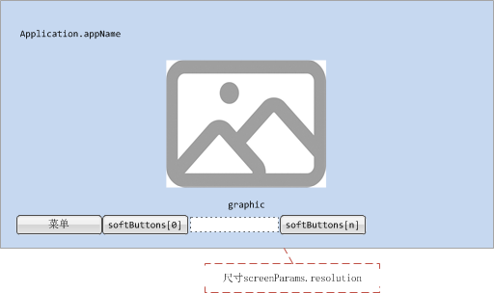

#### 效果图

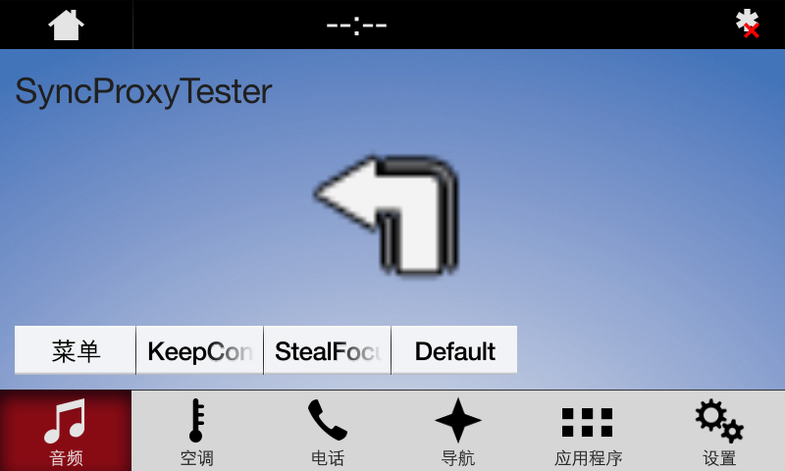

### AppListView

参见3.1.3

### Slider

参见3.1.4

### Alert

参见3.1.5

### AudioPassThru

参见3.1.6

### Choiceset

参见3.1.7

### Command

参见3.1.8

### ScrollableMessage

参见3.1.9

### DialNumber

参见3.1.10

### VideoStream

参见3.1.11

## LARGE_GRAPHIC_ONLY

### 属性

{

"id": 55,

"jsonrpc": "2.0",

"result": {

"code": 0,

"displayCapabilities": {

"displayType": "GEN3_8_INCH",

"graphicSupported": true, //支持图像显示

"imageCapabilities": [ //支持动态静态图片

"STATIC",

"DYNAMIC"

],

"imageFields": [

{

"imageResolution": { //softButton图标尺寸

"resolutionHeight": 35,

"resolutionWidth": 35

},

"imageTypeSupported": [ //softButton支持图标类型

"GRAPHIC_BMP",

"GRAPHIC_JPEG",

"GRAPHIC_PNG"

],

"name": "softButtonImage"

},

{

"imageResolution": { //softButton图标尺寸

"resolutionHeight": 70,

"resolutionWidth": 70

},

"imageTypeSupported": [ //softButton支持图标类型

"GRAPHIC_BMP",

"GRAPHIC_JPEG",

"GRAPHIC_PNG"

],

"name": "softButtonImage"

},

{

"imageResolution": { //首选choice图标尺寸

"resolutionHeight": 35,

"resolutionWidth": 35

},

"imageTypeSupported": [ //首选choice支持图标类型

"GRAPHIC_BMP",

"GRAPHIC_JPEG",

"GRAPHIC_PNG"

],

"name": "choiceImage"

},

{

"imageResolution": { //次选choice图标尺寸

"resolutionHeight": 35,

"resolutionWidth": 35

},

"imageTypeSupported": [ //次选choice支持图标类型

"GRAPHIC_BMP",

"GRAPHIC_JPEG",

"GRAPHIC_PNG"

],

"name": "choiceSecondaryImage"

},

{

"imageResolution": { //vr帮助图标占位尺寸

"resolutionHeight": 35,

"resolutionWidth": 35

},

"imageTypeSupported": [ //vr帮助图标支持的格式

"GRAPHIC_BMP",

"GRAPHIC_JPEG",

"GRAPHIC_PNG"

],

"name": "vrHelpItem"

},

{

"imageResolution": { //菜单图标占位尺寸

"resolutionHeight": 35,

"resolutionWidth": 35

},

"imageTypeSupported": [ //菜单图标支持的格式

"GRAPHIC_BMP",

"GRAPHIC_JPEG",

"GRAPHIC_PNG"

],

"name": "menuIcon"

},

{

"imageResolution": { //命令按钮图标占位尺寸

"resolutionHeight": 35,

"resolutionWidth": 35

},

"imageTypeSupported": [ //命令按钮图标支持的格式

"GRAPHIC_BMP",

"GRAPHIC_JPEG",

"GRAPHIC_PNG"

],

"name": "cmdIcon"

},

{

"imageResolution": { //app显示图标占位尺寸

"resolutionHeight": 35,

"resolutionWidth": 35

},

"imageTypeSupported": [ //app显示图标支持的格式

"GRAPHIC_BMP"

],

"name": "appIcon"

},

{

"imageResolution": { //app显示图标占位尺寸

"resolutionHeight": 70,

"resolutionWidth": 70

},

"imageTypeSupported": [ //app显示图标支持的格式

"GRAPHIC_BMP"

],

"name": "appIcon"

},

{

"imageResolution": { //graphic显示图标占位尺寸

"resolutionHeight": 255,

"resolutionWidth": 770

},

"imageTypeSupported": [ //graphic显示图标支持的格式

"GRAPHIC_BMP",

"GRAPHIC_JPEG",

"GRAPHIC_PNG"

],

"name": "graphic"

},

{

"imageResolution": { //location显示图标占位尺寸

"resolutionHeight": 35,

"resolutionWidth": 35

},

"imageTypeSupported": [ //location显示图标支持的格式

"GRAPHIC_BMP",

"GRAPHIC_JPEG",

"GRAPHIC_PNG"

],

"name": "locationImage"

}

],

"mediaClockFormats": [ //时间显示格式HH:MM:SS

"CLOCK3"

],

"numCustomPresetsAvailable": 8,

"screenParams": {

"resolution": { //画面显示尺寸

"resolutionHeight": 348,

"resolutionWidth": 800

},

"touchEventAvailable": {

"doublePressAvailable": false, // 不支持双击

"multiTouchAvailable": false, //不支持多点触摸

"pressAvailable": true //支持单击

}

},

"templatesAvailable": [ //当前支持的模板

"GRAPHIC_WITH_TEXT",

"TEXT_WITH_GRAPHIC",

"TILES_ONLY",

"GRAPHIC_WITH_TILES",

"TILES_WITH_GRAPHIC",

"GRAPHIC_WITH_TEXT_AND_SOFTBUTTONS",

"TEXT_AND_SOFTBUTTONS_WITH_GRAPHIC",

"GRAPHIC_WITH_TEXTBUTTONS",

"DOUBLE_GRAPHIC_WITH_SOFTBUTTONS",

"TEXTBUTTONS_WITH_GRAPHIC",

"TEXTBUTTONS_ONLY",

"LARGE_GRAPHIC_WITH_SOFTBUTTONS",

"LARGE_GRAPHIC_ONLY",

"MEDIA",

"ONSCREEN_PRESETS"

],

{

"characterSet": "CID1SET",

"name": "alertText1",

"rows": 1,

"width": 40

},

{

"characterSet": "CID1SET",

"name": "alertText2",

"rows": 1,

"width": 40

},

{

"characterSet": "CID1SET",

"name": "alertText3",

"rows": 1,

"width": 40

},

{

"characterSet": "CID1SET",

"name": "scrollableMessageBody",

"rows": 8,

"width": 67

},

{

"characterSet": "CID1SET",

"name": "audioPassThruDisplayText1",

"rows": 1,

"width": 40

},

{

"characterSet": "CID1SET",

"name": "audioPassThruDisplayText2",

"rows": 1,

"width": 40

},

{

"characterSet": "CID1SET",

"name": "sliderHeader",

"rows": 1,

"width": 60

},

{

"characterSet": "CID1SET",

"name": "sliderFooter",

"rows": 1,

"width": 60

},

{

"characterSet": "CID1SET",

"name": "menuName",

"rows": 1,

"width": 35

},

{

"characterSet": "CID1SET",

"name": "secondaryText",

"rows": 1,

"width": 50

},

{

"characterSet": "CID1SET",

"name": "tertiaryText",

"rows": 1,

"width": 13

},

{

"characterSet": "CID1SET",

"name": "locationName",

"rows": 1,

"width": 20

},

{

"characterSet": "CID1SET",

"name": "locationDescription",

"rows": 1,

"width": 15

},

{

"characterSet": "CID1SET",

"name": "addressLines",

"rows": 4,

"width": 15

},

{

"characterSet": "CID1SET",

"name": "phoneNumber",

"rows": 1,

"width": 30

}

]

},

"method": "UI.SetDisplayLayout",

"softButtonCapabilities": [

{

"imageSupported": true, //按钮支持图片显示

"longPressAvailable": true, //支持长按

"shortPressAvailable": true, //支持短压

"upDownAvailable": true //支持按下弹起,有up、down事件及效果

}

]

}

}

### Show

#### 相关RPC

|  |  |
| --- | --- |
| 名字 | 请求内容 |
| UI.Show | **{**  **"id"**: 45**,**  **"jsonrpc"**: "2.0"**,**  **"method"**: "UI.Show"**,**  **"params"**: **{**  **"alignment"**: "CENTERED"**,**  **"appID"**: 22675**,**  **"customPresets"**: **[**  "GEN0"**,**  "GEN1"**,**  "GEN2"**,**  "GEN3"**,**  "GEN4"**,**  "GEN5"  **],**  **"graphic"**: **{**  **"imageType"**: "DYNAMIC"**,**  **"value"**: "/fs/rwdata/storage/sdl/584421907_6b50de75f3391a9e8117be9ded91461eabe62e54f74c8538e897e6621179721a/icon.png"  **},**  **"secondaryGraphic"**: **{**  **"imageType"**: "DYNAMIC"**,**  **"value"**: "/fs/rwdata/storage/sdl/584421907_6b50de75f3391a9e8117be9ded91461eabe62e54f74c8538e897e6621179721a/turn_right.png"  **},**  **"showStrings"**: **[**  **{**  **"fieldName"**: "mainField1"**,**  **"fieldText"**: "Show Line 1"  **},**  **{**  **"fieldName"**: "mainField2"**,**  **"fieldText"**: "Show Line 2"  **},**  **{**  **"fieldName"**: "mainField3"**,**  **"fieldText"**: "Show Line 3"  **},**  **{**  **"fieldName"**: "mainField4"**,**  **"fieldText"**: "Show Line 4"  **},**  **{**  **"fieldName"**: "mediaClock"**,**  **"fieldText"**: "12:34"  **},**  **{**  **"fieldName"**: "mediaTrack"**,**  **"fieldText"**: "Media Track"  **},**  **{**  **"fieldName"**: "statusBar"**,**  **"fieldText"**: "status bar"  **}**  **],**  **"softButtons"**: **[**  **{**  **"isHighlighted"**: false**,**  **"softButtonID"**: 5552**,**  **"systemAction"**: "KEEP_CONTEXT"**,**  **"text"**: "KeepContext"**,**  **"type"**: "TEXT"  **},**  **{**  **"isHighlighted"**: false**,**  **"softButtonID"**: 5553**,**  **"systemAction"**: "STEAL_FOCUS"**,**  **"text"**: "StealFocus"**,**  **"type"**: "TEXT"  **},**  **{**  **"isHighlighted"**: false**,**  **"softButtonID"**: 5554**,**  **"systemAction"**: "DEFAULT_ACTION"**,**  **"text"**: "Default"**,**  **"type"**: "TEXT"  **}**  **]**  **}**  **}** |

#### 设计图

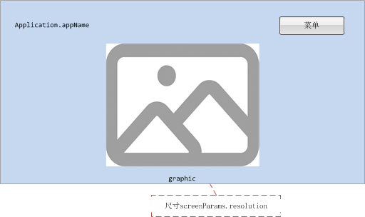

#### 效果图

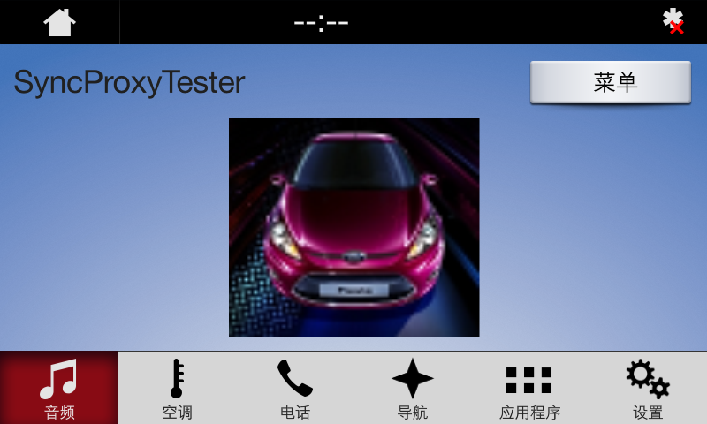

### AppListView

参见3.1.3

### Slider

参见3.1.4

### Alert

参见3.1.5

### AudioPassThru

参见3.1.6

### Choiceset

参见3.1.7

### Command

参见3.1.8

### ScrollableMessage

参见3.1.9

### DialNumber

参见3.1.10

### VideoStream

参见3.1.11

## ONSCREEN_PRESETS

### 属性

{

"id": 62,

"jsonrpc": "2.0",

"result": {

"code": 0,

"displayCapabilities": {

"displayType": "GEN3_8_INCH",

"graphicSupported": true, //支持图像显示

"imageCapabilities": [ //支持动态静态图片

"STATIC",

"DYNAMIC"

],

"imageFields": [

{

"imageResolution": { //softButton图标尺寸

"resolutionHeight": 35,

"resolutionWidth": 35

},

"imageTypeSupported": [ //softButton支持图标类型

"GRAPHIC_BMP",

"GRAPHIC_JPEG",

"GRAPHIC_PNG"

],

"name": "softButtonImage"

},

{

"imageResolution": { //softButton图标尺寸

"resolutionHeight": 70,

"resolutionWidth": 70

},

"imageTypeSupported": [ //softButton支持图标类型

"GRAPHIC_BMP",

"GRAPHIC_JPEG",

"GRAPHIC_PNG"

],

"name": "softButtonImage"

},

{

"imageResolution": { //首选choice图标尺寸

"resolutionHeight": 35,

"resolutionWidth": 35

},

"imageTypeSupported": [ //首选choice支持图标类型

"GRAPHIC_BMP",

"GRAPHIC_JPEG",

"GRAPHIC_PNG"

],

"name": "choiceImage"

},

{

"imageResolution": { //次选choice图标尺寸

"resolutionHeight": 35,

"resolutionWidth": 35

},

"imageTypeSupported": [ //次选choice支持图标类型

"GRAPHIC_BMP",

"GRAPHIC_JPEG",

"GRAPHIC_PNG"

],

"name": "choiceSecondaryImage"

},

{

"imageResolution": { //vr帮助图标占位尺寸

"resolutionHeight": 35,

"resolutionWidth": 35

},

"imageTypeSupported": [ //vr帮助图标支持的格式

"GRAPHIC_BMP",

"GRAPHIC_JPEG",

"GRAPHIC_PNG"

],

"name": "vrHelpItem"

},

{

"imageResolution": { //菜单图标占位尺寸

"resolutionHeight": 35,

"resolutionWidth": 35

},

"imageTypeSupported": [ //菜单图标支持的格式

"GRAPHIC_BMP",

"GRAPHIC_JPEG",

"GRAPHIC_PNG"

],

"name": "menuIcon"

},

{

"imageResolution": { //命令按钮图标占位尺寸

"resolutionHeight": 35,

"resolutionWidth": 35

},

"imageTypeSupported": [ //命令按钮图标支持的格式

"GRAPHIC_BMP",

"GRAPHIC_JPEG",

"GRAPHIC_PNG"

],

"name": "cmdIcon"

},

{

"imageResolution": { //app显示图标占位尺寸

"resolutionHeight": 35,

"resolutionWidth": 35

},

"imageTypeSupported": [ //app显示图标支持的格式

"GRAPHIC_BMP"

],

"name": "appIcon"

},

{

"imageResolution": { //app显示图标占位尺寸

"resolutionHeight": 70,

"resolutionWidth": 70

},

"imageTypeSupported": [ //app显示图标支持的格式

"GRAPHIC_BMP"

],

"name": "appIcon"

},

{

"imageResolution": { //location显示图标占位尺寸

"resolutionHeight": 35,

"resolutionWidth": 35

},

"imageTypeSupported": [ //location显示图标支持的格式

"GRAPHIC_BMP",

"GRAPHIC_JPEG",

"GRAPHIC_PNG"

],

"name": "locationImage"

}

],

"mediaClockFormats": [ //时间显示格式HH:MM:SS

"CLOCK3"

],

"numCustomPresetsAvailable": 8,

"screenParams": {

"resolution": { //画面显示尺寸

"resolutionHeight": 348,

"resolutionWidth": 800

},

"touchEventAvailable": {

"doublePressAvailable": false, // 不支持双击

"multiTouchAvailable": false, //不支持多点触摸

"pressAvailable": true //支持单击

}

},

"templatesAvailable": [ //当前支持的模板

"GRAPHIC_WITH_TEXT",

"TEXT_WITH_GRAPHIC",

"TILES_ONLY",

"GRAPHIC_WITH_TILES",

"TILES_WITH_GRAPHIC",

"GRAPHIC_WITH_TEXT_AND_SOFTBUTTONS",

"TEXT_AND_SOFTBUTTONS_WITH_GRAPHIC",

"GRAPHIC_WITH_TEXTBUTTONS",

"DOUBLE_GRAPHIC_WITH_SOFTBUTTONS",

"TEXTBUTTONS_WITH_GRAPHIC",

"TEXTBUTTONS_ONLY",

"LARGE_GRAPHIC_WITH_SOFTBUTTONS",

"LARGE_GRAPHIC_ONLY",

"MEDIA",

"ONSCREEN_PRESETS"

],

"textFields": [ //各文本字段名字、字符集、显示行数、文本宽度

{

"characterSet": "CID1SET",

"name": "mainField1",

"rows": 1,

"width": 50

},

{

"characterSet": "CID1SET",

"name": "mainField2",

"rows": 1,

"width": 40

},

{

"characterSet": "CID1SET",

"name": "mainField3",

"rows": 1,

"width": 20

},

{

"characterSet": "CID1SET",

"name": "alertText1",

"rows": 1,

"width": 40

},

{

"characterSet": "CID1SET",

"name": "alertText2",

"rows": 1,

"width": 40

},

{

"characterSet": "CID1SET",

"name": "alertText3",

"rows": 1,

"width": 40

},

{

"characterSet": "CID1SET",

"name": "scrollableMessageBody",

"rows": 8,

"width": 67

},

{

"characterSet": "CID1SET",

"name": "audioPassThruDisplayText1",

"rows": 1,

"width": 40

},

{

"characterSet": "CID1SET",

"name": "audioPassThruDisplayText2",

"rows": 1,

"width": 40

},

{

"characterSet": "CID1SET",

"name": "sliderHeader",

"rows": 1,

"width": 60

},

{

"characterSet": "CID1SET",

"name": "sliderFooter",

"rows": 1,

"width": 60

},

{

"characterSet": "CID1SET",

"name": "menuName",

"rows": 1,

"width": 35

},

{

"characterSet": "CID1SET",

"name": "secondaryText",

"rows": 1,

"width": 50

},

{

"characterSet": "CID1SET",

"name": "tertiaryText",

"rows": 1,

"width": 13

},

{

"characterSet": "CID1SET",

"name": "locationName",

"rows": 1,

"width": 20

},

{

"characterSet": "CID1SET",

"name": "locationDescription",

"rows": 1,

"width": 15

},

{

"characterSet": "CID1SET",

"name": "addressLines",

"rows": 4,

"width": 15

},

{

"characterSet": "CID1SET",

"name": "phoneNumber",

"rows": 1,

"width": 30

}

]

},

"method": "UI.SetDisplayLayout",

"softButtonCapabilities": [

{

"imageSupported": true, //按钮支持图片显示

"longPressAvailable": true, //支持长按

"shortPressAvailable": true, //支持短压

"upDownAvailable": true //支持按下弹起,有up、down事件及效果

}

]

}

}

### Show

#### 相关RPC

|  |  |
| --- | --- |
| 名字 | 请求内容 |
| UI.Show | **{**  **"id"**: 45**,**  **"jsonrpc"**: "2.0"**,**  **"method"**: "UI.Show"**,**  **"params"**: **{**  **"alignment"**: "CENTERED"**,**  **"appID"**: 22675**,**  **"customPresets"**: **[**  "GEN0"**,**  "GEN1"**,**  "GEN2"**,**  "GEN3"**,**  "GEN4"**,**  "GEN5"  **],**  **"graphic"**: **{**  **"imageType"**: "DYNAMIC"**,**  **"value"**: "/fs/rwdata/storage/sdl/584421907_6b50de75f3391a9e8117be9ded91461eabe62e54f74c8538e897e6621179721a/icon.png"  **},**  **"secondaryGraphic"**: **{**  **"imageType"**: "DYNAMIC"**,**  **"value"**: "/fs/rwdata/storage/sdl/584421907_6b50de75f3391a9e8117be9ded91461eabe62e54f74c8538e897e6621179721a/turn_right.png"  **},**  **"showStrings"**: **[**  **{**  **"fieldName"**: "mainField1"**,**  **"fieldText"**: "Show Line 1"  **},**  **{**  **"fieldName"**: "mainField2"**,**  **"fieldText"**: "Show Line 2"  **},**  **{**  **"fieldName"**: "mainField3"**,**  **"fieldText"**: "Show Line 3"  **},**  **{**  **"fieldName"**: "mainField4"**,**  **"fieldText"**: "Show Line 4"  **},**  **{**  **"fieldName"**: "mediaClock"**,**  **"fieldText"**: "12:34"  **},**  **{**  **"fieldName"**: "mediaTrack"**,**  **"fieldText"**: "Media Track"  **},**  **{**  **"fieldName"**: "statusBar"**,**  **"fieldText"**: "status bar"  **}**  **],**  **"softButtons"**: **[**  **{**  **"isHighlighted"**: false**,**  **"softButtonID"**: 5552**,**  **"systemAction"**: "KEEP_CONTEXT"**,**  **"text"**: "KeepContext"**,**  **"type"**: "TEXT"  **},**  **{**  **"isHighlighted"**: false**,**  **"softButtonID"**: 5553**,**  **"systemAction"**: "STEAL_FOCUS"**,**  **"text"**: "StealFocus"**,**  **"type"**: "TEXT"  **},**  **{**  **"isHighlighted"**: false**,**  **"softButtonID"**: 5554**,**  **"systemAction"**: "DEFAULT_ACTION"**,**  **"text"**: "Default"**,**  **"type"**: "TEXT"  **}**  **]**  **}**  **}** |
| UI.SetMediaClockTimer | **{**  **"id"**: 47**,**  **"jsonrpc"**: "2.0"**,**  **"method"**: "UI.SetMediaClockTimer"**,**  **"params"**: **{**  **"appID"**: 12077**,**  **"endTime"**: **{**  **"hours"**: 0**,**  **"minutes"**: 20**,**  **"seconds"**: 50  **},**  **"startTime"**: **{**  **"hours"**: 0**,**  **"minutes"**: 12**,**  **"seconds"**: 34  **},**  **"updateMode"**: "COUNTUP"  **}**  **}** |

#### 设计图

执行SetMediaClockTimer之前



执行SetMediaClockTimer之后



#### 效果图

执行SetMediaClockTimer之前



执行SetMediaClockTimer之后



### AppListView

参见3.1.3

### Slider

参见3.1.4

### Alert

参见3.1.5

### AudioPassThru

参见3.1.6

### Choiceset

参见3.1.7

### Command

参见3.1.8

### ScrollableMessage

参见3.1.9

### DialNumber

参见3.1.10

### VideoStream

参见3.1.11